

KAUNAS UNIVERSITY OF TECHNOLOGY

FACULTY OF INFORMATICS

T120B166 Development of Computer Games and Interactive Applications

Escape the Lab VR

**Done by:**

|  |
| --- |
| Eligijus Kiudys  IFF-7/14 |
|  |
| **Date:**  2020-02-17 |

Kaunas, 2019

Tables of Contents

Tables of Images 3

Table of Tables/functions 4

Work Distribution Table: 5

Description of Your Game 6

Laboratory work #1 7

List of tasks 7

Solution 7

Task #1. Create second level 7

Task #2. Implement Virtual Reality player movement (in this case, teleportation) 13

Task #3. Decorate the level with at least 20 GameObjects, 5 Lights and 5 materials 16

Task #4. Make a new GameObject, give it a Collider, use onTriggerEnter to track when the Player touches it, then destroy it and print out a message that says “Player touched me” 18

Task #5. Create flask breaking onCollisionEnter 19

Task #6. Create a GameObject and make that object starts hover by pressing spacebar and pressing space second time it come down (defense task) 22

Laboratory work #2 25

Task #7. Experiment with Polybrush / SpriteShapes / ProBuilder / Tilemap Palette tools. 25

Literature list 45

ANNEX 46

# **Tables of Images**

Figure 1. Second level scene with some used prefabs below 8

Figure 2. Objects inside of a shelf 9

Figure 3. Timer trigger 10

Figure 4. Correct teleportation 14

Figure 5. Incorrect teleportation 14

Figure 6. VRTK Teleportation hierarchy 15

Figure 7. Main teleportation component inspector 15

Figure 8. Scene decoration with various GameObjects 16

Figure 9. Objects used in the scene #1 16

Figure 10. Objects used in the scene #2 17

Figure 11. Objects used in the scene #3 17

Figure 12. Lamp model #1 17

Figure 13. Lamp model #2 18

Figure 14. Capsule standign still 23

Figure 15. Hovering capsule 23

Figure 16. Created terrain 25

Figure 17 Created terrain 25

Figure 18 Open hands 26

Figure 19 Using grip 26

Figure 20 Using index finger with trigger 26

Figure 21 Running flask 27

Figure 22 Flickering lights 27

Figure 23 Driving car 28

Figure 24 Water particles 28

Figure 25 Liquid chemical particles 29

Figure 26 Flask smash particle 29

Figure 27 Outlet particles 30

Figure 28 Dry ice reaction 30

Figure 29 Editor woth open scene with night skybox 31

Figure 30 Bouncy pen 31

Figure 31 bouncines material 31

Figure 32 Flask with friction 32

Figure 33 Friction material 32

Figure 34 Slipery mouse 32

Figure 35 Slipery material 32

Figure 36 Objects set to static 37

Figure 37 Objcets set to static 37

Figure 38 Camera settings 38

Figure 39 In game statistics 38

Figure 40 profiler results 39

Figure 41 Baked light map 39

Figure 42 profiler results with baked light map 40

Figure 43 Material exampl 40

Figure 44 Material example 41

Figure 45 Material example 41

Figure 46 Frame debugger 42

Figure 47 Low quality 42

Figure 48 High Quality 43

Figure 49 Ultra Quality 43

# **Table of Tables/functions**

Table 1. Timeleft.cs script component 11

Table 2. StopTime.cs script component 11

Table 3. LockUnlockWithKey.cs script component 13

Table 4. destroyontouch script component 18

Table 5. BottleSmah.cs code 22

Table 6. Hovering.cs script 24

Table 7 Liquid absorber code 34

Table 8 On trigger enter note 35

Table 9 OnTrigger enter timer 35

Table 10 Doors on trigger enter 36

# **Work Distribution Table:**

|  |  |
| --- | --- |
| ***Name/Surname*** | ***Description of game development part*** |
| *Airidas Janonis* | Mostly responsible for project management, game design, 2D assets (sprites, sprite sheets, etc. ), game balancing, creating visual effects ( unity VFX, particle systems ), a smaller portion of programming |
| *Eligijus Kiudys* | Mostly responsible for a bigger portion of the programming, creating some of the 3D assets, implementing new systems into the game (Steam VR, Virtual reality toolkit VRTK, etc.), shader writing for game mechanics such as drawing, writing, creating some of visual effects. |

# **Description of Your Game**

Description of Your Game.

1. **2D or 3D?** 3D.
2. **Genres:** Casual, Indie, Simulation, Educational
3. **Platforms:** PC
4. **Scenario Description:** The main concept of the game was taken from laboratory facilities of KTU Chemistry faculty. The goal of the game is to escape from the laboratory in a certain amount of time. To progress further, the player has to look for clues and perform chemical reactions/experiments. After completion of these tasks, the player is awarded another clue or a part of a three-digit code, which is required for the exit door keylock

**Laboratory work #1**

**List of tasks**

1. Create second level
2. Implement Virtual Reality player movement (in this case, teleportation)
3. Decorate the level with at least 20 GameObjects, 5 Lights and 5 materials
4. Make a new GameObject, give it a Collider, use onTriggerEnter to track when the Player touches it, then destroy it and print out a message that says “Player touched me”
5. Create flask breaking onCollisionEnter
6. Create a GameObject and make that object starts hover by pressing spacebar and pressing space second time it come down (defense task)

# **Solution**

## **Task #1. Create second level**

Second level scene was made by using all kinds of different GameObjects:

* Models, that were created inside of a 3D modeling software Blender;
* First level models;
* Various light sources;
* Timer;
* Various Liquids, flasks;
* Other laboratory interior objects.

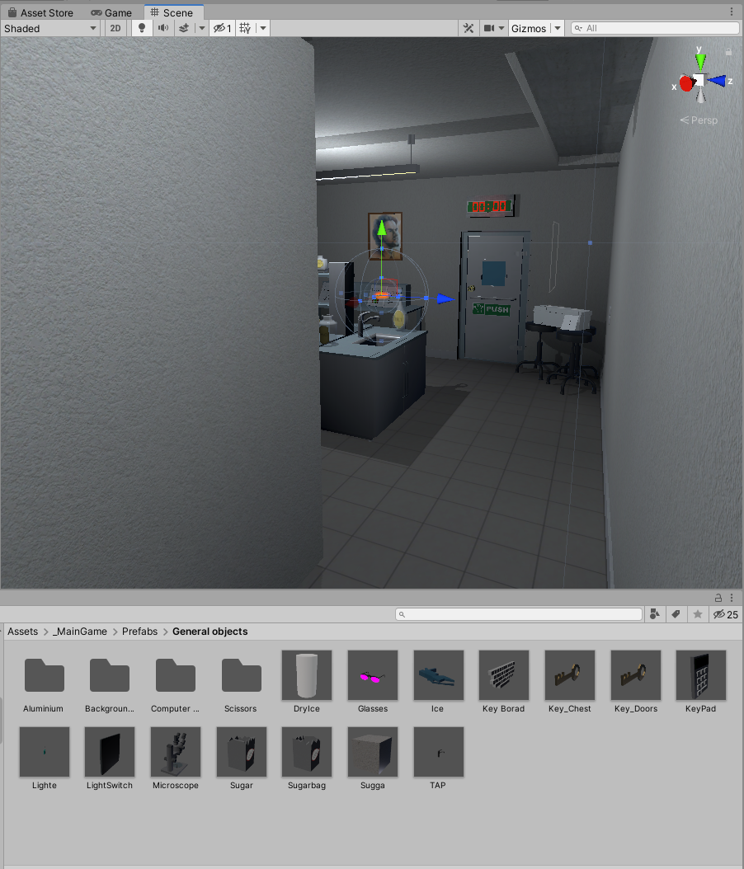

Figure 1. Second level scene with some used prefabs below

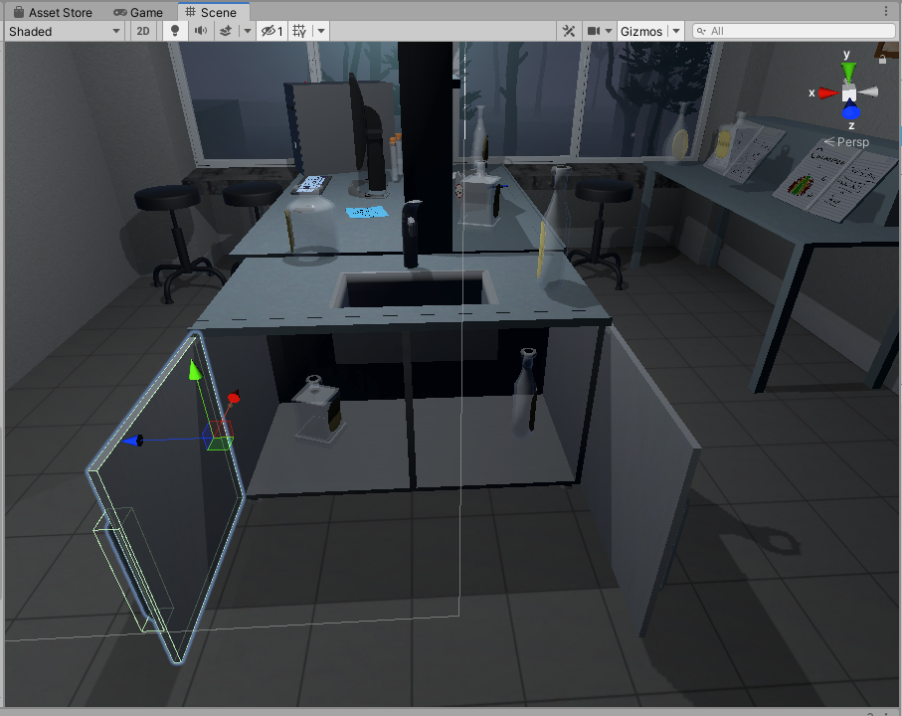

Figure 2. Objects inside of a shelf

**Timer workflow:**

The timer is activated via TimeLeft.cs script component when the player hits a trigger collider (Figure 3). If the timer is over, player loses the game. If the player completes the level during the time limit, the timer stops via StopTime.cs script component.

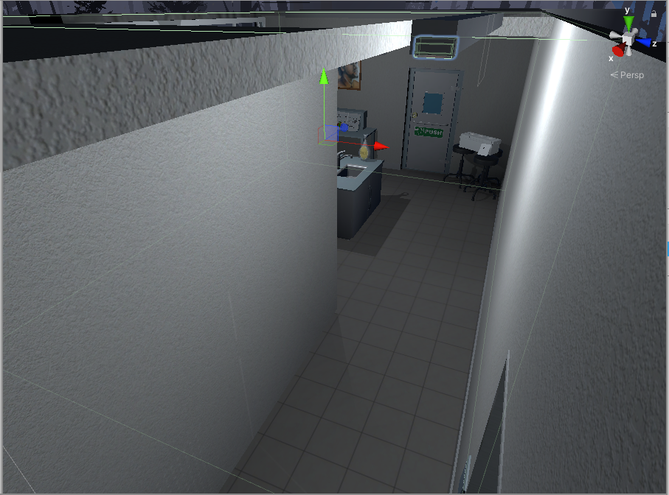

Figure 3. Timer trigger

|  |
| --- |
| public class TimeLeft : MonoBehaviour  {  [SerializeField] TextMeshPro timerMinutes;  [SerializeField] TextMeshPro timerSeconds;  private float stopTime;  public float timerTime;  public bool finalStop = false;  private bool isRunning = false;  private bool check = false;  private void Start()  {  StopTimer();  GlobalData.LevelsTime += timerTime;  }  private void Update()  {  if (isRunning && !finalStop)  {  timerTime = stopTime + (timerTime - Time.deltaTime);  int minutesInt = (int)timerTime / 60;  int secondsInt = (int)timerTime % 60;  timerMinutes.text = (minutesInt < 10) ? "0" + minutesInt : minutesInt.ToString();  timerSeconds.text = (secondsInt < 10) ? "0" + secondsInt : secondsInt.ToString();  if(timerTime <= 0)  {  GameData.SetEnd(true);  GameData.SetVictory(false);  isRunning = false;  }  }  else if(!isRunning && finalStop && !check)  {  OneTimeSend();  check = true;  }  }  public void StopTimer()  {  isRunning = false;  }  public void TimerStart()  {  if(!isRunning)  {  print("timer is running");  isRunning = true;  }  }  public void MinusTime(float seconds)  {  timerTime -= seconds;  }  public void OneTimeSend()  {  //Debug.Log(timerTime.ToString());  GlobalData.Timer.Add(timerTime);  }  } |

Table 1. Timeleft.cs script component

|  |
| --- |
| public class StopTime : MonoBehaviour  {  public LockUnlockWithKey locks;  [SerializeField] TimeLeft time;  // Start is called before the first frame update  // Update is called once per frame  void Update()  {  if (locks.isChestOpen())  {  time.StopTimer();  time.finalStop = true;  //time.OneTimeSend();  }  }  } |

Table 2. StopTime.cs script component

**Door unlocking workflow:**

To pass the level, player has to preforme two experiments to get key, which is used to unlock the door. Key and doors have specific tags, which are evaluated. LockUnlockWithKey.cs script component is used to check key GameObject by tag – if the tag is correct, the script component unlocks the door.

|  |
| --- |
| public class LockUnlockWithKey : MonoBehaviour  {  [SerializeField] GameObject[] Note;  [SerializeField] GameObject doorsControll;  [SerializeField] Rigidbody rb;  [SerializeField] string checkKey;  [SerializeField] bool x = false;  [SerializeField] bool y = false;  [SerializeField] bool z = false;  bool isSnapped = false;  IdForUnlock[] unlock;  public bool Open = false;  bool oneTime = true;  bool check = false;  private int unlockId = 0;  bool rigidbodyExists = false;  int index = 0;  [SerializeField] DelegateChange Task;  // Start is called before the first frame update  void Start()  {  doorsControll.SetActive(false);  foreach ( GameObject obj in Note )  {  obj.SetActive(false);  }  if (x)  {  rb.constraints = RigidbodyConstraints.FreezeRotationX;  }  else if (y)  {  rb.constraints = RigidbodyConstraints.FreezeRotationY;  }  else if (z)  {  rb.constraints = RigidbodyConstraints.FreezeRotationZ;  }  }  // Update is called once per frame  void Update()  {  if (!check && isSnapped)  {  unlock = FindObjectsOfType<IdForUnlock>();  if (index < unlock.Length)  {  if (unlock[index] != null && unlock[index].tag == checkKey)  {  int id = Random.Range(1, 20);  unlockId = id;  unlock[index].SetId(id);  check = true;  }  else if(unlock[index] != null && unlock[index].tag != checkKey)  {  index++;  }  }  else if(index >= unlock.Length)  {  index = 0;  }  }  else  {  if (Open == true && oneTime)  {  doorsControll.SetActive(true);  rb.constraints = RigidbodyConstraints.None;  foreach (GameObject obj in Note)  {  obj.SetActive(true);  }  oneTime = false;  rigidbodyExists = true;  Task.AddTask();  Destroy(this);  }  if (isSnapped && unlock[index].GetId() == unlockId)  {  Open = true;  }  }  }  public bool isChestOpen()  {  if (rigidbodyExists)  return Open;  else  return false;  }  public void Snap()  {  isSnapped = true;  }  public void UnSnap()  {  isSnapped = false;  }  } |

Table 3. LockUnlockWithKey.cs script component

## **Task #2. Implement Virtual Reality player movement (in this case, teleportation)**

The Virtual reality basic controls, such as Teleportation were implemented with the help of VRTK (Virtual Reality Toolkit) plugin. The scripts and mechanics from VRTK are based on script inheritance.

There is a player’s Head at the same position as a VR headset, which is actively tracked. The VR has a zone which is called play area, where player can walk freely until he reaches the end of this zone. If he steps out of the zone, the tracking of headset might be stopped.

**The teleportation workflow:**

First of all, the offset of player’s head and the play area is calculated. After putting a finger on the teleportation button (most of the time it is touchpad button) the program reads one input, which enables curved raycast line. Another input is when the button is being pressed, which teleports the player to the targeted position (the last point of curved raycast line) by calculating the offset of the play area and the last position of the curved raycast line. Later on, the saved offset from beginning is restored and the player is spawned at the pointed location.

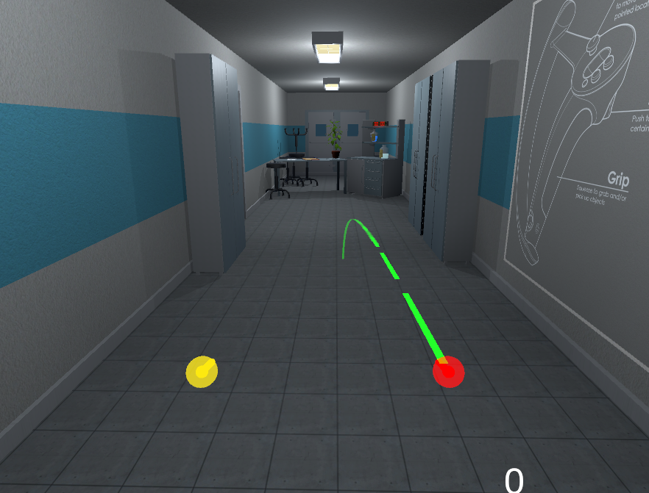

Figure 4. Correct teleportation

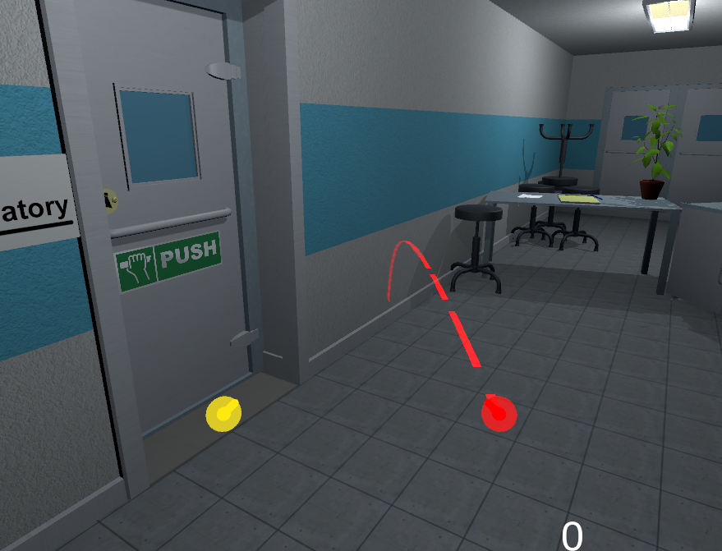

Figure 5. Incorrect teleportation

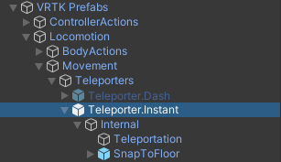

Figure 6. VRTK Teleportation hierarchy

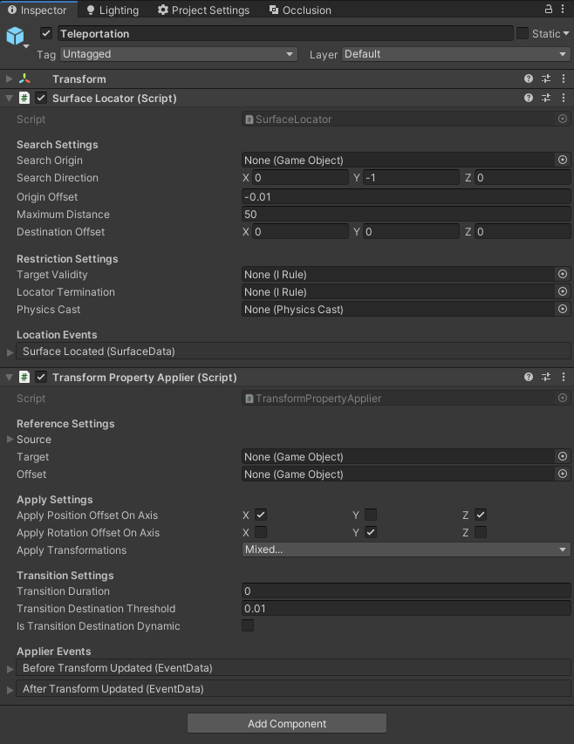

Figure 7. Main teleportation component inspector

## **Task #3. Decorate the level with at least 20 GameObjects, 5 Lights and 5 materials**

The level has been decorated with objects that were modeled in Blender, as mentioned during the first task. Before using these objects inside of the scene, they have been given various components – colliders, rigidbodies, tags, layers, etc.

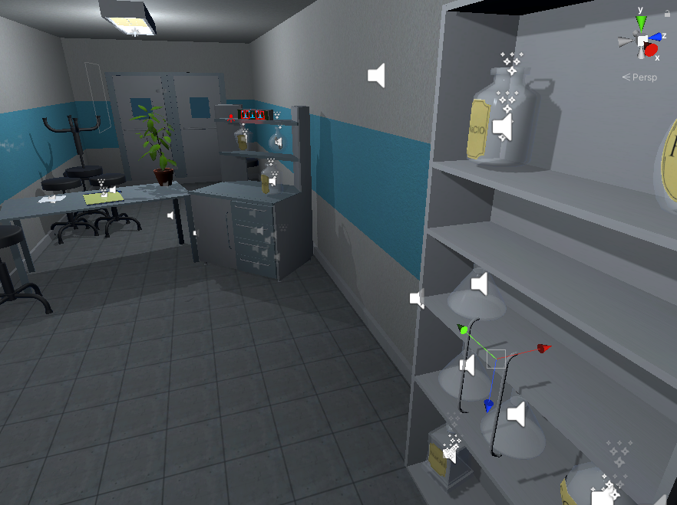

Figure 8. Scene decoration with various GameObjects

Some of the GameObjects that were used in the mentioned scene decoration are are shown at Figures 4-6.

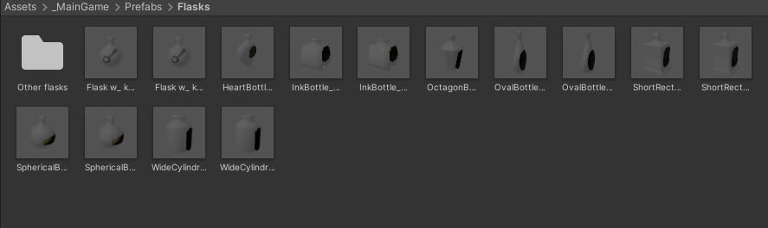

Figure 9. Objects used in the scene #1

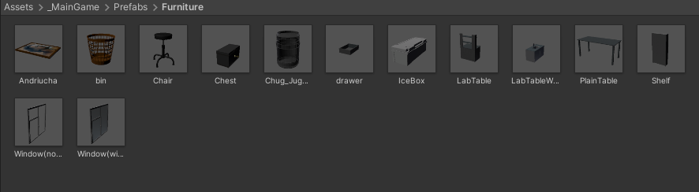

Figure 10. Objects used in the scene #2

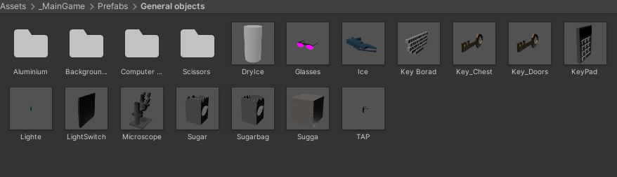

Figure 11. Objects used in the scene #3

The light sources has been made with a few different models.

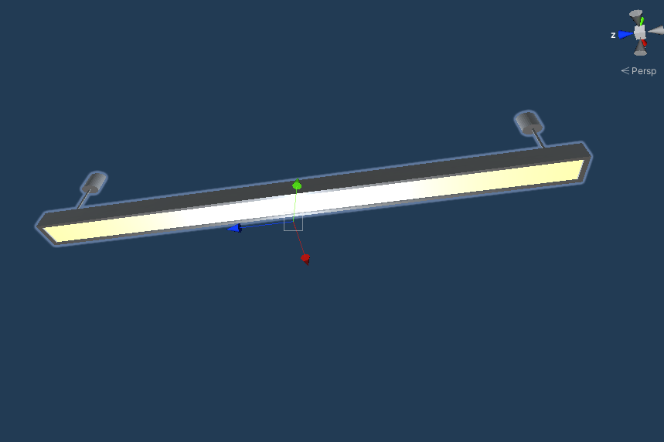

Figure 12. Lamp model #1

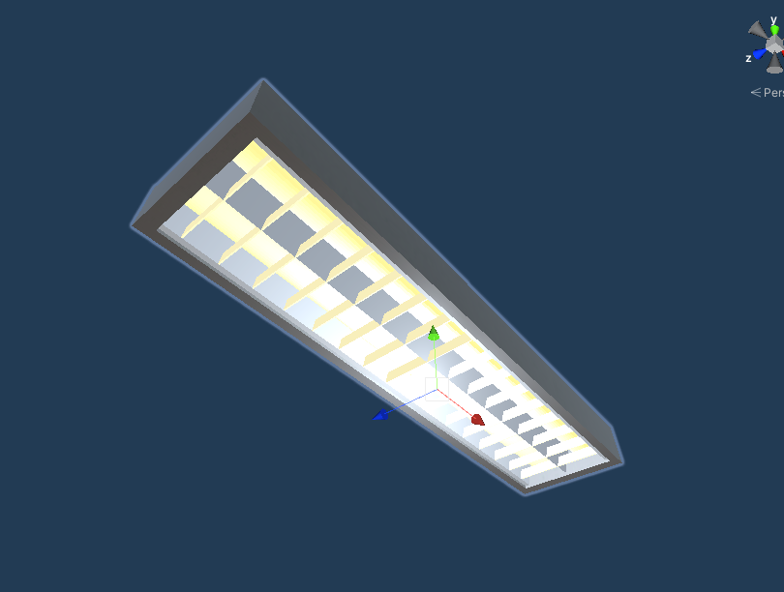

Figure 13. Lamp model #2

## **Task #4. Make a new GameObject, give it a Collider, use onTriggerEnter to track when the Player touches it, then destroy it and print out a message that says “Player touched me”**

Implemented the functionality by adding DestroyOnTouch.cs script component into GameObject. If this GameObject collides with another GameObject, which has a layer of 10 (which is a player’s Hand), the “Player has touched me” message gets printed out and the object destroys itself.

|  |
| --- |
| public class destroyontouch : MonoBehaviour  {  private void OnTriggerEnter(Collider other)  {  if (other.gameObject.layer == 10)  {  Debug.Log("Player has touched me!");  Destroy(this.gameObject);  }  }  } |

Table 4. destroyontouch script component

## **Task #5.** **Create flask breaking onCollisionEnter**

Implemented the functionality by adding BootleSmash.cd script to GameObject.

Script checks if GameObject is not in the hand and it collides. onCollisionEnter checks how fast it collides if it faster than set minimum limit then flask shards is enabled and breaking particles are enabled, after particles and flask shard are enabled game object is destroyed. Shards after 5 seconds are destroyed.

|  |
| --- |
| using System.Collections;  using System.Collections.Generic;  using UnityEngine;  public class BottleSmash : MonoBehaviour {  // Use this for initialization  //all of the required items in order to gie the impression of hte glass breaking.  [ColorUsageAttribute(true, true, 0f, 8f, 0.125f, 3f)]  public Color color;  //to use to find any delta  [HideInInspector]  private Color cachedColor;  //used to update any colors when the value changes, not by polling  [SerializeField]  [HideInInspector]  private List<ColorBase> registeredComponents;  public GameObject Cork, Liquid, Glass, Glass_Shattered, Label;  //default despawn time;  public float DespawnTime = 5.0f;  public float time = 0.5f;  float tempTime;  float clacTime;  public float splashLevel = 0.006f;  public bool colided = false;  //splash effect.  public ParticleSystem Effect;  //3D mesh on hte ground (given a specific height).  public GameObject Splat;  //such as the ground layer otherwise the broken glass could be considered the 'ground'  public LayerMask SplatMask;  //distance of hte raycast  public float maxSplatDistance = 5.0f;  //if the change in velocity is greater than this THEN it breaks  public float shatterAtSpeed = 2.0f;  //if the is disabled then it wont shatter by itself.  public bool allowShattering = true;  //if it collides with an object then and only then is there a period of 0.2f seconds to shatter.  public bool onlyAllowShatterOnCollision = true;  //for the ability to find the change in velocity.  [SerializeField]  [HideInInspector]  private Vector3 previousPos;  [SerializeField]  [HideInInspector]  private Vector3 previousVelocity;  [SerializeField]  [HideInInspector]  private Vector3 randomRot;  [SerializeField]  [HideInInspector]  private float _lastHitSpeed = 0;  //dont break if we have already broken, only applies to self breaking logic, not by calling Smash()  public bool broken = false;  //timeout  float collidedRecently = -1;  LiquidVolumeAnimator lva;  SteamVrSceleton skeleton;  void Start () {  if (Liquid != null)  {  lva = Liquid.GetComponent<LiquidVolumeAnimator>();  }  skeleton = GetComponent<SteamVrSceleton>();  clacTime = time;  tempTime = time;  previousPos = transform.position;  }  //Smash function so it can be tied to buttons.  public void RandomizeColor()  {  color = new Color(Random.Range(0, 1), Random.Range(0, 1), Random.Range(0, 1), 1);  }  void OnCollisionEnter(Collision collision)  {  //set a timer for about 0.2s to be able to be broken  _lastHitSpeed = collision.impulse.magnitude;  if (collision.transform.tag != "Liquid" && collision.transform.tag != "Absorver")  {  //Debug.Log(collision.transform.name);  collidedRecently = 0.2f;  }    }  public void AttemptCollision(Collision col)  {  OnCollisionEnter(col);  }  public void RegisterColorBase(ColorBase cb)  {  registeredComponents.Add(cb);  }  public void ChangedColor()  {  if(cachedColor != color)  {  cachedColor = color;  //update all registered components  foreach (ColorBase cb in registeredComponents)  {  cb.Unify();  }  }  }  public Vector3 GetRandomRotation()  {  return randomRot;  }  public void RandomRotation()  {  randomRot = (Random.insideUnitSphere + Vector3.forward).normalized;  }  public void Smash()  {  skeleton.UnGrab();  broken = true;  //the Corks collider needs to be turned on;  if (Cork != null)  {  Cork.transform.parent = null;  Cork.GetComponent<Collider>().enabled = true;  Cork.GetComponent<Rigidbody>().isKinematic = false;  Destroy(Cork.gameObject, DespawnTime);  }  //the Liquid gets removed after n seconds  if (Liquid != null)  {  float t = 0.0f;  //if (Effect != null)  // t = (Effect.main.startLifetime.constantMin + Effect.main.startLifetime.constantMax)/2;  Destroy(Liquid.gameObject, t);  }  //particle effect  if(Effect != null && lva != null && lva.level > splashLevel)  {  Effect.Play();  Destroy(Effect.gameObject, Effect.main.startLifetime.constantMax);  }  else if (Effect != null && lva != null && lva.level < splashLevel)  {  Destroy(Effect.gameObject, Effect.main.startLifetime.constantMax);  }  else if (Effect != null && lva == null)  {  Destroy(Effect.gameObject, Effect.main.startLifetime.constantMax);  }  //now the label;  if (Label != null)  {  //Label.transform.parent = null;  //Label.GetComponent<Collider>().enabled = true;  //Label.GetComponent<Rigidbody>().isKinematic = false;  Destroy(Label.gameObject);  }  //turn Glass off and the shattered on.  if (Glass != null)  {  Destroy(Glass.gameObject);  }  if (Glass_Shattered != null)  {  Glass_Shattered.SetActive(true);  Glass_Shattered.transform.parent = null;  Destroy(Glass_Shattered, DespawnTime);  }  //instantiate the splat.  RaycastHit info = new RaycastHit();  if(Splat != null)  if (Physics.Raycast(transform.position, Vector3.down, out info, maxSplatDistance, SplatMask))  {  GameObject newSplat = Instantiate(Splat);  newSplat.transform.position = info.point;    }  Destroy(transform.gameObject, DespawnTime);  }  // Update is called once per frame, for the change in velocity and all that jazz...  void FixedUpdate () {  ChangedColor();  collidedRecently -= Time.deltaTime;  Vector3 currentVelocity = (transform.position - previousPos) / Time.fixedDeltaTime;  if ((onlyAllowShatterOnCollision && collidedRecently >= 0.0f) | !onlyAllowShatterOnCollision)  {  if (allowShattering)  {  if (Vector3.Distance(currentVelocity, previousVelocity) > shatterAtSpeed || _lastHitSpeed > shatterAtSpeed)  {  if (!broken)  Smash();  }  }  }  _lastHitSpeed = 0;  previousVelocity = currentVelocity;  previousPos = transform.position;  }  public void ResetVelocity()  {  previousVelocity = Vector3.zero;  previousPos = transform.position;  }  } |

Table 5. BottleSmah.cs code

## **Task #6. Create a GameObject and make that object starts hover by pressing spacebar and pressing space second time it come down (defense task)**

Created a capsule GameObject, gave it rigidbody and collider components. To implement the jumping mechanic, a Defense.cs script was written and given to the GameObject.

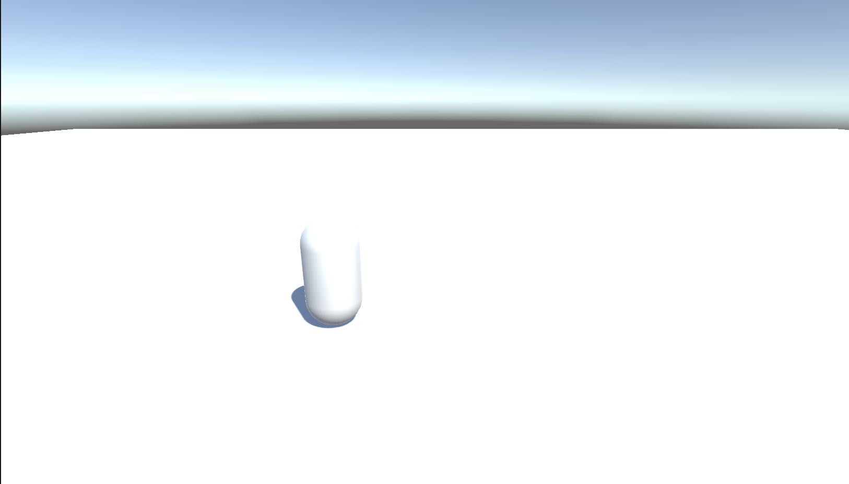

Figure 14. Capsule standign still

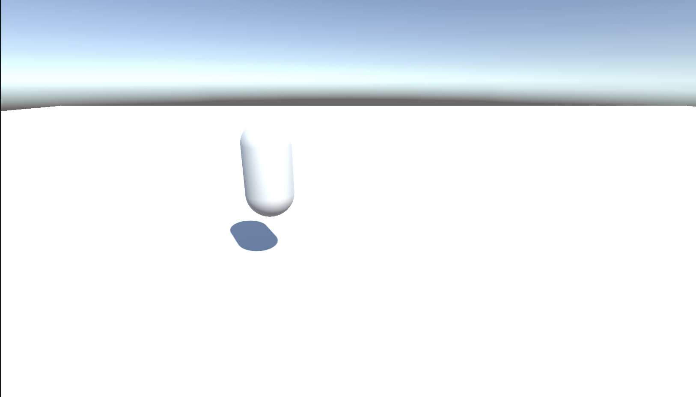

Figure 15. Hovering capsule

The hovering works by adding force up to capsule when space is pressed first time. When capsule reached specific point rigidbody is changed to kinematic. When space is pressed second time rigidbody kinematic is set false.

|  |
| --- |
| using System.Collections;  using System.Collections.Generic;  using UnityEngine;  public class Hovering : MonoBehaviour  {  Rigidbody rb;  float startPos = 0;  float difference = 0;  [SerializeField] float height = 0.1f;  bool isHovering = true;  // Start is called before the first frame update  void Start()  {  rb = GetComponent<Rigidbody>();  startPos = rb.worldCenterOfMass.y;  }  // Update is called once per frame  void Update()  {  if (isHovering)  {  if (difference == 0 || difference < height)  {  rb.isKinematic = false;  rb.AddForce(Vector3.up * 5f, ForceMode.Impulse);  }  difference = rb.worldCenterOfMass.y - startPos;  if (difference > height)  {  rb.isKinematic = true;  }  }  if (Input.GetKeyDown(KeyCode.Space) && isHovering)  {  isHovering = false;  rb.velocity = Vector3.zero;  rb.isKinematic = false;  }  else if (Input.GetKeyDown(KeyCode.Space) && !isHovering)  {  isHovering = true;  }  }  } |

Table 6. Hovering.cs script

**Laboratory work #2**

## **Task #7. Experiment with Polybrush / SpriteShapes / ProBuilder / Tilemap Palette tools.**

Created main scene terrain with polybrush and unity terrain tool.

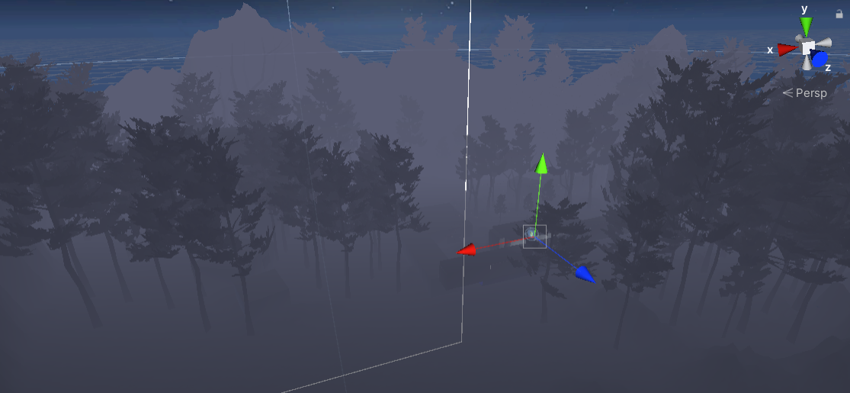

Figure 16. Created terrain

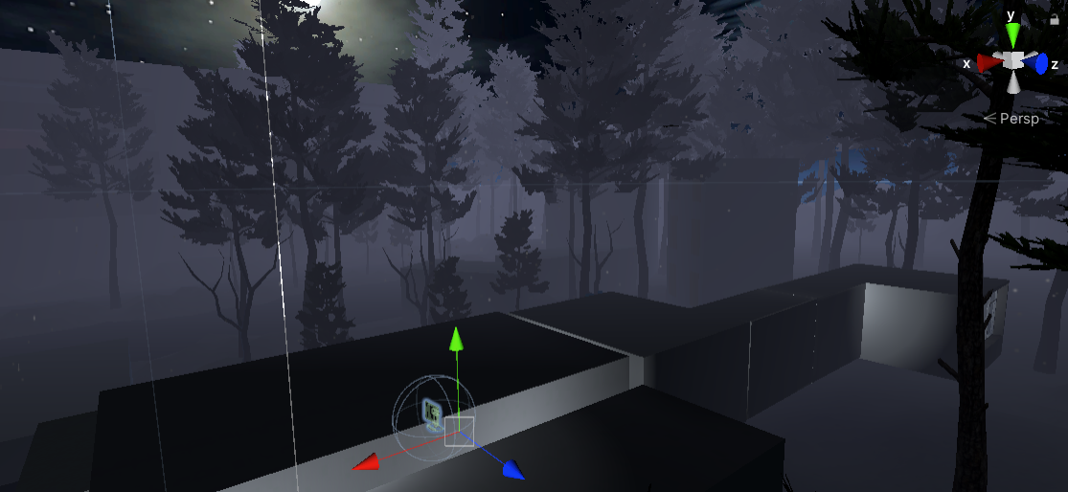

Figure 17 Created terrain

In this scene I was using polybrush for hills and trees

**Task #8 Add animations to your game character (Assuming you have a working PlayerController.**

In Escape the Lab the player is the game character, which means that the character’s animations are based on real-time inputs through the Virtual Reality controllers – currently only the hands and fingers are animated. There are a few different approaches to these hand inputs: • If the character hands are controlled with Valve Index device controllers, the in-game hands and fingers will be moved accordingly; • If the character hands are controlled with HTC Vive, Oculus Rift or any other similar controller, the fingers moves inwards when the player puts his fingers on a button, and it does the opposite when the player removes his finger from the button.

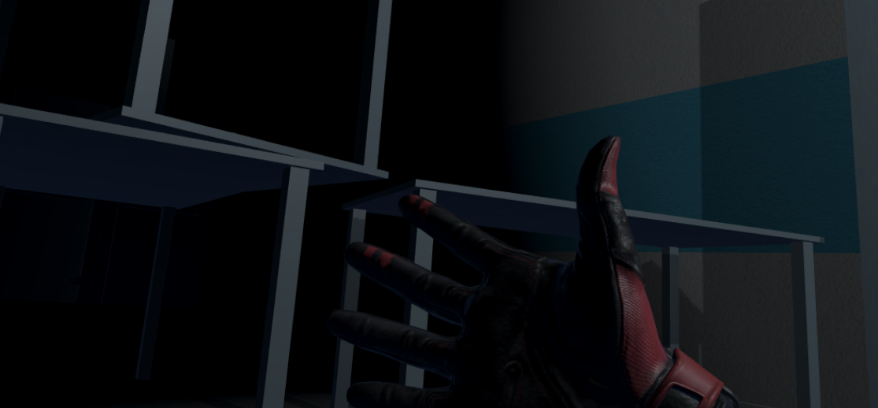

Figure 18 Open hands

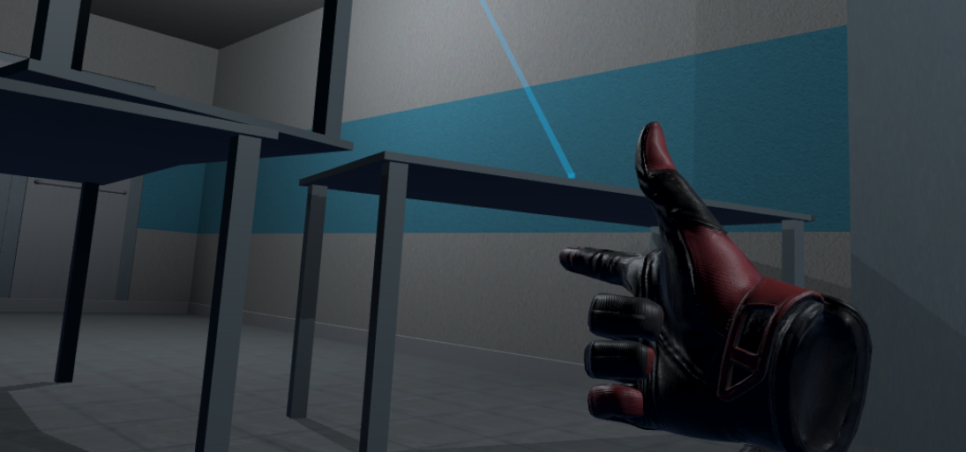

Figure 19 Using grip

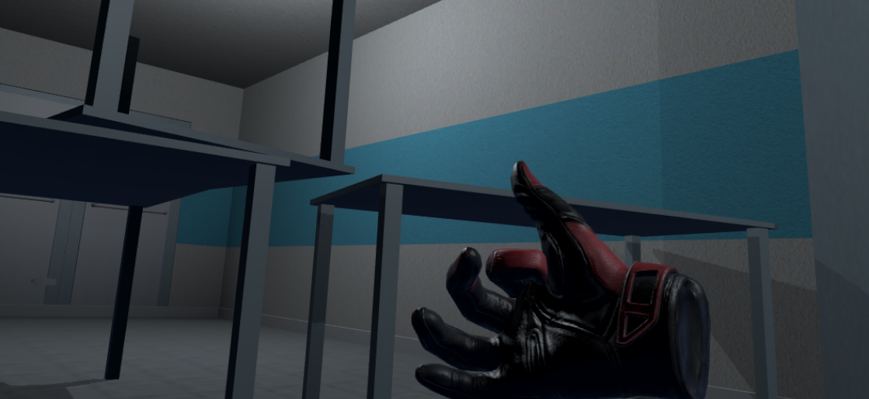

Figure 20 Using index finger with trigger

**Task #9. Create and/or animate 5 objects of your choice in your World (you can use Animator Component and/or Timeline).**

The game is fully interactable, which means that there are loads of objects that are mostly based on physics and collisions, not animations.

Some of the animated objects:

• Flask humanoid – when the player comes too close to the flask, the humanoid flask gets scared away and hides under a shelf

• Flickering lights – corridor lights are flickering from time to time

• Driving vehicle – a car that drives through the terrain from time to time.

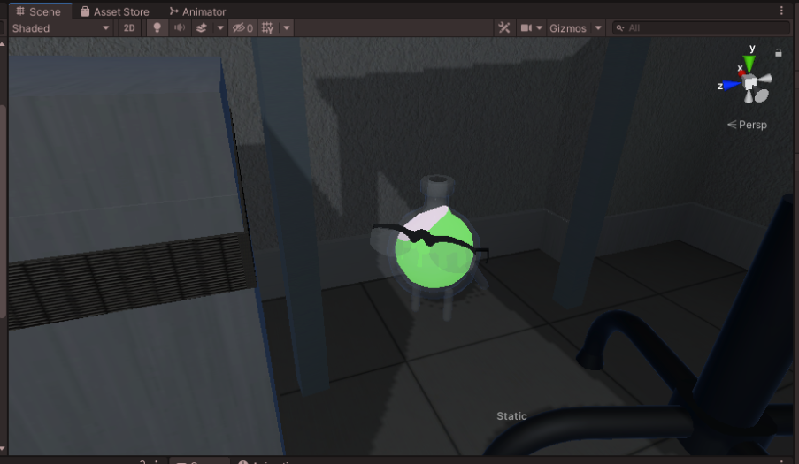

Figure 21 Running flask

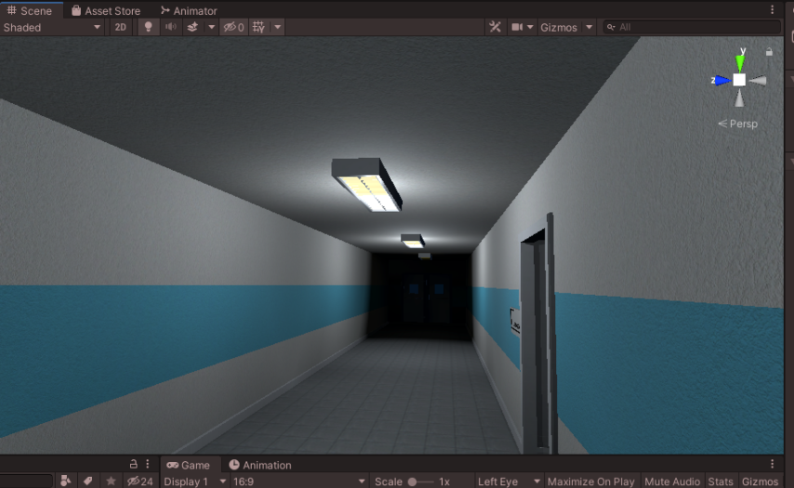

Figure 22 Flickering lights

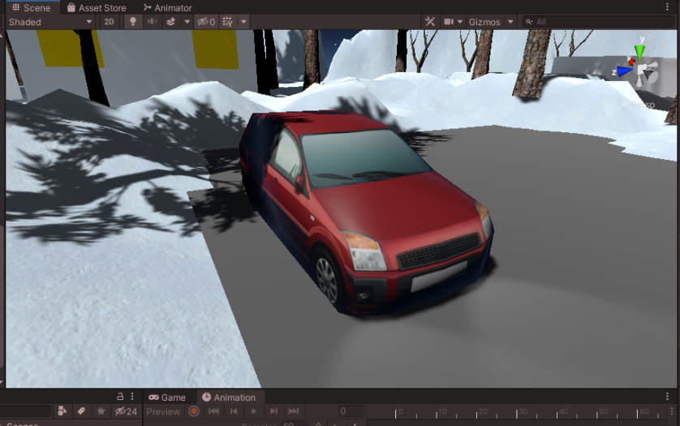

Figure 23 Driving car

**Task #10. Create at least 5 particle effects for your environment (dust, explosion, smoke gas, light sparks, etc.).**

In this project we use two particle systems physic and graphics. Almost all particles are using physics system because VFX doesn’t interact with physic colliders.

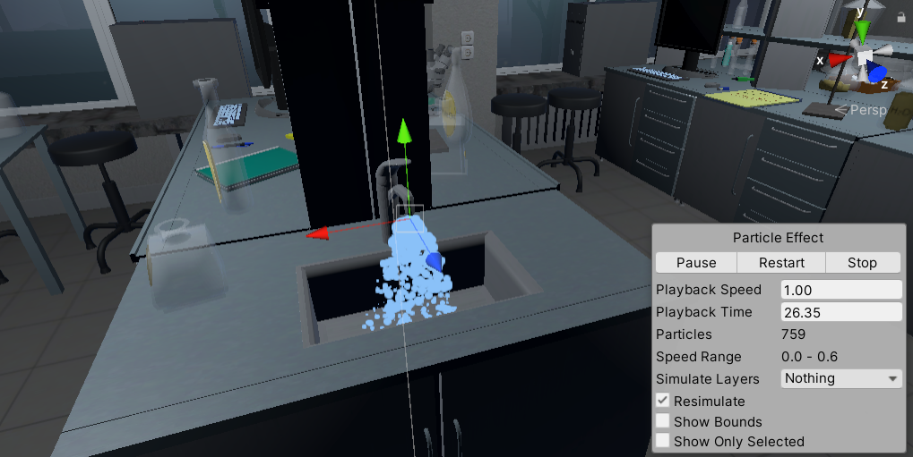

Figure 24 Water particles

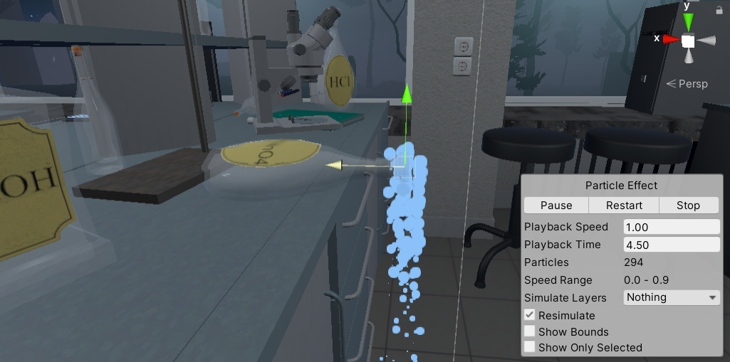

Figure 25 Liquid chemical particles

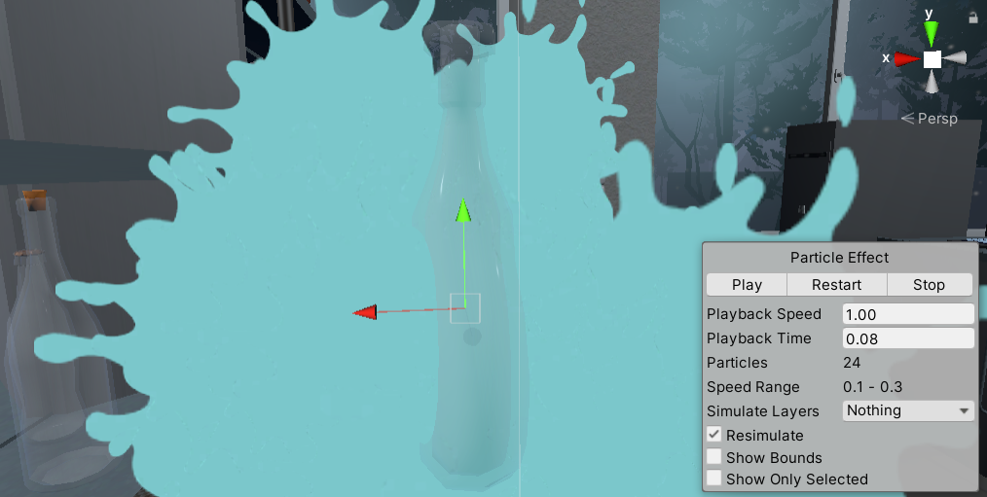

Figure 26 Flask smash particle

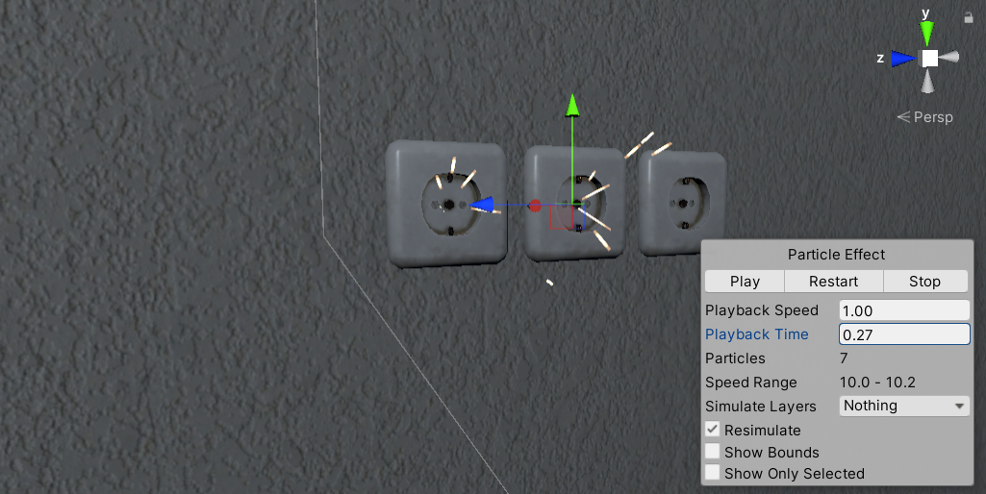

Figure 27 Outlet particles

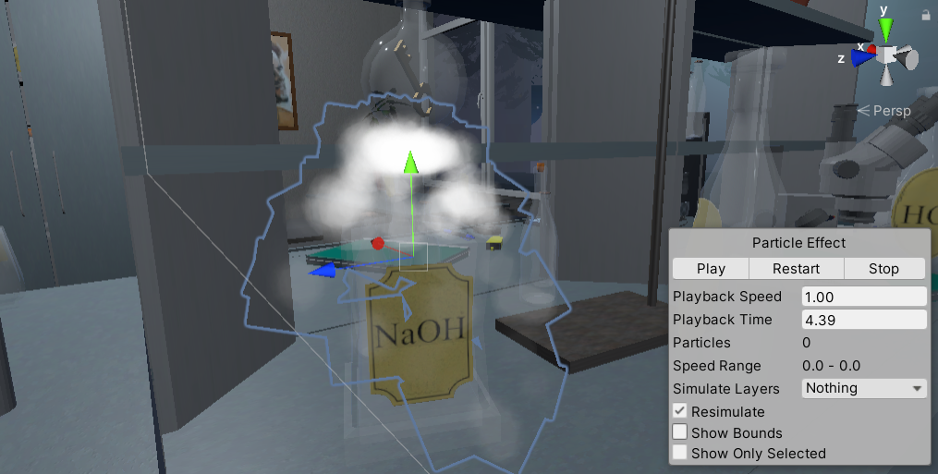

Figure 28 Dry ice reaction

**Task #11. Add a custom skybox.**

This project contains several skyboxes, this is one of them.

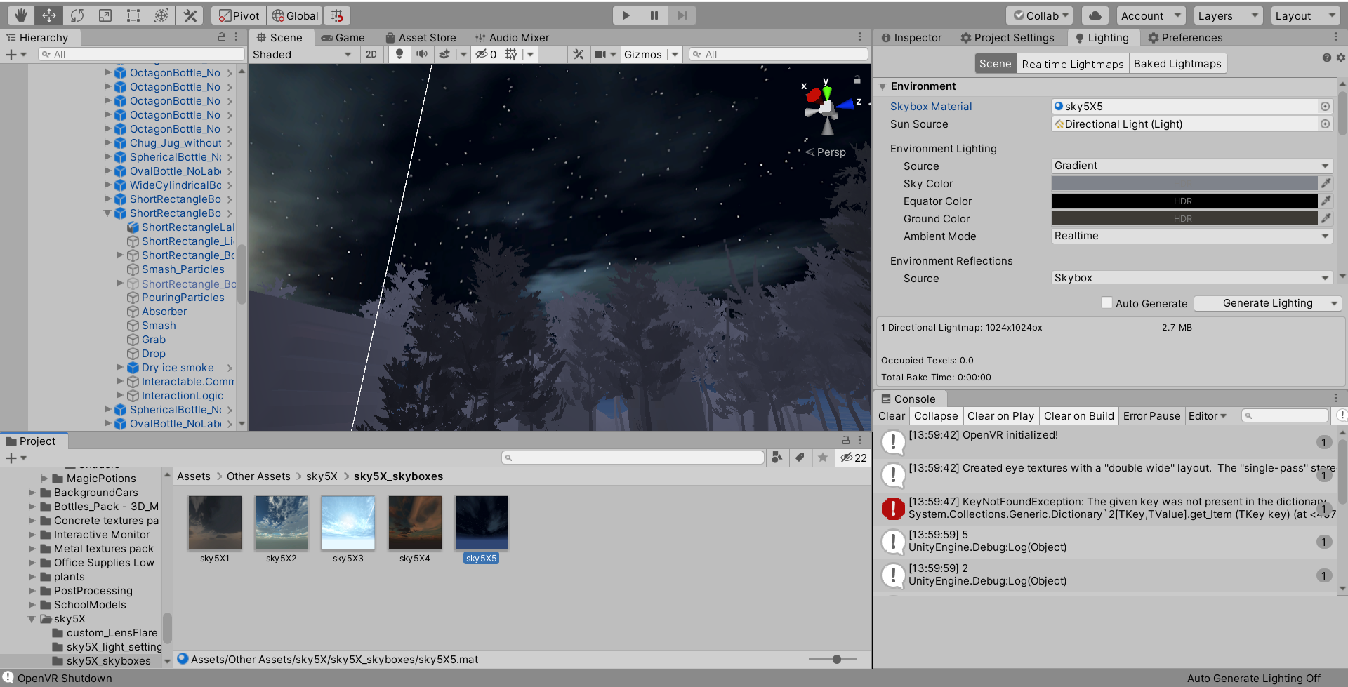

Figure 29 Editor woth open scene with night skybox

**Task #12. Create at least 3 different Physics Materials for various parts of the map (either it’s a slippery platform/ice, bouncy wall, non-slippery ground, etc.).**

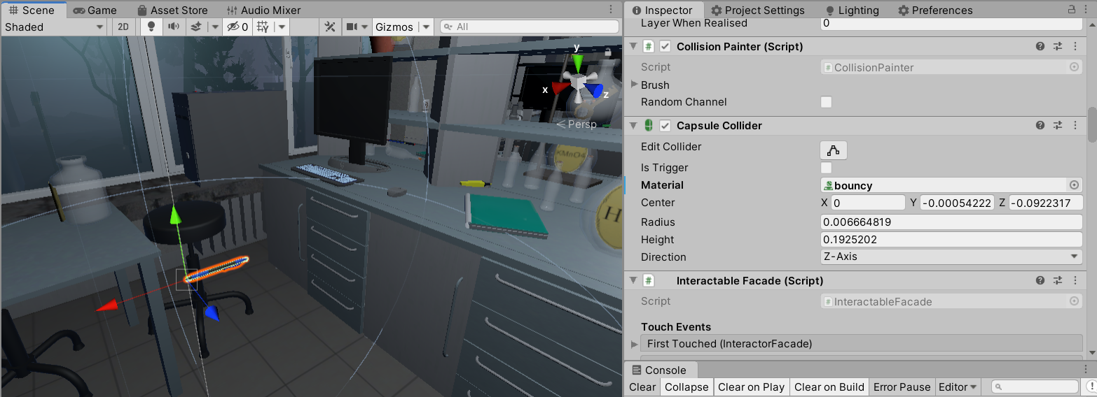

Figure 30 Bouncy pen

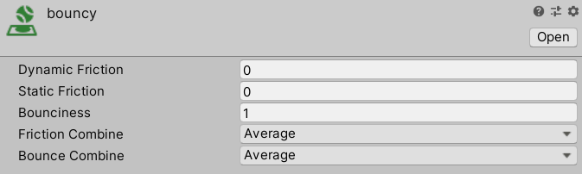

Figure 31 bouncines material

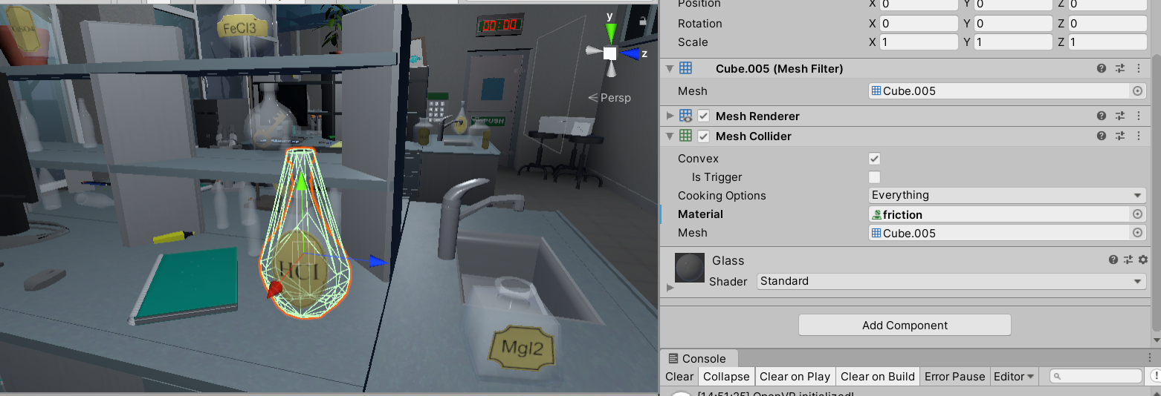

Figure 32 Flask with friction

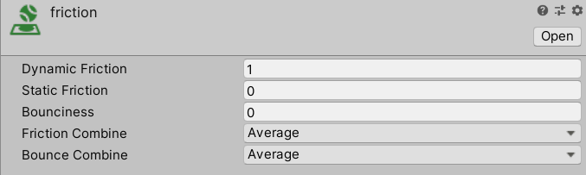

Figure 33 Friction material

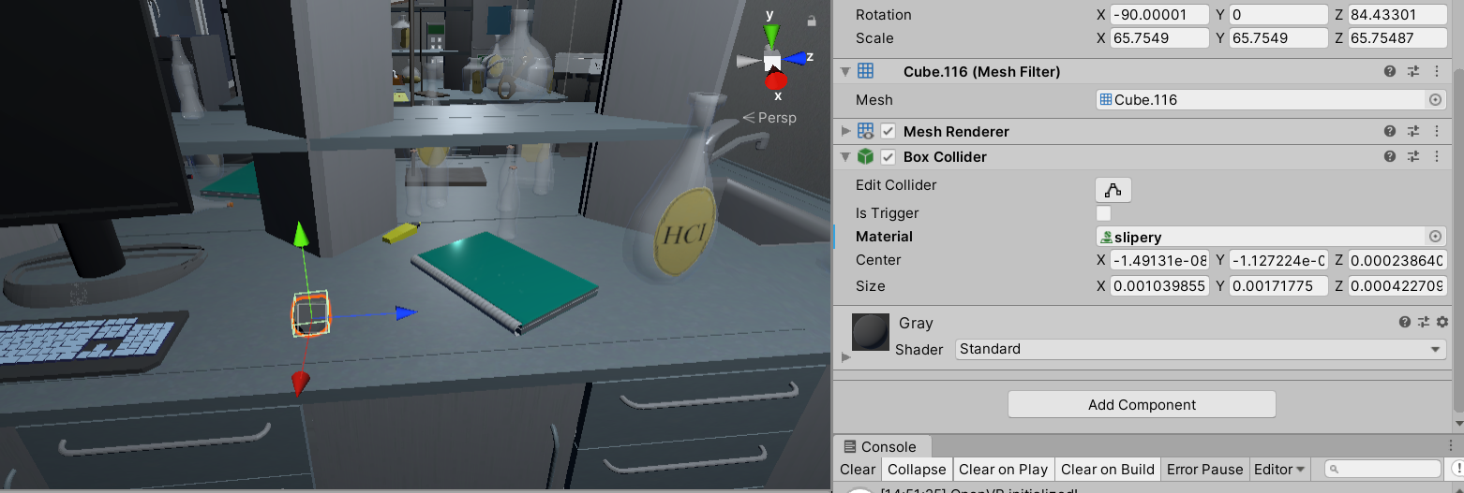

Figure 34 Slipery mouse

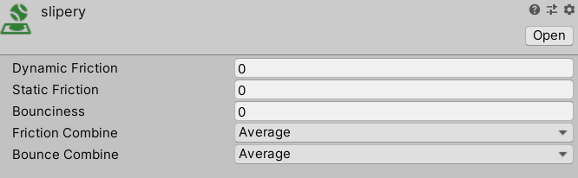

Figure 35 Slipery material

**Task #13. Create 4 types of objects that use OnCollisionEnter / OnCollisionEnter2D / OnTriggerEnter / OnTriggerEnter2D.**

This game fully utilizes on collision and on trigger enter systems. With these systems is used almost in all scritpts.

* Flask liquid absorber

This script absorbs liquid and changes main liquid color

|  |
| --- |
| using System.Collections;  using System.Collections.Generic;  using UnityEngine;  using System.Linq;  public class LiquidAbsorption : MonoBehaviour {  //public int collisionCount = 0;  [SerializeField] List<string> tagsIgnore = new string[] { "Fire", "DrySmoke" }.ToList<string>();  public Color currentColor;  public BottleSmash smashScript;  public LiquidLevel level;  [SerializeField] ParticleColor particleColor;  public float particleValue = 0.02f;  //public LiquidVolumeAnimator LVA;  // Use this for initialization  void Start () {  //if(LVA == null)  //LVA = GetComponent<LiquidVolumeAnimator>();  }  void OnParticleCollision(GameObject other)  {  //check if it is the same factory.  if (!tagsIgnore.Contains(other.tag))  {  if (other.transform.parent == transform.parent)  return;  bool available = false;  if (smashScript.Cork == null)  {  available = true;  }  else  {  //if the cork is not on!  if (!smashScript.Cork.activeSelf)  {  available = true;  }  //or it is disabled (through kinamism)? is that even a word?  else if (!smashScript.Cork.GetComponent<Rigidbody>().isKinematic)  {  available = true;  }  }  if (available)  {  currentColor = smashScript.color;  if (level.level < 1.0f - particleValue)  {  //essentially, take the ratio of the bottle that has liquid (0 to 1), then see how much the level will change, then interpolate the color based on the dif.  Color impactColor;  if (other.GetComponentInParent<BottleSmash>() != null)  {  impactColor = other.GetComponentInParent<BottleSmash>().color;  }  else  {  impactColor = other.GetComponent<ParticleSystem>().GetComponent<Renderer>().material.GetColor("_TintColor");  }  if (level.level <= float.Epsilon * 10)  {  currentColor = impactColor;  }  else  {  currentColor = Color.Lerp(currentColor, impactColor, particleValue / level.level);  }  //collisionCount += 1;  level.level += particleValue;  smashScript.color = currentColor;  }  }  }  }  // Update is called once per frame  void Update ()  {  smashScript.ChangedColor();  currentColor = smashScript.color;  particleColor.Unify();  }  } |

Table 7 Liquid absorber code

* Note trigger

Entering on note trigger shows note number on board

|  |
| --- |
| using System.Collections;  using System.Collections.Generic;  using UnityEngine;  using TMPro;  using VRTK;  public class NoteBoard : MonoBehaviour  {  [SerializeField] GameObject printKey;  bool isGrabbed = false;  TextMeshPro print;  TextMeshPro key;  int count = 0;  [SerializeField] DelegateChange Task;  // Start is called before the first frame update  void Start()  {  print = printKey.GetComponent<TextMeshPro>();  key = GetComponentInChildren<TextMeshPro>();  }  // Update is called once per frame  void FixedUpdate()  {    if (isGrabbed)  {  print.text = key.text;  Task.AddTask();  }  }  private void OnTriggerEnter(Collider other)  {  isGrabbed = true;  }  private void OnTriggerEnter(Collider other)  {  isGrabbed = false;  }  } |

Table 8 On trigger enter note

* Start timer when player enter on trigger

|  |
| --- |
| using System.Collections;  using System.Collections.Generic;  using UnityEngine;  public class StartTime : MonoBehaviour  {  TimeLeft time;  int count = 0;  void Start()  {  time = GetComponentInParent<TimeLeft>();  }  private void OnTriggerEnter(Collider other)  {  if (other.name == "Head" && count <= 2)  {  time.TimerStart();  count++;  }  //else if (other.name == "[VRTK][AUTOGEN][Controller][NearTouch][CollidersContainer]" && count >= 3)  //{    //}  }  } |

Table 9 OnTrigger enter timer

* Doors trigger

When player enters on trigger door closes.

|  |
| --- |
| using System.Collections;  using System.Collections.Generic;  using UnityEngine;  using VRTK;  using VRTK.Prefabs.Interactions.Controllables;  using VRTK.Prefabs.Interactions.Controllables.ComponentTags;  public class CloseDoors : MonoBehaviour  {  [SerializeField] GameObject doorController;  [SerializeField] float doorSpeed = 0.05f;  [SerializeField] GroundControll controll;  public Rigidbody rb;  public bool isClosing = false;  bool isGrabbed = false;  //public RotationalJointDrive rotator;  public GameObject rotator;  int count = 0;  // Start is called before the first frame update  void Start()  {  //rotator = doorController.GetComponent<RotationalDriveFacade>();  //rb = doorController.GetComponent<Rigidbody>();  }  private void Update()  {  //Debug.Log(doorController.transform.localRotation.eulerAngles.y);  if (doorController.transform.localRotation.eulerAngles.y < 0.002 && doorController.transform.localRotation.eulerAngles.y > 0 && isClosing)  {  rb.constraints = RigidbodyConstraints.FreezeRotationY;  Destroy(this);  count++;  }  else if ((doorController.transform.localRotation.eulerAngles.y > 350 || doorController.transform.localRotation.eulerAngles.y < 0.002) && isClosing)  {  rb.constraints = RigidbodyConstraints.FreezeRotationY;  Destroy(this);  count++;  }  }  public void Grabb()  {  isGrabbed = true;  }  public void UnGrabb()  {  isGrabbed = false;  }  private void OnTriggerEnter(Collider other)  {  if (other.name == "Head" && count < 1 && doorController.transform.rotation.eulerAngles.y > 1)  {  isClosing = true;  ForceToClose();  Lock();  count++;  }  }  void ForceToClose()  {  rb.AddForce(transform.right * doorSpeed);  }  void Lock()  {  //controll.coridorOff();  rotator.SetActive(false);  }  } |

Table 10 Doors on trigger enter

**Task #14. Assign optimal colliders for the environment objects that are not moving and set their flags to static (test performance before and after).**

The optimal colliders for static objects and background elements were assigned at the beginning of the scene development. To optimize the performance even further, we have added Occlusion culling so that the objects, which are hidden or just simply cannot be seen are not being rendered.

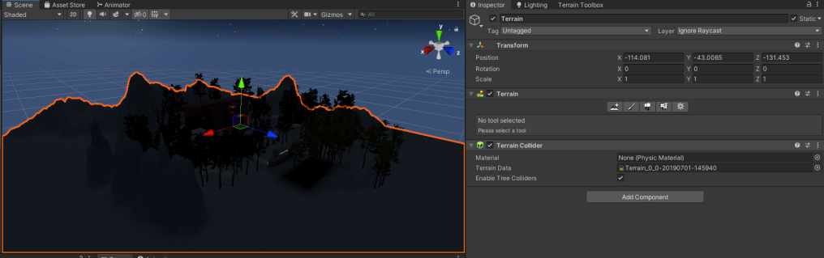

Figure 36 Objects set to static

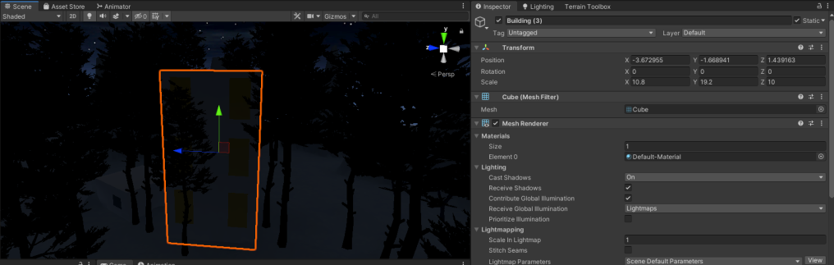

Figure 37 Objcets set to static

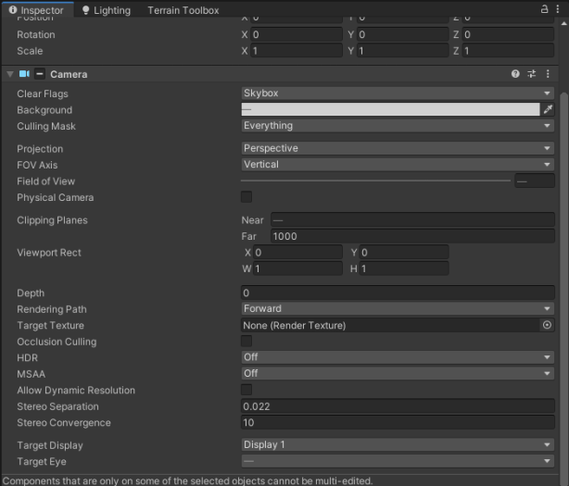

Figure 38 Camera settings

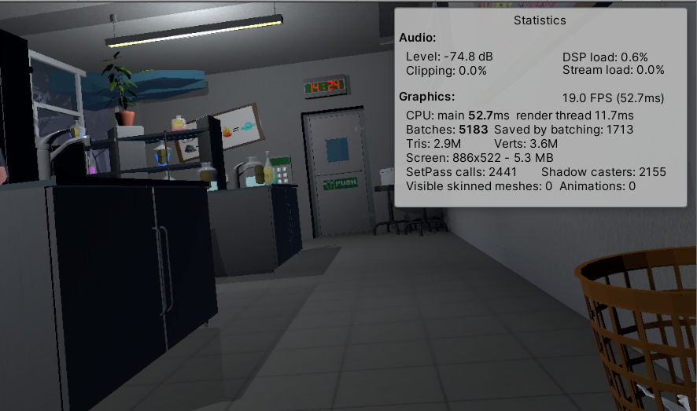

Figure 39 In game statistics

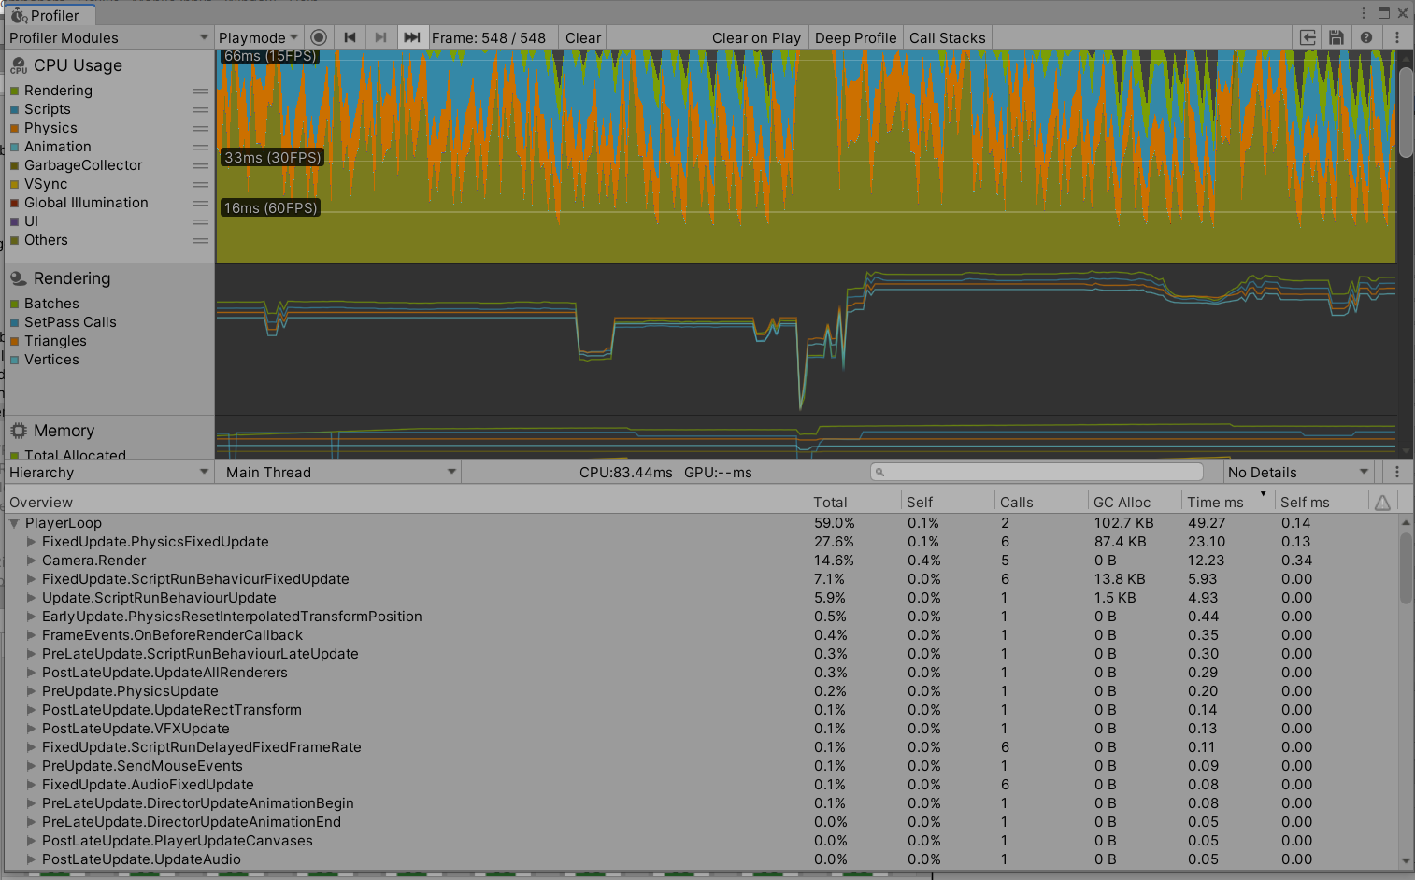

Figure 40 profiler results

**Task #15. Bake a lightmap and measure performance.**

The baked lightmap is almost fully black, because it was baked with most of the lights turned off in scene. Most of these lights have various effects, such as turning them off and on. That is why baking the lightmap this way was the optimal variant.

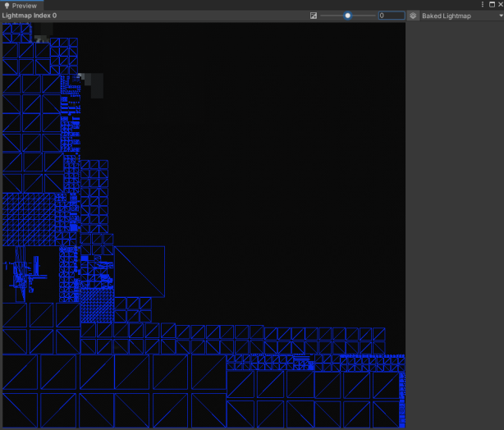

Figure 41 Baked light map



Figure 42 profiler results with baked light map

**Task #16. Optimize all textures depending on their parameters and measure graphical memory load.**

Using textures is optimized, texture resolution is decresed. For texture depth we using normal map. Gpu instancing is enabled.

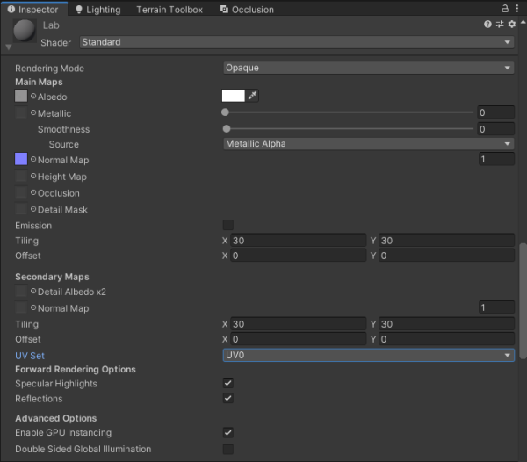

Figure 43 Material exampl

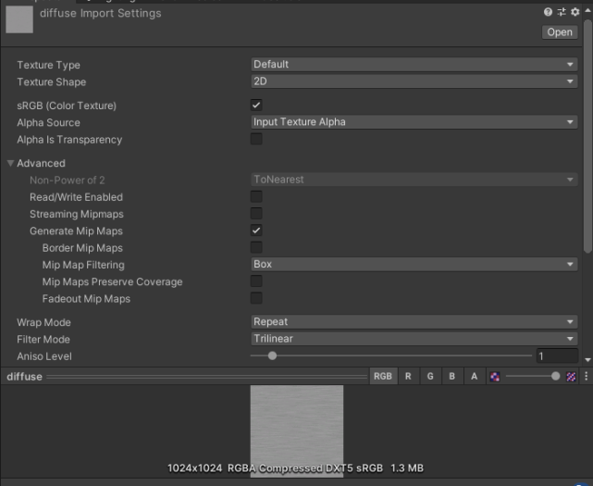

Figure 44 Material example



Figure 45 Material example

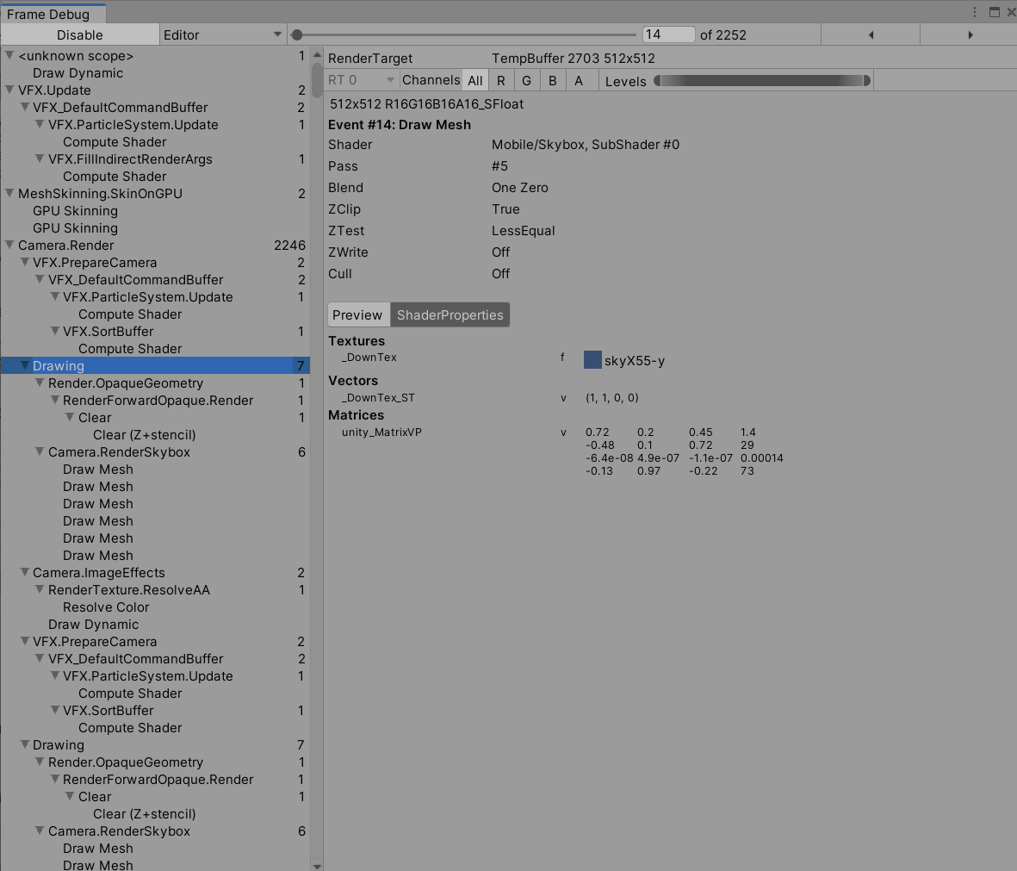

Figure 46 Frame debugger

**Task #17. Try hard vs soft shadows, different quality settings and measure the performance.**

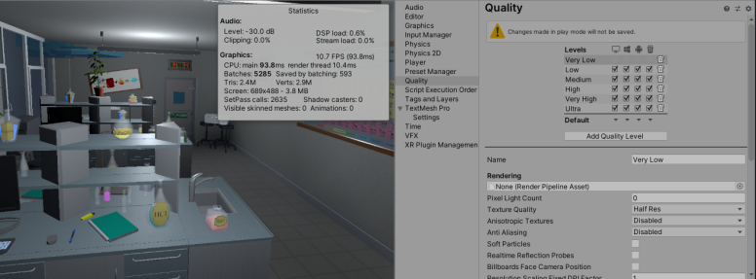

Figure 47 Low quality

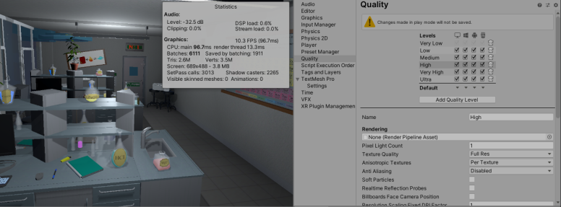

Figure 48 High Quality

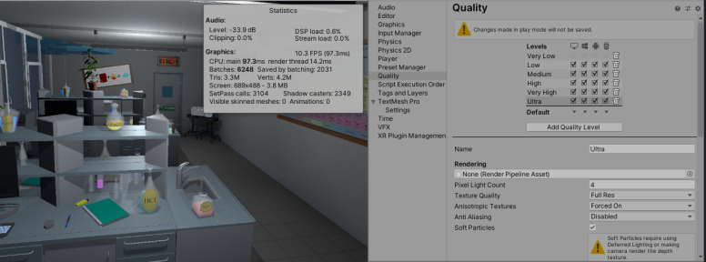

Figure 49 Ultra Quality

**Task #18. Bake on cube each side different light.**

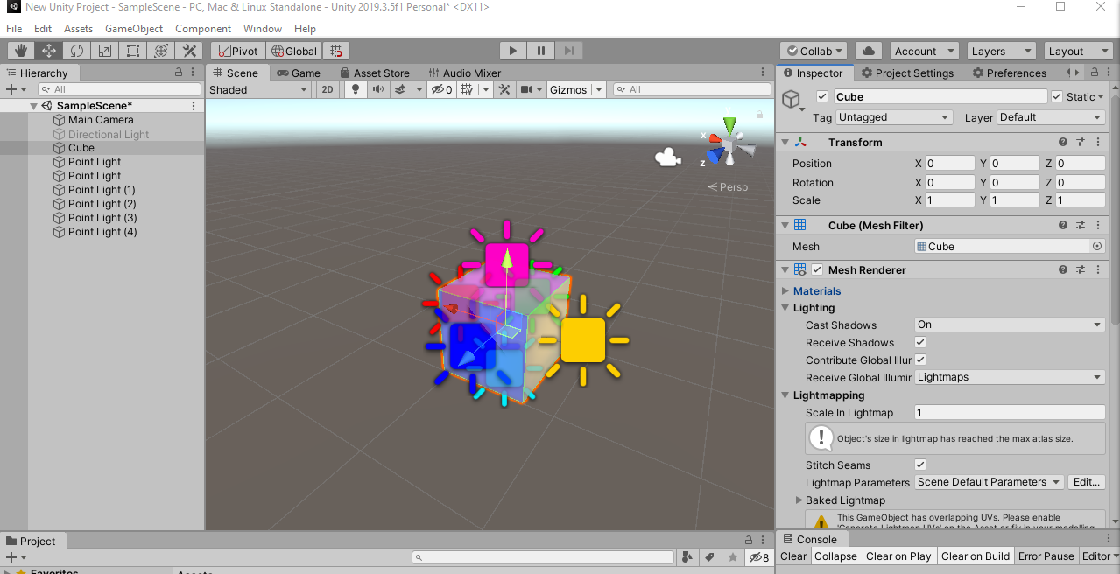

Figure 50 Cube for baking

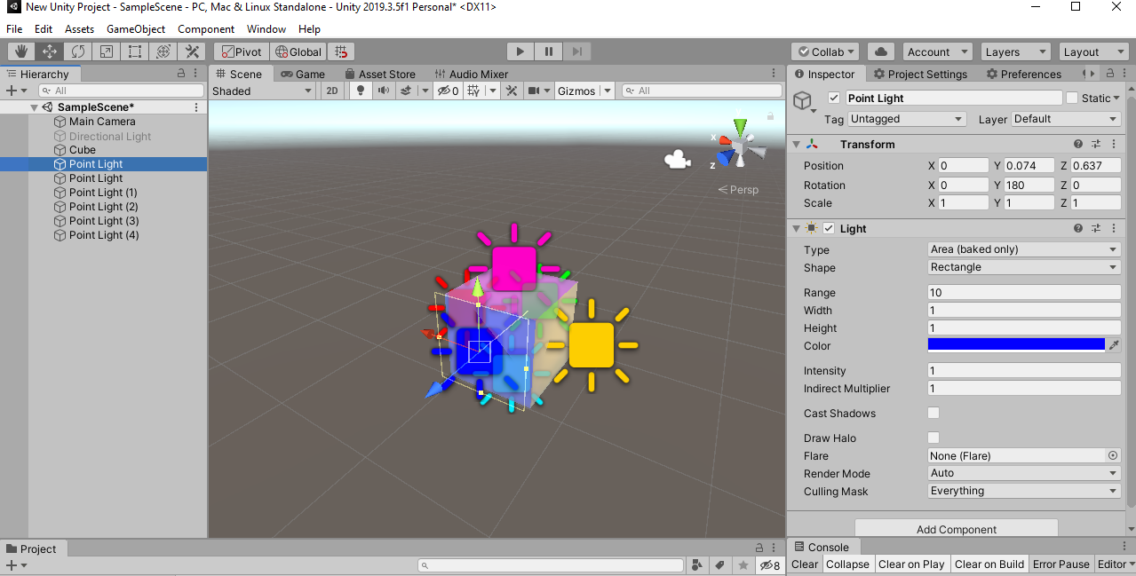

Figure 51 baking Light

Other lights are similar, color of lights just changes.

**Laboratory work #3**

**List of tasks**

1. Add a MENU system to your game (New Game, Choose Level [If Applies], Options, About, Exit)
2. Add OPTIONS (2 separate sound bars for music and effects)
3. Game must have a GUI (elements should vary based on your game: health bars, scores, money, resources, button to go back to main menu, etc.)
4. Add attack mechanics (might be replaced with puzzle mechanics, push off the road mechanics (racing game), etc.)
5. Implement Opponents (enemy moves towards you and tries to kill you, might be replaced with random puzzles, race opponents, etc.)
6. Add health / powerup mechanics and indication in the GUI
7. Add scoring system (e.g., Easiest enemy – 100, most difficult – 500, powerup – 1000, total game time calculated, etc.)
8. Add "Game over" condition (once the game ends you should display a high score and reload/main menu buttons.
9. Add "Post Processing" (Blurring, blood screen, etc.)
10. Add Interactive sounds (Sound of step, shoot, die, scream, etc. - minimum 10 different) and music (1 for menu + minimum 3 for in-game)

# **Solution**

## **Task #1. Add a MENU system to your game (New Game, Choose Level [If Applies], Options, About, Exit**

Both Main Menu and Pause Menu systems are implemented into the game. When the player launches the game, he starts at Main Menu scene and has the possibilities to Start the main level, join a tutorial room, check out his settings and game controls, or just leave the game.

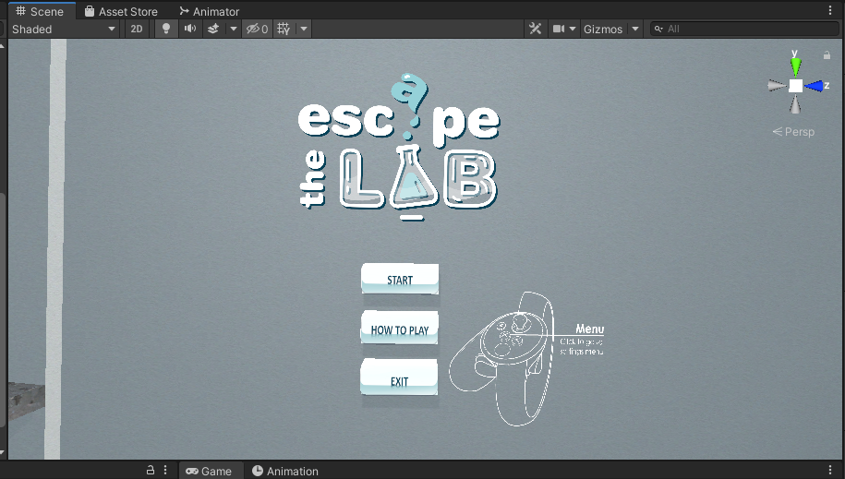

Figure 52 Main menu scene

If player enters Pause Menu during the playthrough, he can go to the same Menu pages that were mentioned in the Main Menu, Restart the level or go back to Main Menu.

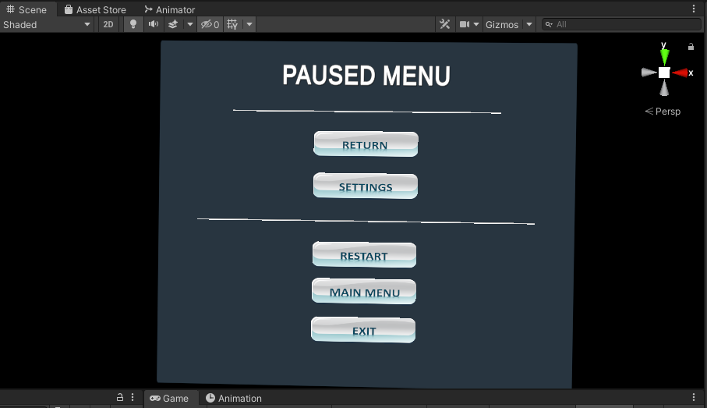

Figure 53 Paused menu

|  |
| --- |
| public class InteractableCollisionUI : MonoBehaviour  {  [SerializeField] float sliderOffset = 0.5f;  [SerializeField] float thicknes = 0.01f;  [SerializeField] bool buttonPressWithTrigger = false;  [SerializeField] GameObject triggerGo;  BoxCollider colliderForPosition;  List<UiButtonClick> buttons;  List<UiSliderControll> sliders;  List<UiDropdownControll> dropdowns;  RectTransform uiTransform;  static float SliderOffset = 0;  void Start()  {  if (triggerGo != null)  {  if (buttonPressWithTrigger)  {  triggerGo.SetActive(true);  }  else  {  triggerGo.SetActive(false);  }  }  buttons = new List<UiButtonClick>();  sliders = new List<UiSliderControll>();  dropdowns = new List<UiDropdownControll>();  gameObject.AddComponent<Rigidbody>();  gameObject.AddComponent<BoxCollider>();  uiTransform = GetComponent<RectTransform>();  colliderForPosition = gameObject.GetComponent<BoxCollider>();  colliderForPosition.size = new Vector3(uiTransform.sizeDelta.x, uiTransform.sizeDelta.y, thicknes);  colliderForPosition.isTrigger = true;  Rigidbody rb = GetComponent<Rigidbody>();  rb.isKinematic = true;  RecursiveChilds(gameObject.transform);  SliderOffset = sliderOffset;  }  void RecursiveChilds(Transform transformGo)  {  for (int i = 0; i < transformGo.childCount; i++)  {  if (transformGo.GetChild(i).GetComponent<Button>() != null)  {  transformGo.GetChild(i).gameObject.AddComponent<BoxCollider>();  UiButtonClick btn = transformGo.GetChild(i).gameObject.AddComponent<UiButtonClick>();  buttons.Add(btn);  btn.SetUiController(this);  btn.UseButtonWithTrigger(buttonPressWithTrigger);  RectTransform uiTransformTemp = transformGo.GetChild(i).gameObject.GetComponent<RectTransform>();  BoxCollider colliderForPositionTemp = transformGo.GetChild(i).gameObject.GetComponent<BoxCollider>();  float tempThicknes = thicknes + 0.02f;  colliderForPositionTemp.size = new Vector3(uiTransformTemp.sizeDelta.x, uiTransformTemp.sizeDelta.y, tempThicknes);  colliderForPositionTemp.center = new Vector3(0, 0, 0);  }  if (transformGo.GetChild(i).GetComponent<Slider>() != null)  {  transformGo.GetChild(i).gameObject.AddComponent<BoxCollider>();  UiSliderControll slider = transformGo.GetChild(i).gameObject.AddComponent<UiSliderControll>();  sliders.Add(slider);  slider.SetUiController(this);  slider.UseButtonWithTrigger(buttonPressWithTrigger);  RectTransform uiTransformTemp = transformGo.GetChild(i).gameObject.GetComponent<RectTransform>();  BoxCollider colliderForPositionTemp = transformGo.GetChild(i).gameObject.GetComponent<BoxCollider>();  float tempThicknes = thicknes + 0.02f;  colliderForPositionTemp.size = new Vector3(uiTransformTemp.sizeDelta.x, uiTransformTemp.sizeDelta.y, tempThicknes);  colliderForPositionTemp.center = new Vector3(0, 0, 0);  }  if (transformGo.GetChild(i).GetComponent<TMP_Dropdown>() != null || transformGo.GetChild(i).GetComponent<Dropdown>() != null)  {  transformGo.GetChild(i).gameObject.AddComponent<BoxCollider>();  UiDropdownControll dropdown = transformGo.GetChild(i).gameObject.AddComponent<UiDropdownControll>();  dropdowns.Add(dropdown);  dropdown.SetUiController(this);  dropdown.UseButtonWithTrigger(buttonPressWithTrigger);  RectTransform uiTransformTemp = transformGo.GetChild(i).gameObject.GetComponent<RectTransform>();  BoxCollider colliderForPositionTemp = transformGo.GetChild(i).gameObject.GetComponent<BoxCollider>();  float tempThicknes = thicknes + 0.02f;  colliderForPositionTemp.size = new Vector3(uiTransformTemp.sizeDelta.x, uiTransformTemp.sizeDelta.y, tempThicknes);  colliderForPositionTemp.center = new Vector3(0, 0, 0);  }  if (transformGo.GetChild(i).GetComponent<Scrollbar>() != null)  {  BoxCollider bx = transformGo.GetChild(i).gameObject.AddComponent<BoxCollider>();  ScrollRect sr = transformGo.GetChild(i).parent.GetComponent<ScrollRect>();  bx.center = new Vector3(-(bx.gameObject.GetComponent<RectTransform>().sizeDelta.x / 2), -(sr.GetComponent<RectTransform>().sizeDelta.y / 2), 0);  bx.size = new Vector3(bx.gameObject.GetComponent<RectTransform>().sizeDelta.x, sr.GetComponent<RectTransform>().sizeDelta.y, 0.1f);  transformGo.GetChild(i).gameObject.AddComponent<VerticalScroll>();  VerticalScroll temp = sr.gameObject.transform.GetChild(sr.gameObject.transform.childCount - 1).gameObject.GetComponent<VerticalScroll>();  temp.UseButtonWithTrigger(buttonPressWithTrigger);  }  RecursiveChilds(transformGo.GetChild(i).transform);  }  }  public static float SliderOffsetReturn()  {  return SliderOffset;  }  public bool buttonWithTrigger()  {  return buttonPressWithTrigger;  }  } |

Table 11 InteractableCollisionUI.cs script component

|  |
| --- |
| public class UiButtonControll : MonoBehaviour  {  [SerializeField] GameObject loadingScreen;  [SerializeField] AudioMixer volumeControll;  ButtonClick menu;  private void OnEnable()  {  menu = gameObject.transform.parent.parent.GetComponent<ButtonClick>();  }  public void LoadLevel(int index)  {  StartCoroutine(LoadAsynchronously(index));  }  public void RestartLevel()  {  StartCoroutine(LoadAsynchronously(SceneManager.GetActiveScene().buildIndex));  }  IEnumerator LoadAsynchronously(int sceneIndex)  {  loadingScreen.SetActive(true);  AsyncOperation operation = SceneManager.LoadSceneAsync(sceneIndex);  while (!operation.isDone)  {  float progress = Mathf.Clamp01(operation.progress / .9f);  Debug.Log(progress);  yield return null;  }  }  public void LoadExit()  {  Debug.Log("EXIT");  Application.Quit();  }  public void BackToPlay()  {  menu.ButtonPress();  }  public void MasterVolumeSlider(float masterVolume)  {  volumeControll.SetFloat("MasterVolume", masterVolume);  }  public void FXVolumeSlider(float fxVolume)  {  volumeControll.SetFloat("SoundFxVolume", fxVolume);  }  public void MusicVolumeSlider(float musicVolume)  {  volumeControll.SetFloat("MusicVolume", musicVolume);  }  } |

Table 12 UiButtonControll.cs script component

## **Task #2. Add OPTIONS (2 separate sound bars for music and effects)**

In the Settings window player can view his game Controls, adjust Audio or Graphics settings.

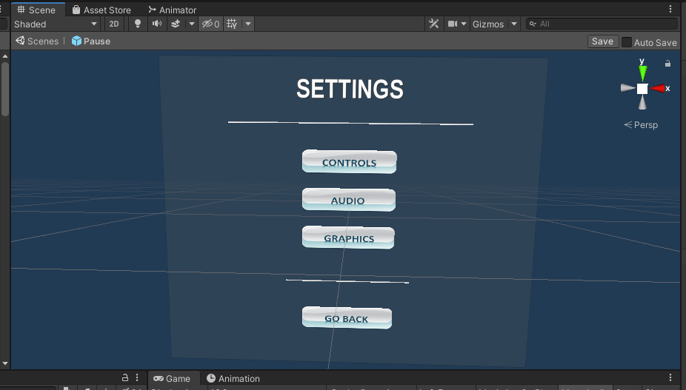

Figure 54 Settings menu

The audio settings screen includes Master, Music or Sound effects volume adjustments.

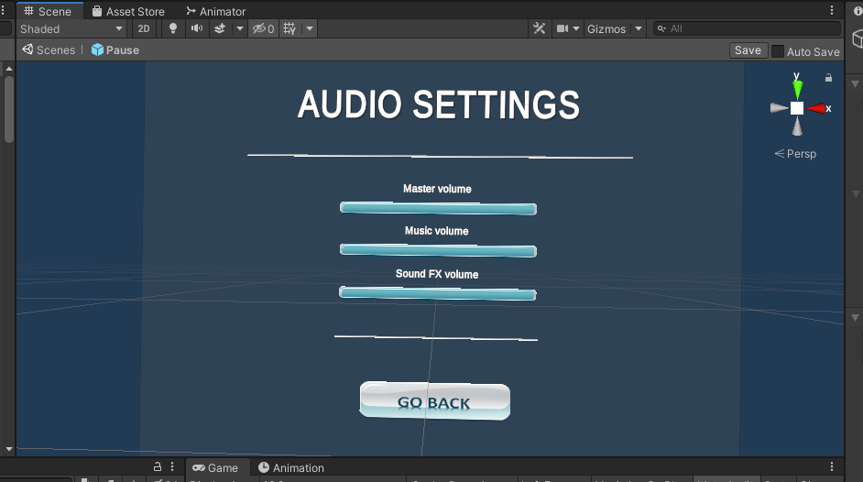

Figure 55 Audio settings menu

Controls window consists of game movement controls that are based on the virtual reality device that the player is using.

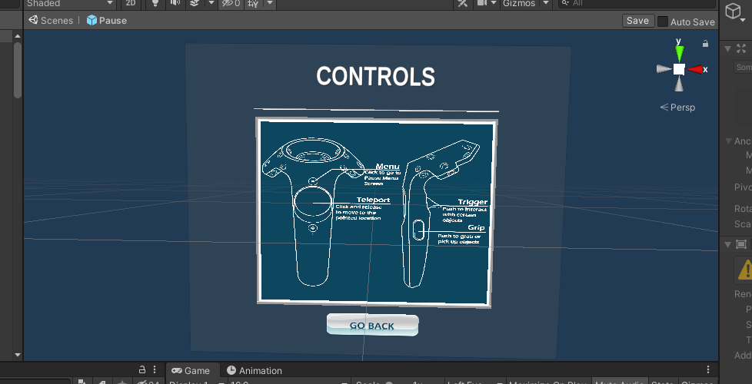

Figure 56 Controls menu

Graphics settings includes different types of adjustments – screen resolution, window mode, Overall quality level.

There is also a possibility to customize the graphics even more with additional settings, such as shadow resolution, shadow cascades, shadow quality, shadow distance, anti-aliasing, enabling or disabling soft particles, or resetting all of the graphics settings back to their defaults.

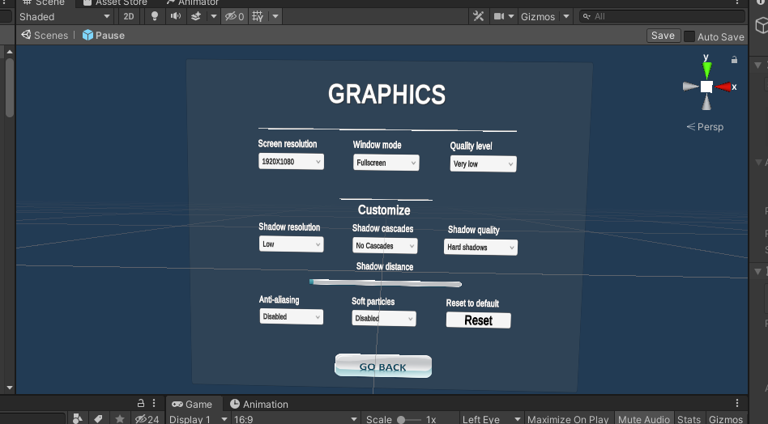

Figure 57 Graphics settings menu

|  |
| --- |
| public class StartResolutionUi : MonoBehaviour  {  TMP_Dropdown dropdown;  int indexResolution = 0;  bool found = false;  List<Resolution> res;  public static bool fullScreen = false;  public bool firstTime = true;  void OnEnable()  {  indexResolution = 0;  if (firstTime)  {  found = false;  if (PlayerPrefs.HasKey("WindowMode"))  {  if (PlayerPrefs.GetInt("WindowMode") == 0)  {  fullScreen = true;  }  else  {  fullScreen = false;  }  }  else  {  fullScreen = Screen.fullScreen;  }  Resolution[] resolutions = Screen.resolutions;  dropdown = GetComponent<TMP_Dropdown>();  dropdown.ClearOptions();  List<string> options = new List<string>();  res = new List<Resolution>();  foreach (Resolution item in resolutions)  {  res.Add(item);  options.Add(item.width + "X" + item.height);  if (!PlayerPrefs.HasKey("ResolutionSave"))  {  if (item.width != Screen.width && item.height != Screen.height && !found)  {  indexResolution++;  }  else if (item.width == Screen.width && item.height == Screen.height && !found)  {  found = true;  }  }  else  {  if (item.width + "X" + item.height != PlayerPrefs.GetString("ResolutionSave") && !found)  {  indexResolution++;  }  else if (item.width + "X" + item.height == PlayerPrefs.GetString("ResolutionSave") && !found)  {  found = true;  }  }  }  dropdown.AddOptions(options);  firstTime = false;  }  else  {  found = false;  for (int i = 0; i < res.Count; i++)  {  if (!PlayerPrefs.HasKey("ResolutionSave"))  {  if (res[i].width == Screen.width && res[i].height == Screen.height && !found)  {  found = true;  indexResolution = i;  }  }  else  {  if (res[i].width + "X" + res[i].height == PlayerPrefs.GetString("ResolutionSave") && !found)  {  found = true;  indexResolution = i;  }  }  }  }  dropdown.value = indexResolution;  ChangeResolution(indexResolution);  }  public void ChangeResolution(int index)  {  Screen.SetResolution(res[index].width, res[index].height, fullScreen);  PlayerPrefs.SetString("ResolutionSave", res[index].width + "X" + res[index].height);  //UpdateSettings.Save = true;  }  } |

Table 13 StartResolutionUi.cs script component

|  |
| --- |
| public class WindowUI : MonoBehaviour  {  TMP_Dropdown dropdown;  private void OnEnable()  {  if (dropdown == null)  {  dropdown = GetComponent<TMP_Dropdown>();  }  if (Screen.fullScreen)  {  dropdown.value = 0;  }  else  {  dropdown.value = 1;  }  }  public void SetFullscreen(int isFullscreen)  {  if (isFullscreen == 0)  {  Screen.fullScreen = true;  StartResolutionUi.fullScreen = true;  }  else if (isFullscreen == 1)  {  Screen.fullScreen = false;  StartResolutionUi.fullScreen = false;  }  UpdateSettings.Save = true;  }  } |

Table 14 WindowUI.cs script component

|  |
| --- |
| public class StartQualityUi : MonoBehaviour  {  TMP_Dropdown dropdown;  // Start is called before the first frame update  private void OnEnable()  {  if (dropdown != null)  {  dropdown.value = QualitySettings.GetQualityLevel();  }  }  void Start()  {  dropdown = GetComponent<TMP_Dropdown>();  dropdown.ClearOptions();  List<string> options = new List<string>();  for (int i = 0; i < QualitySettings.names.Length; i++)  {  options.Add(QualitySettings.names[i]);  }  dropdown.AddOptions(options);  dropdown.value = QualitySettings.GetQualityLevel();    }  public void ChangeQuality(int index)  {  QualitySettings.SetQualityLevel(index, true);  transform.parent.gameObject.SetActive(false);  transform.parent.gameObject.SetActive(true);  UpdateSettings.Save = true;  }  } |

Table 15 StartQualityUi.cs script component

|  |
| --- |
| public class ShadowQualityResUi : MonoBehaviour  {  TMP_Dropdown dropdown;  // Start is called before the first frame update  private void OnEnable()  {  if (dropdown == null)  {  dropdown = GetComponent<TMP_Dropdown>();  }  if (QualitySettings.shadowResolution == ShadowResolution.Low)  {  dropdown.value = 0;  }  else if (QualitySettings.shadowResolution == ShadowResolution.Medium)  {  dropdown.value = 1;  }  else if (QualitySettings.shadowResolution == ShadowResolution.High)  {  dropdown.value = 2;  }  else if (QualitySettings.shadowResolution == ShadowResolution.VeryHigh)  {  dropdown.value = 3;  }  }  public void ChangeShadowRes(int index)  {  if (index == 0)  {  QualitySettings.shadowResolution = ShadowResolution.Low;  }  else if (index == 1)  {  QualitySettings.shadowResolution = ShadowResolution.Medium;  }  else if (index == 2)  {  QualitySettings.shadowResolution = ShadowResolution.High;  }  else if (index == 3)  {  QualitySettings.shadowResolution = ShadowResolution.VeryHigh;  }  UpdateSettings.Save = true;  }  } |

Table 16 ShadowQualityResUi.cs script component

|  |
| --- |
| public class ShadowCascadesUi : MonoBehaviour  {  TMP_Dropdown dropdown;  private void OnEnable()  {  if (dropdown == null)  {  dropdown = GetComponent<TMP_Dropdown>();  }  if (QualitySettings.shadowCascades == 0)  {  dropdown.value = 0;  }  else if (QualitySettings.shadowCascades == 2)  {  dropdown.value = 1;  }  else if (QualitySettings.shadowCascades == 4)  {  dropdown.value = 2;  }  }  public void SetShadowCascades(int index)  {  if (index == 0)  {  QualitySettings.shadowCascades = 0;  }  else if (index == 1)  {  QualitySettings.shadowCascades = 2;  }  else if (index == 2)  {  QualitySettings.shadowCascades = 4;  }  UpdateSettings.Save = true;  }  } |

Table 17 ShadowCascadesUi.cs script component

|  |
| --- |
| public class ShadowDistanceUi : MonoBehaviour  {  Slider slider;  private void OnEnable()  {  if (slider == null)  {  slider = GetComponent<Slider>();  }  slider.value = QualitySettings.shadowDistance;  }  public void SetShadowDistance(float index)  {  QualitySettings.shadowDistance = slider.value;  UpdateSettings.Save = true;  }  } |

Table 18 ShadowDistanceUi.cs script component

|  |
| --- |
| public class AntiAliasing : MonoBehaviour  {  TMP_Dropdown dropdown;  void Start()  {  dropdown = GetComponent<TMP_Dropdown>();  }  private void OnEnable()  {  if (dropdown != null)  {  switch (QualitySettings.antiAliasing)  {  case 0:  dropdown.value = 0;  break;  case 2:  dropdown.value = 1;  break;  case 4:  dropdown.value = 2;  break;  default:  dropdown.value = 3;  break;  }  }  }  public void SetAntiAliasing(int index)  {  switch (dropdown.value)  {  case 0:  index = 1;  break;  case 1:  index = 2;  break;  case 2:  index = 4;  break;  default:  index = 8;  break;  }  QualitySettings.antiAliasing = index;  UpdateSettings.Save = true;  }  } |

Table 19 AntiAliasing.cs script component

|  |
| --- |
| public class SoftParticlesUi : MonoBehaviour  {  TMP_Dropdown dropdown;  // Start is called before the first frame update  private void OnEnable()  {  if (dropdown == null)  dropdown = GetComponent<TMP_Dropdown>();  if (QualitySettings.softParticles == false)  {  dropdown.value = 0;  }  else  dropdown.value = 1;  }  public void SetSoftParticle(int index)  {  if (index == 0)  {  QualitySettings.softParticles = false;  }  else if (index == 1)  {  QualitySettings.softParticles = true;  }  UpdateSettings.Save = true;  }  } |

Table 20 SoftParticlesUi.cs script component

|  |
| --- |
| public class ShadowQualityUi : MonoBehaviour  {  TMP_Dropdown dropdown;  private void OnEnable()  {  if (dropdown == null)  {  dropdown = GetComponent<TMP_Dropdown>();  if (QualitySettings.shadows == ShadowQuality.HardOnly)  {  dropdown.value = 0;  }  else if (QualitySettings.shadows == ShadowQuality.All)  {  dropdown.value = 1;  }  }  else  {  if (QualitySettings.shadows == ShadowQuality.HardOnly)  {  dropdown.value = 0;  }  else if (QualitySettings.shadows == ShadowQuality.All)  {  dropdown.value = 1;  }  }  }  public void ChangeShadowQuality(int index)  {  if (index == 0)  {  QualitySettings.shadows = ShadowQuality.HardOnly;  }  else if (index == 1)  {  QualitySettings.shadows = ShadowQuality.All;  }  UpdateSettings.Save = true;  }  } |

Table 21 ShadowQualityUi.cs script component

## **Task #3. Game must have a GUI (elements should vary based on your game: health bars, scores, money, resources, button to go back to main menu, etc.)**

Pause menu has an option to go to main menu scene, leaderboard sums up all of the gathered points during the course of the game.

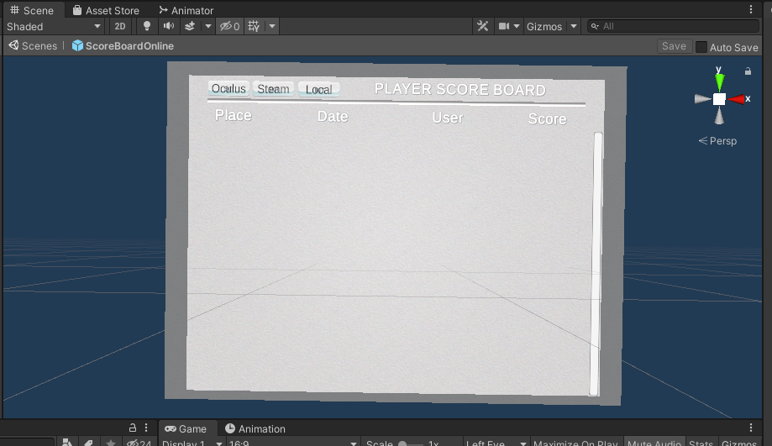

Figure 58 Leaderboard

## **Task #4. Add attack mechanics (might be replaced with puzzle mechanics, push off the road mechanics (racing game), etc.)**

Since this is more of a Sandbox Puzzle title, the game consists of different Puzzle mechanics, such as code locks, timers and so on.

One of these mechanics include searching for key that unlocks door which is hidden in flask. After breaking flask with key, key spawns in spot where flask was broken.

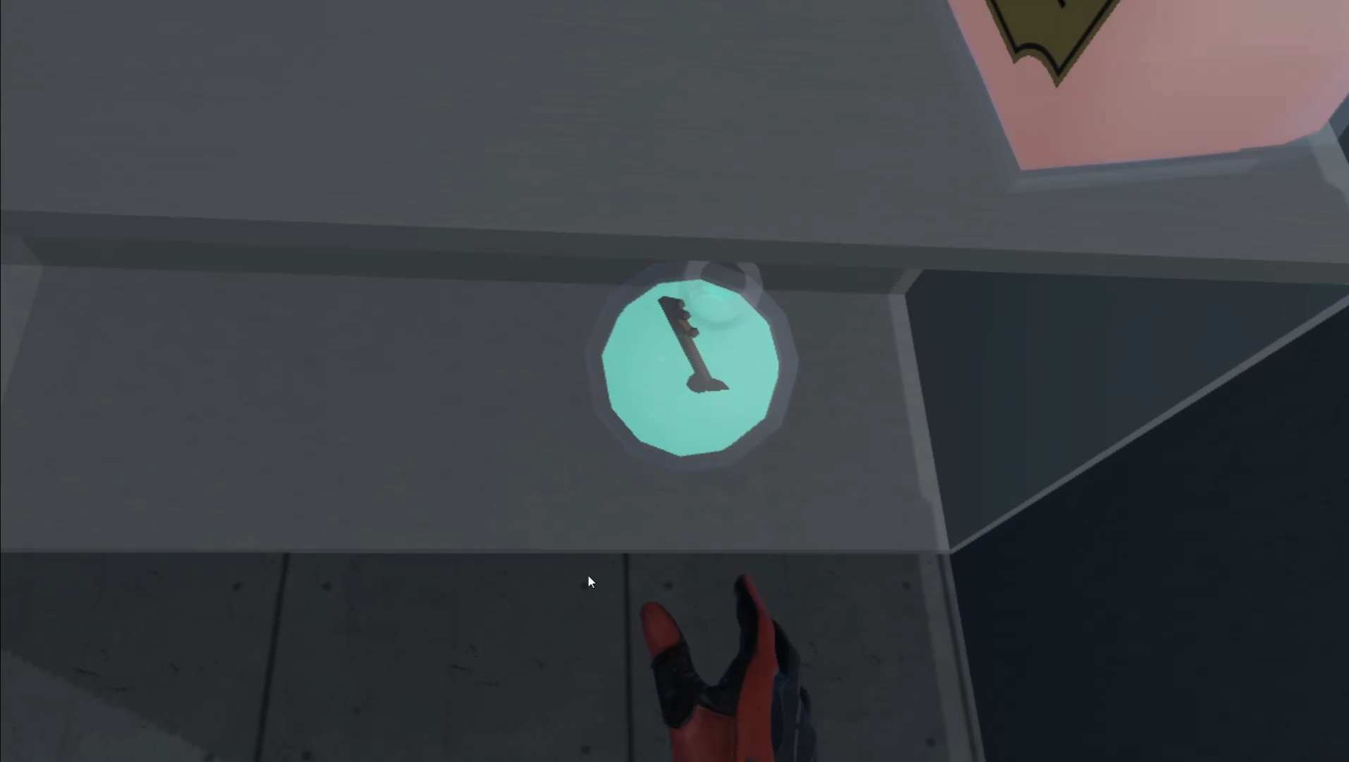

Figure 59 Flak with key

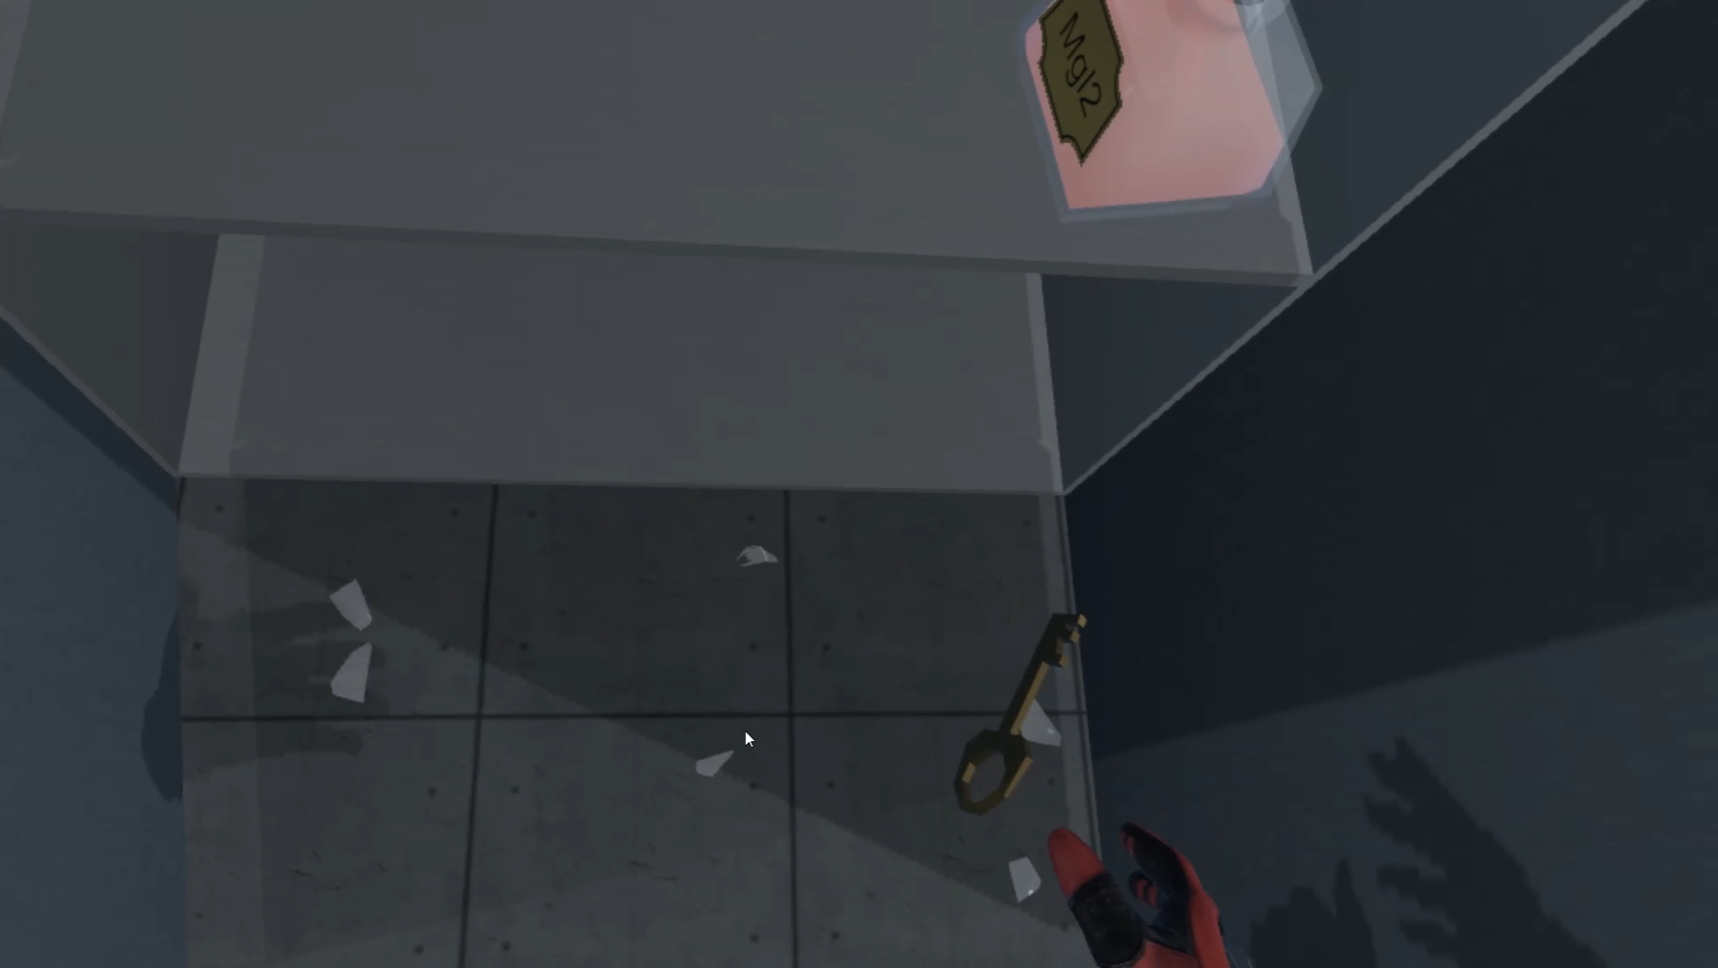

Figure 60 Spaw key

|  |
| --- |
| public class KeySpawn : MonoBehaviour  {  public GameObject key;  public GameObject Flask;  public SteamVrSceleton skeleton;  [SerializeField] DelegateChange Task;  int count;  private void Start()  {  count = 1;  skeleton = GetComponent<SteamVrSceleton>();  }  // Update is called once per frame  void Update()  {  if(Flask == null && count == 1)  {  InstantiateKey();  }  }  private void InstantiateKey()  {  GameObject reference = Instantiate(key, transform.position, transform.rotation);  //reference.GetComponent<SteamVrSceleton>().LeftHand = skeleton.LeftHand;  //reference.GetComponent<SteamVrSceleton>().RightHand = skeleton.RightHand;  Task.AddTask();  Debug.Log("Key spawned!");  count++;  } |

Table 22 Spawn key script

After finding key, the player has the possibility to unlock door by putting key to keyhole and realizing grabbing button.

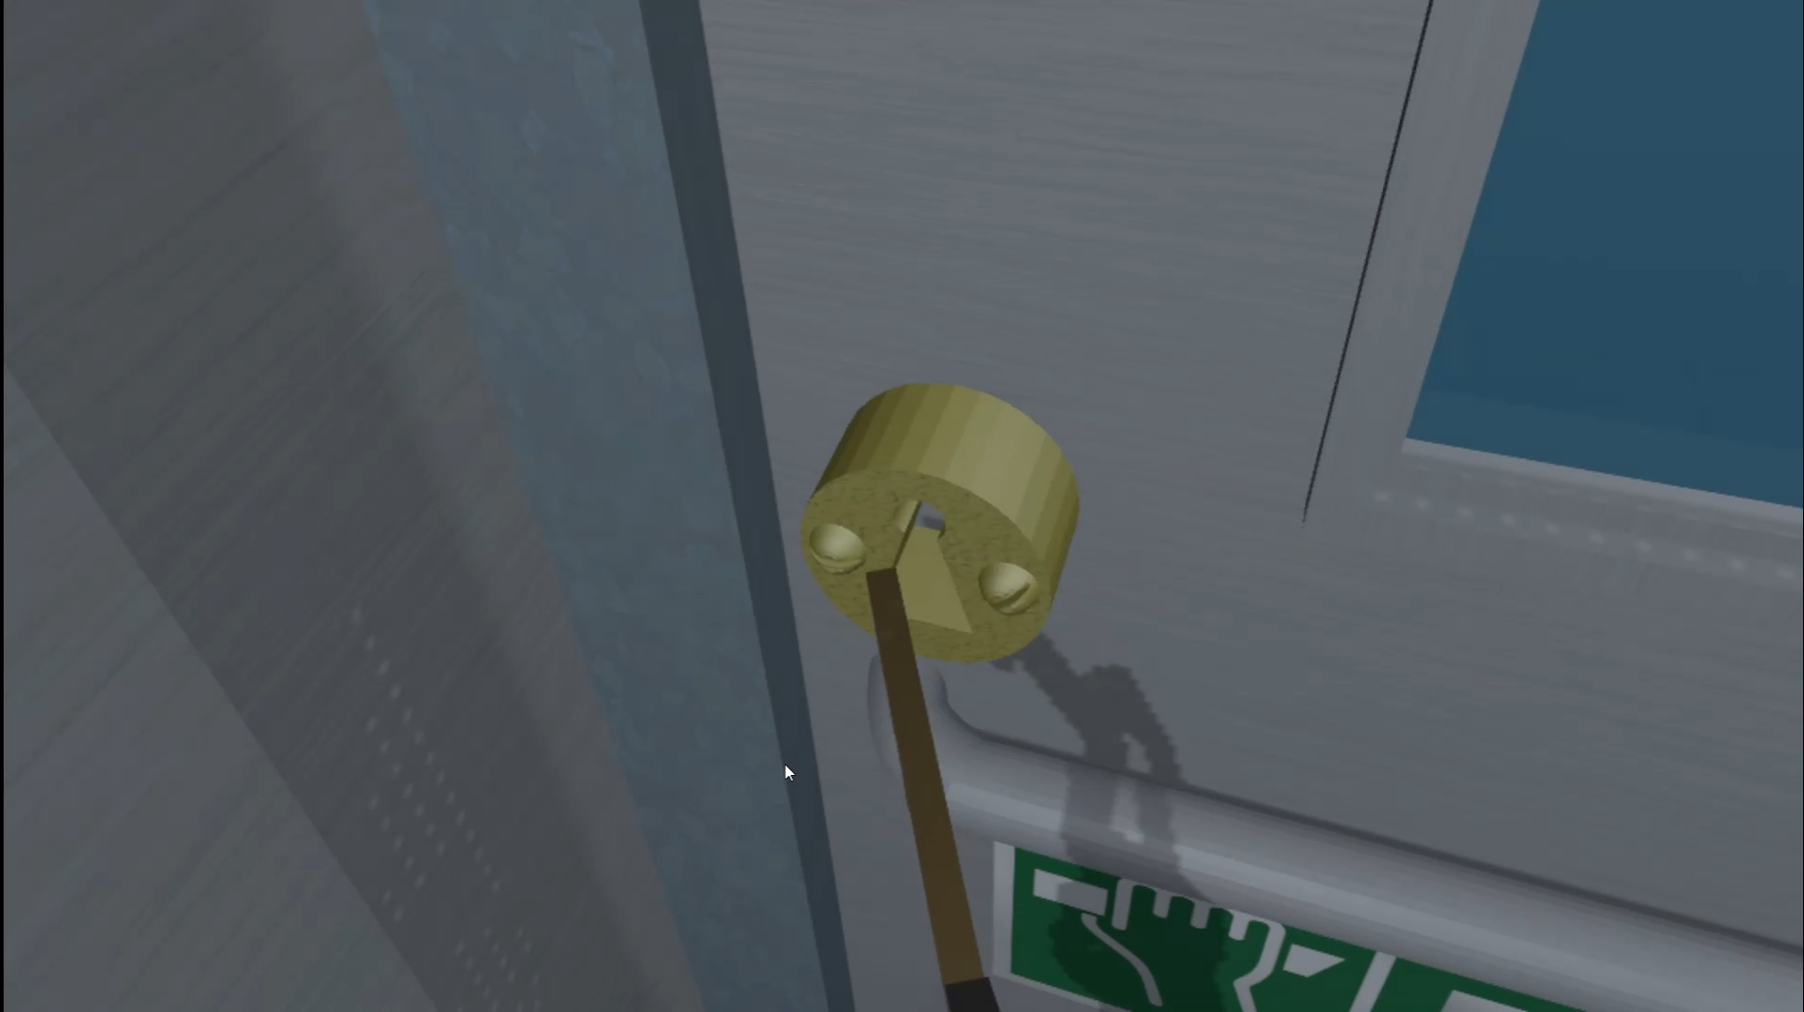

Figure 61 unlock door

|  |
| --- |
| public class LockUnlockWithKey : MonoBehaviour  {  [SerializeField] GameObject[] Note;  [SerializeField] GameObject doorsControll;  [SerializeField] Rigidbody rb;  [SerializeField] string checkKey;  [SerializeField] bool x = false;  [SerializeField] bool y = false;  [SerializeField] bool z = false;  bool isSnapped = false;  IdForUnlock[] unlock;  public bool Open = false;  bool oneTime = true;  bool check = false;  private int unlockId = 0;  bool rigidbodyExists = false;  int index = 0;  [SerializeField] DelegateChange Task;  // Start is called before the first frame update  void Start()  {  doorsControll.SetActive(false);  if (Note.Length > 0)  {  foreach (GameObject obj in Note)  {  if (obj != null)  {  obj.SetActive(false);  }  }  }  if (x)  {  rb.constraints = RigidbodyConstraints.FreezeRotationX;  }  if (y)  {  rb.constraints = RigidbodyConstraints.FreezeRotationY;  }  if (z)  {  rb.constraints = RigidbodyConstraints.FreezeRotationZ;  }  }  // Update is called once per frame  void Update()  {  if (!check && isSnapped)  {  unlock = FindObjectsOfType<IdForUnlock>();  if (index < unlock.Length)  {  if (unlock[index] != null && unlock[index].tag == checkKey)  {  int id = Random.Range(1, 20);  unlockId = id;  unlock[index].SetId(id);  check = true;  }  else if(unlock[index] != null && unlock[index].tag != checkKey)  {  index++;  }    }  else if(index >= unlock.Length)  {  index = 0;  }  }  else  {  if (Open == true && oneTime)  {  doorsControll.SetActive(true);  rb.constraints = RigidbodyConstraints.None;  foreach (GameObject obj in Note)  {  obj.SetActive(true);  }  oneTime = false;  rigidbodyExists = true;  Task.AddTask();  Destroy(this);  }  if (isSnapped && unlock[index].GetId() == unlockId)  {  Open = true;  }  }    }  public bool isChestOpen()  {  if (rigidbodyExists)  return Open;  else  return false;  }  public void Snap()  {  isSnapped = true;  }  public void UnSnap()  {  isSnapped = false;  }  } |

Table 23 LockUnlockWithKey.cs script component

## **Task #5. Implement Opponents (enemy moves towards you and tries to kill you, might be replaced with random puzzles, race opponents, etc.)**

One of the main puzzles in the game is called chameleon. The main goal of this experiment is to find a part of sugar, two liquids and mix these components into each other. After mixing everything up, the player must wait for reaction.

To find out what liquids are the correct ones, the player must look for a hint notebook. The notebook displays a combination of formulas – which are written on flask. The formula line represents which liquids are needed to mix and last line (sugar) represents that after mixing sugar must be added to mixed liquids.

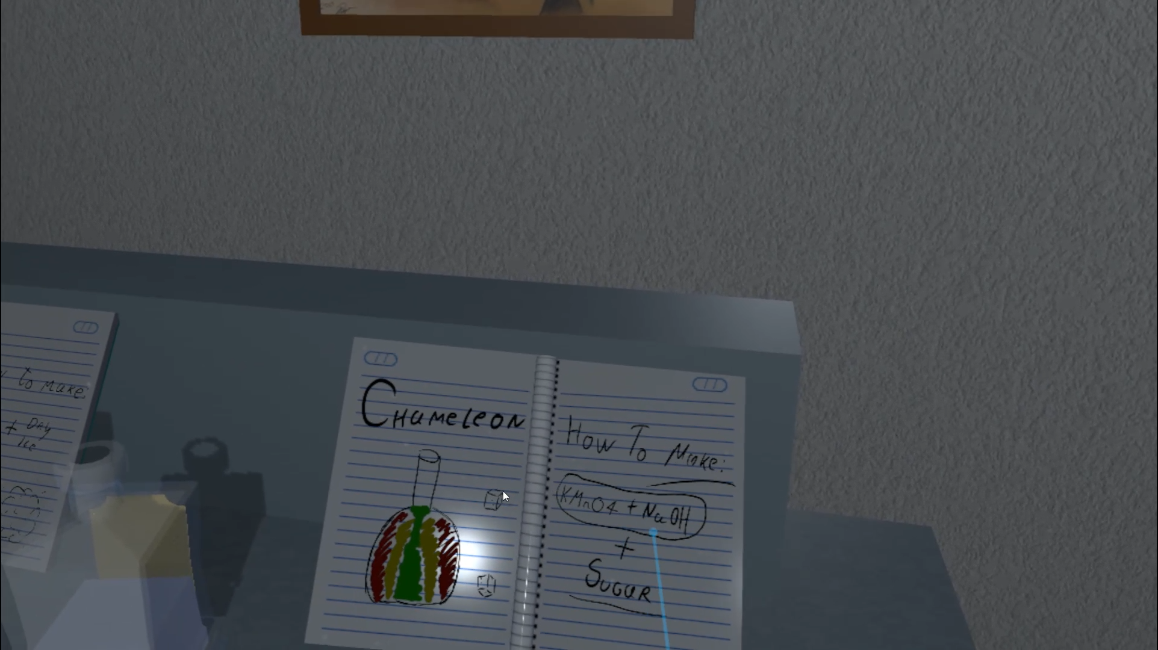

Figure 62 Chameleon experiment hint

After liquids are mixed and sugar added to the liquid, then liquid should start changing its colors.

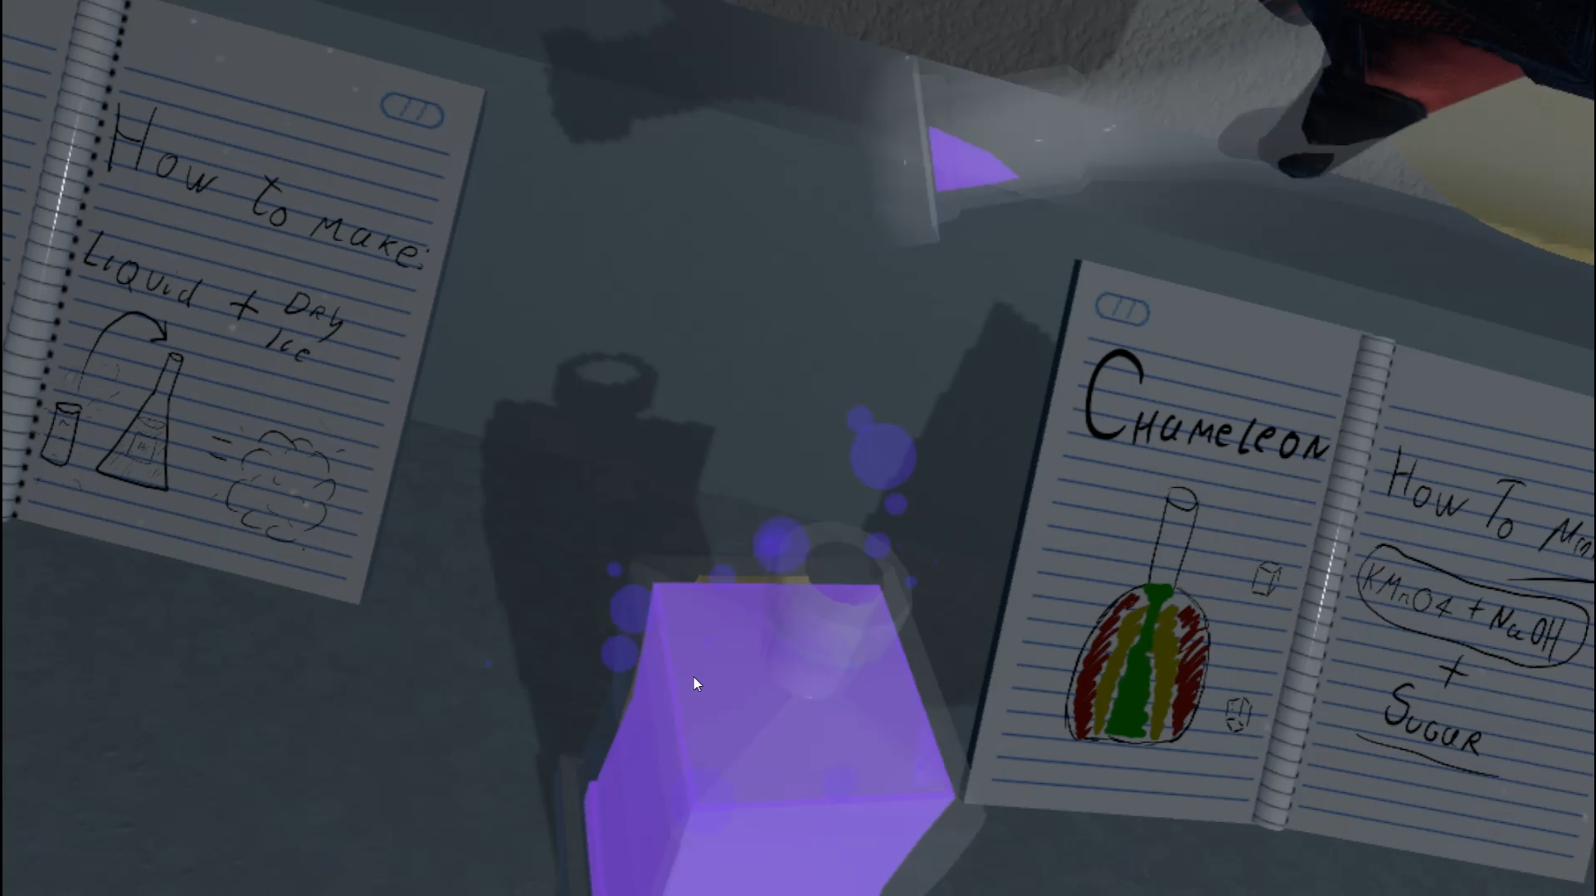

Figure 63 Mix liquids

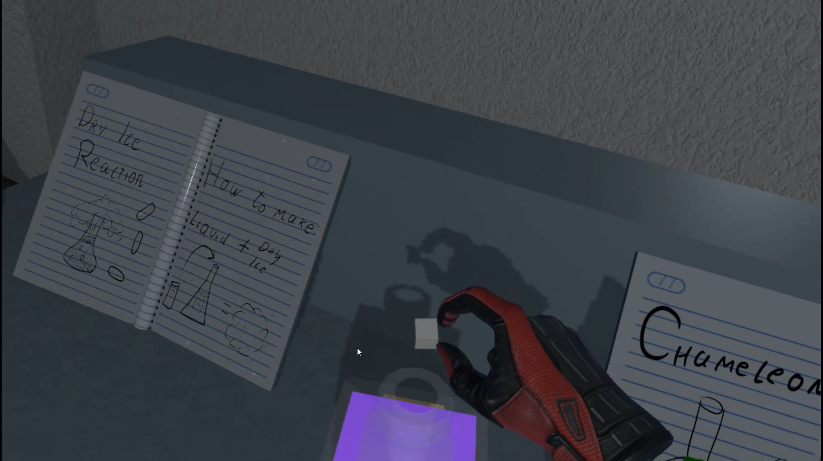

Figure 64 Add sugar to mixed liquid

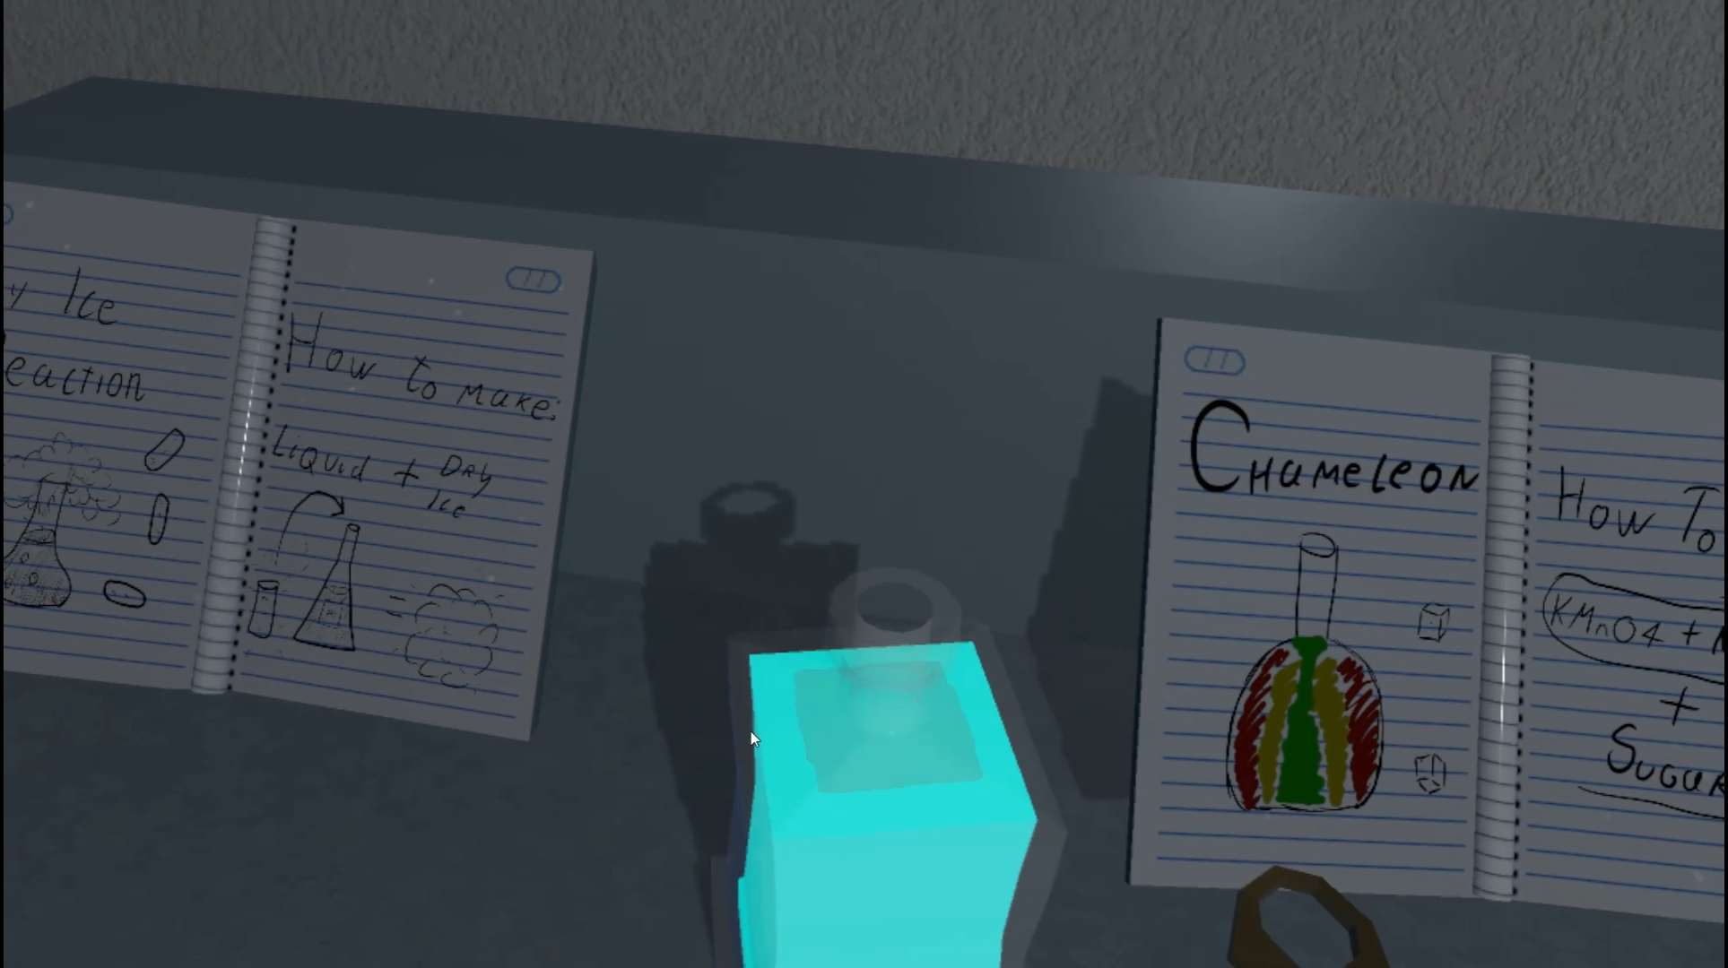

Figure 65 Liquid changing colors

|  |
| --- |
| public class MixingScript : MonoBehaviour  {  [SerializeField] string mixedTag = "Mixed";  [SerializeField] int specialLimit = 0;  [SerializeField] string fire;  [SerializeField] List<string> ignoreCollision;  [SerializeField] GameObject ps;  [SerializeField] List<string> LiquidTags;  [SerializeField] int[] absorve;  [SerializeField] bool special;  List<string> tags;  public bool mix = true;  int[] liquidAbsorve;  int MixSpec = 0;  int check = 0;  int cnt = 0;  int indexCheckTag = 0;  bool checkForMixed = false;  public bool mixed = false;  void Start()  {  liquidAbsorve = new int[LiquidTags.Count];  tags = new List<string>();  }  void OnParticleCollision(GameObject other)  {  if (fire != other.tag && other.tag != "Untagged" && !ignoreCollision.Contains(other.tag) && other.tag != mixedTag)  {  if (!tags.Contains(other.tag))  {  tags.Add(other.tag);  }  int i = 0;  foreach (string tag in LiquidTags)  {  if (other.tag == tag && absorve[i] > liquidAbsorve[i])  {  liquidAbsorve[i]++;  break;  }  i++;  }  }  else if (other.tag == mixedTag && special)  {  MixSpec++;  }  }  void Update()  {  if (tags.Count >= LiquidTags.Count)  {  if (indexCheckTag < tags.Count)  {  checkForMixed = false;  string tag = tags[indexCheckTag];  if (!LiquidTags.Contains(tag))  {  mix = false;  }  indexCheckTag++;  }  else if (indexCheckTag >= tags.Count)  {  indexCheckTag = 0;  checkForMixed = true;  }  if (checkForMixed)  {  if (!mixed)  {  if (cnt < liquidAbsorve.Length)  {  if (liquidAbsorve[cnt] >= absorve[cnt])  {  check++;  }  cnt++;  }  else  {  cnt = 0;  check = 0;  }  if ((check == liquidAbsorve.Length && tags.Count == LiquidTags.Count && mix) || (special && specialLimit <= MixSpec && mix))  {  mixed = true;  ps.tag = mixedTag;  }  }  else  {  if ((check == liquidAbsorve.Length && tags.Count > LiquidTags.Count && !mix) || (!mix && special && (tags.Count < LiquidTags.Count)))  {  mixed = false;  ps.tag = "Untagged";  }  }  }  }  }  public void ResetMix()  {  liquidAbsorve = new int[LiquidTags.Count];  tags = new List<string>();  checkForMixed = false;  indexCheckTag = 0;  mixed = false;  mix = true;  cnt = 0;  check = 0;  ps.tag = "Untagged";  }  } |

Table 24 MixingScript.cs script component

|  |
| --- |
| public class ChameleonCheck : MonoBehaviour  {  [SerializeField] string changeTagMixed = "SugarNaOHKMnO4";  [SerializeField] string changeTagNoMixed = "SugarNaOH";  [SerializeField] string tag;  [SerializeField] MixingScript mix;  [SerializeField] ParticleSystem ps;  [SerializeField] GameObject material;  [SerializeField] LiquidVolumeAnimator lva;  public bool check;  [SerializeField] DelegateChange Task;  public static bool chameleonActive = false;  BottleSmash smash;  bool change = false;  int cnt = 0;  GameObject go;  Color color;  private void Start()  {  chameleonActive = false;  mix = gameObject.GetComponent<MixingScript>();  smash = gameObject.transform.parent.GetComponent<BottleSmash>();  }  private void OnCollisionEnter(Collision collision)  {  if (collision.collider.tag == tag)  {    go = collision.gameObject;  go.GetComponent<Melting>().lva = lva;  go.GetComponent<Melting>().OneTimeTrigger = true;  collision.gameObject.GetComponent<BoxCollider>().isTrigger = true;  color = lva.mats[0].GetColor("_Color");  }  }  private void Update()  {  if (go != null && go.transform.position.y < lva.finalPoint.y && !check && mix.mixed)  {  ps.tag = changeTagMixed;  check = true;  }  else if (go != null && go.transform.position.y < lva.finalPoint.y && !check && !mix.mixed)  {  ps.tag = changeTagNoMixed;  }  else if (go == null && !check && mix.mixed && ps.tag == changeTagMixed)  {  color = lva.mats[0].GetColor("_Color");  check = true;  }  if (check && ps.tag == changeTagMixed)  {  chameleonActive = true;  Task.AddTask();  if (!change)  {  if (cnt == 0)  {  color.r -= 0.01f;  if (color.r <= 0)  {  color.r = 0;  change = true;  cnt++;  }  }  else if (cnt == 2)  {  color.b -= 0.01f;  if (color.b <= 0)  {  color.b = 0;  change = true;  cnt++;  }  }  else if (cnt == 4)  {  color.g -= 0.01f;  if (color.g <= 0)  {  color.g = 0;  change = true;  }  }  }  else if (change)  {  if (cnt == 1)  {  color.g += 0.01f;  if (color.g >= 1)  {  color.g = 1;  change = false;  cnt++;  }  }  else if (cnt == 3)  {  color.r += 0.01f;  if (color.r >= 1)  {  color.r = 1;  change = false;  cnt++;  }  }  }  smash.color = color;  smash.ChangedColor();  if (cnt == 5)  {  check = false;  Destroy(this);  }      }  }  } |

Table 25 ChameleonCheck.cs script component

Another one of the main puzzles in the game is called dry ice. The main goal of this experiment is to find a dry ice cylinder and some liquid. After adding dry ice to liquid, cloud of smoke is created. There is a notebook with hint that shows how experiment works.

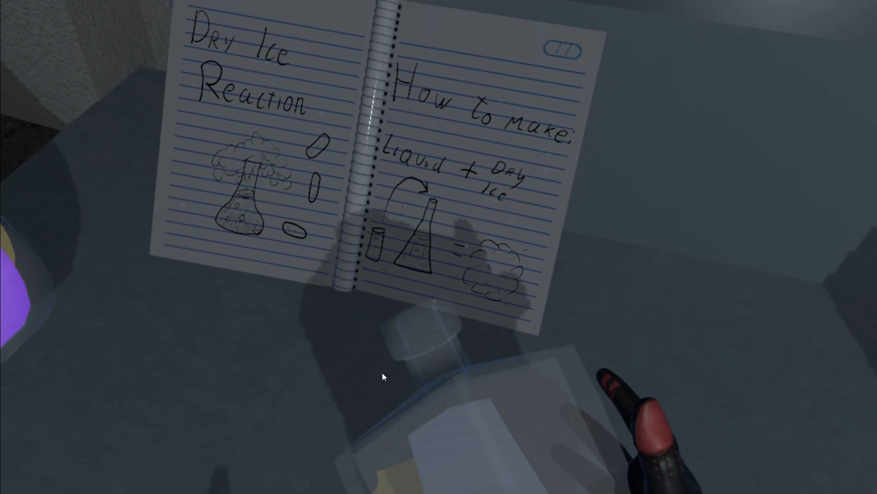

Figure 66 Experiment hint

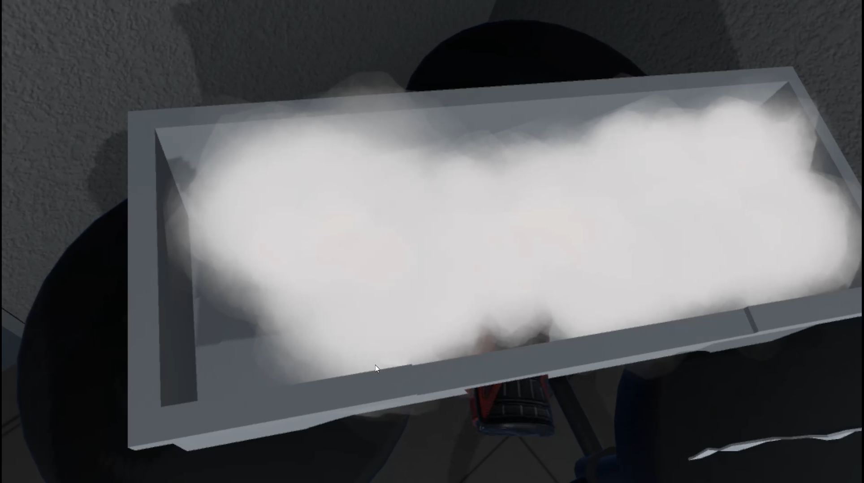

Figure 67 Dry Ice box

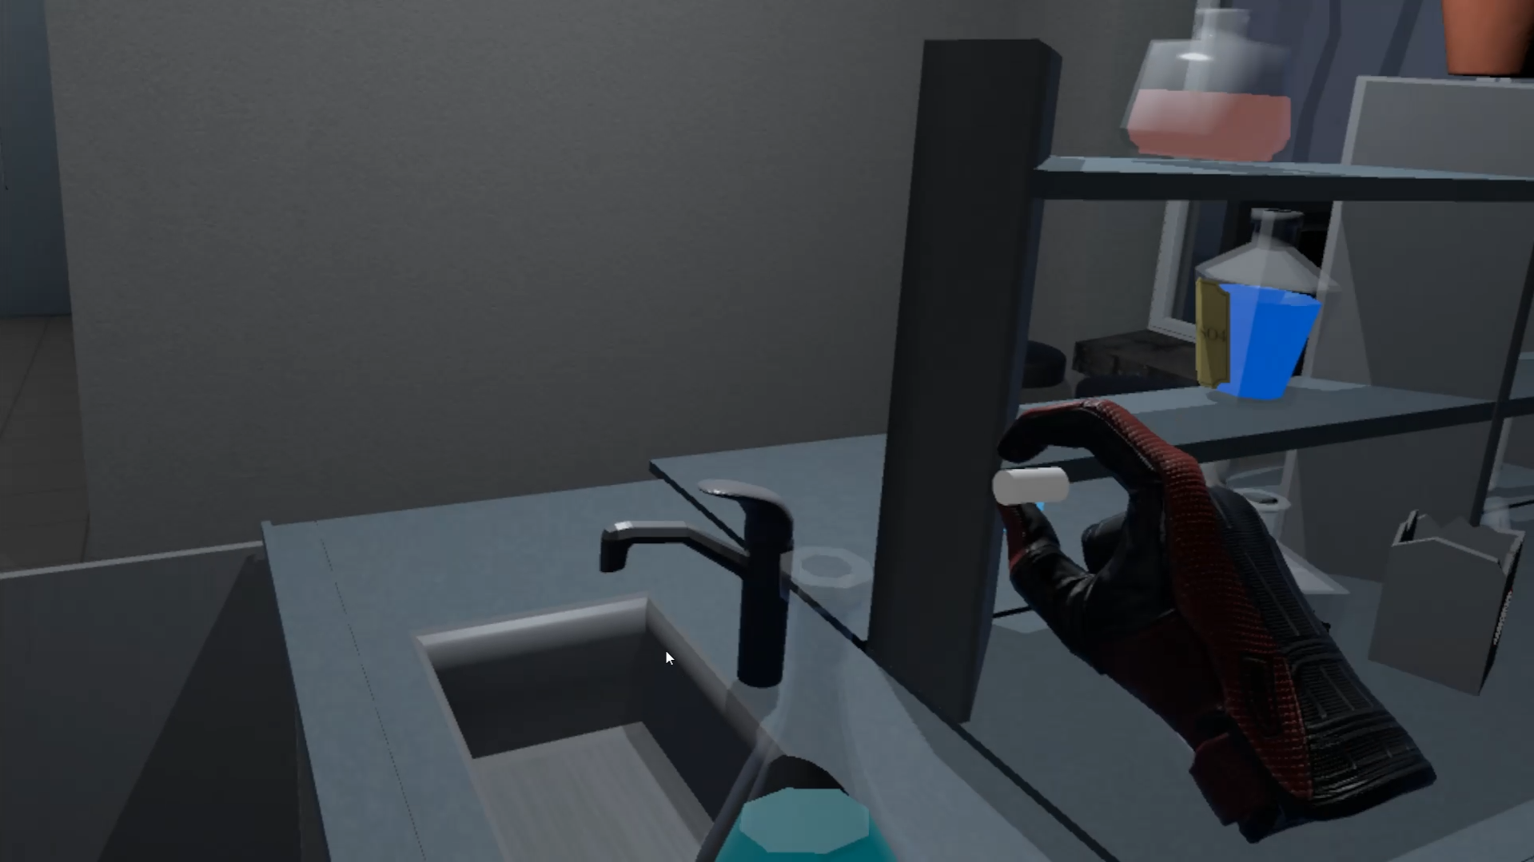

Figure 68 Add dry ice to liquid

|  |
| --- |
| public class DryIceCheck : MonoBehaviour  {  [SerializeField] string tag;  [SerializeField] ParticleSystem ps;  public LiquidVolumeAnimator lva;  [SerializeField] BottleSmash bottle;  [SerializeField] LiquidLevel level;  [SerializeField] DelegateChange Task;  public static bool dryIceActive = false;  private void Start()  {  dryIceActive = false;  }  private void OnCollisionEnter(Collision collision)  {  if (collision.collider.tag == tag)  {  dryIceActive = true;  collision.gameObject.GetComponent<Melting>().lva = lva;  collision.gameObject.GetComponent<Collider>().isTrigger = true;  collision.gameObject.GetComponent<Melting>().pscheck = ps;  collision.gameObject.GetComponent<Melting>().collided = true;  collision.gameObject.GetComponent<Melting>().smash = bottle;  level.pscheck = ps;  Task.AddTask();  }  }  } |

Table 26 DryIce Component

## **Task #6. Add health / powerup mechanics and indication in the GUI**

Since Escape the Lab title is a Virtual Reality exploration puzzle title, there are no power ups available. Instead, the players are given various tools and objects that help them to complete the levels.  
The timer acts like health in the game – if it hits zero, the player loses and gets dropped into Game Over scene.

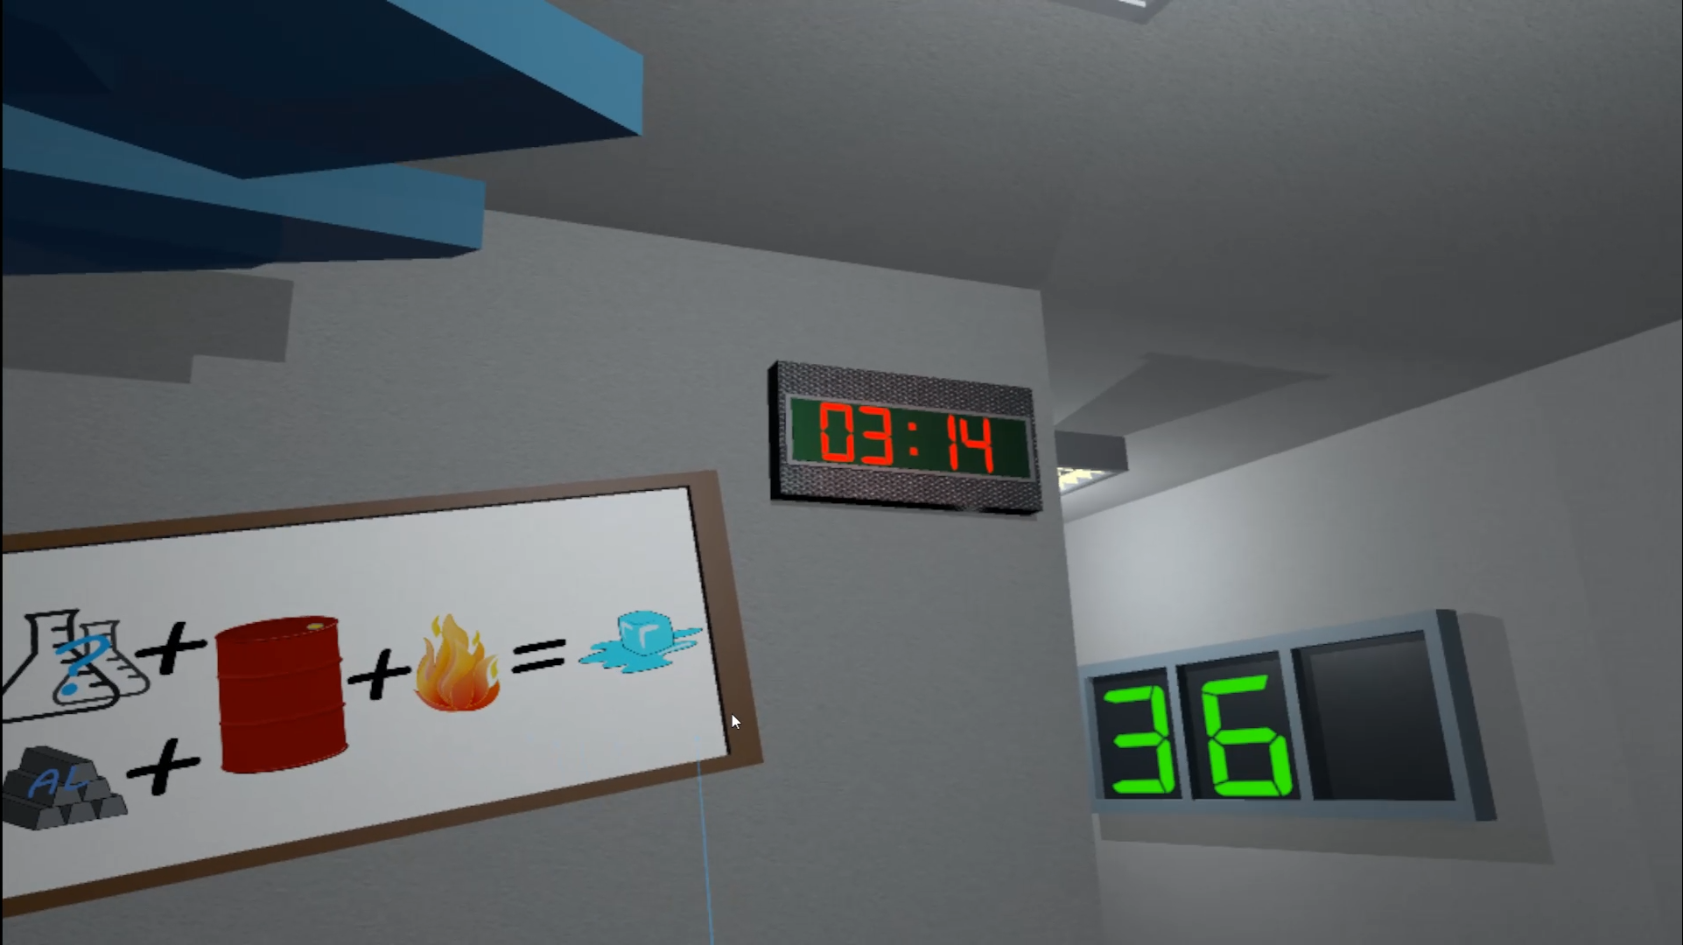

Figure 69 Timer

## **Task #7. Add scoring system (e.g., Easiest enemy – 100, most difficult – 500, powerup – 1000, total game time calculated, etc.)**

When the finish is reached, player has the possibility to write his name into the leaderboard and compete with Local, Steam store or Oculus store high scores. The total score is measured by how quickly each level has been finished.

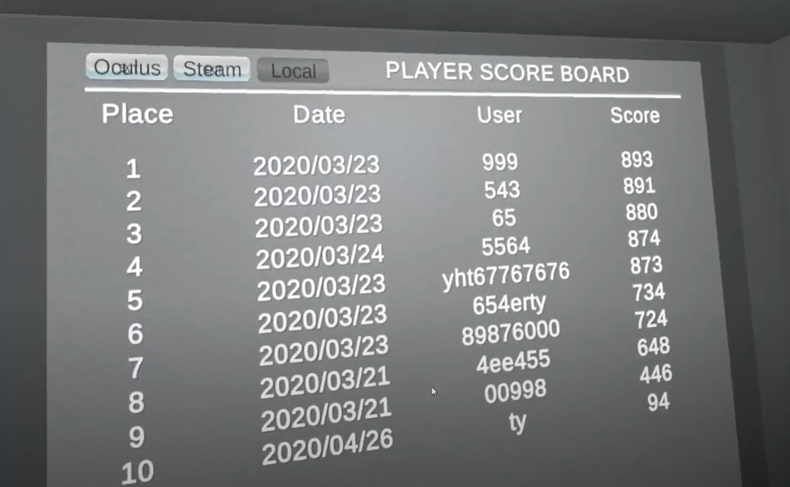

Figure 70 Local leaderboard

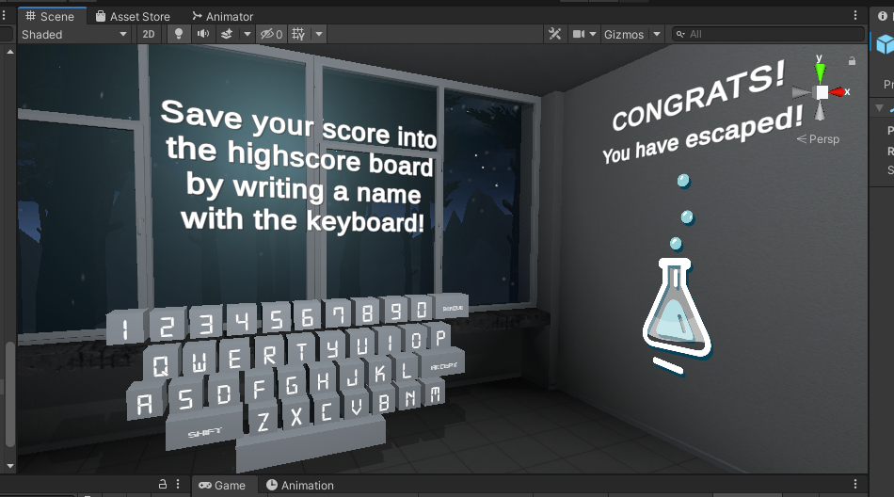

Figure 71 Leaderboard name input keyboard

|  |
| --- |
| public class ScoreBoardDatabase : MonoBehaviour  {  public static MySqlConnection MySqlConnetionRef;  [SerializeField] string tableName;  [SerializeField] bool isLocal = false;  [SerializeField] int AllLevels = 0;  [SerializeField] GameObject prefab;  [SerializeField] GameObject loading;  [SerializeField] float firstXCoordinate;  [SerializeField] float firstYCoordinate;  [SerializeField] float firstZCoordinate;  [SerializeField] float offSet;  MySqlConnection connection;  float tempPosition;  List<Data> allData;  WriteReadFile file;  bool oneTime = true;  bool dataUpdated = false;  Thread onlineData;  Vector2 firstDimmensionsRect = Vector2.zero;  bool usingSteam = false;  private void OnEnable()  {  if (file == null)  {  file = new WriteReadFile("save.data");  }  if (isLocal)  {  dataUpdated = false;  allData = new List<Data>();  allData = file.ReadAllData();  dataUpdated = true;  }  else  {  if (onlineData != null)  {  onlineData.Join();  }  onlineData = new Thread(DataUpdate);  onlineData.Start();  dataUpdated = false;  }  DestroyAllChild();  loading.SetActive(true);  }  void DataUpdate()  {  allData = new List<Data>();  string connectionInfo = String.Format("server={0};user={1};database={2};password={3}", "server", "user ", "db", "lol");  if (connection == null && MySqlConnetionRef == null)  {  connection = new MySqlConnection(connectionInfo);  MySqlConnetionRef = connection;  }  if (MySqlConnetionRef != null && connection == null)  {  connection = MySqlConnetionRef;  }  using (connection)  {  try  {  connection.Open();  string get = String.Format("SELECT * FROM `{0}` WHERE Level={1} ORDER BY Score DESC", tableName, AllLevels);  using (var command = new MySqlCommand(get, connection))  {  using (var reader = command.ExecuteReader())  {  while (reader.Read())  {  Data data = new Data(reader.GetDateTime(1), reader.GetString(2), reader.GetFloat(3));  allData.Add(data);  }  }  }  connection.Close();  }  catch (Exception ex)  {  Debug.Log(ex.ToString());  }  }  if (usingSteam)  {  string name = SteamFriends.GetPersonaName();  CSteamID steamId = SteamUser.GetSteamID();  using (connection)  {  try  {  connection.Open();  string get = String.Format("SELECT * FROM `SteamScoreBoard` WHERE Level={0} AND OwnerKey={1} ORDER BY Score DESC", AllLevels, steamId);  using (var command = new MySqlCommand(get, connection))  {  using (var reader = command.ExecuteReader())  {  while (reader.Read())  {  if (reader.GetString(2) != name)  {  String updateUsername = String.Format("UPDATE SteamScoreBoard SET Usernam={0} WHERE OwnerKey={1}", name, steamId);  }  }  }  }  connection.Close();  }  catch (Exception ex)  {  Debug.Log(ex.ToString());  }  }  }  dataUpdated = true;  onlineData.Abort();  }  void FillScoreBoard()  {  tempPosition = 0;  for (int i = 0; i < allData.Count; i++)  {  if (i == 0)  {  RectTransform rect = gameObject.GetComponent<RectTransform>();  GameObject List = Instantiate(prefab);  rect.sizeDelta = firstDimmensionsRect;  List.gameObject.SetActive(true);  List.name = prefab.name + (i + 1).ToString();  List.transform.SetParent(transform);  List.GetComponent<RectTransform>().localPosition = new Vector3(firstXCoordinate, firstYCoordinate, firstZCoordinate);  List.GetComponent<RectTransform>().localScale = new Vector3(1, 1, 1);  List.GetComponent<RectTransform>().localRotation = Quaternion.Euler(0, 0, 0);  tempPosition = firstYCoordinate;  List.transform.Find("Place").GetComponent<TextMeshProUGUI>().text = (i + 1).ToString();  List.transform.Find("Date").GetComponent<TextMeshProUGUI>().text = allData[i].DatePlay.ToString("yyyy/MM/dd");  List.transform.Find("User").GetComponent<TextMeshProUGUI>().text = allData[i].NickName;  List.transform.Find("Score").GetComponent<TextMeshProUGUI>().text = allData[i].Score.ToString();  }  if (i > 0)  {  RectTransform rect = gameObject.GetComponent<RectTransform>();  rect.sizeDelta = new Vector2(rect.sizeDelta.x, rect.sizeDelta.y + Math.Abs(offSet));  GameObject List = Instantiate(prefab);  List.gameObject.SetActive(true);  List.name = prefab.name + (i + 1).ToString();  List.transform.SetParent(transform);  float yPosition = tempPosition + offSet;  List.GetComponent<RectTransform>().localPosition = new Vector3(firstXCoordinate, yPosition, firstZCoordinate);  List.GetComponent<RectTransform>().localScale = new Vector3(1, 1, 1);  List.GetComponent<RectTransform>().localRotation = Quaternion.Euler(0, 0, 0);  tempPosition = yPosition;  List.transform.Find("Place").GetComponent<TextMeshProUGUI>().text = (i + 1).ToString();  List.transform.Find("Date").GetComponent<TextMeshProUGUI>().text = allData[i].DatePlay.ToString("yyyy/MM/dd");  List.transform.Find("User").GetComponent<TextMeshProUGUI>().text = allData[i].NickName;  List.transform.Find("Score").GetComponent<TextMeshProUGUI>().text = allData[i].Score.ToString();  }  }  }  void Start()  {  usingSteam = SteamManager.Initialized;  RectTransform rect = gameObject.GetComponent<RectTransform>();  firstDimmensionsRect = rect.sizeDelta;  }  void Update()  {  if (GameData.End == true && oneTime && GameEnd.Inserted)  {  if (isLocal)  {  dataUpdated = false;  allData = new List<Data>();  allData = file.ReadAllData();  dataUpdated = true;  }  else  {  if (onlineData != null)  {  onlineData.Join();  }  onlineData = new Thread(DataUpdate);  onlineData.Start();  dataUpdated = false;  }  loading.SetActive(true);  DestroyAllChild();  oneTime = false;  }  if (dataUpdated)  {  FillScoreBoard();  loading.SetActive(false);  dataUpdated = false;  }  }  void DestroyAllChild()  {  int i = 0;  foreach (Transform objects in transform)  {  if (i > 1)  {  Destroy(objects.gameObject);  }  i++;  }  }  } |

Table 27 ScoreBoardDatabase.cs script component

## **Task #8. Add "Game over" condition (once the game ends you should display a high score and reload/main menu buttons**

As mentioned before, when the timer reaches 00:00, the player loses and gets teleported into the Lose scene.

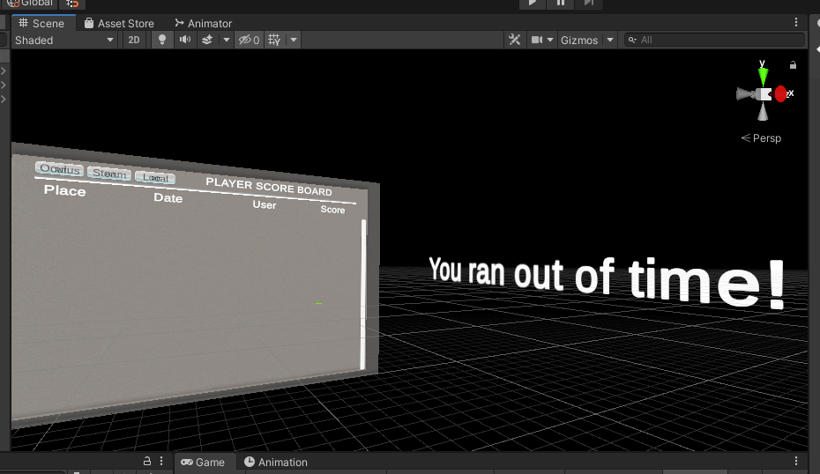

Figure 72 Lose scene with leaderboard

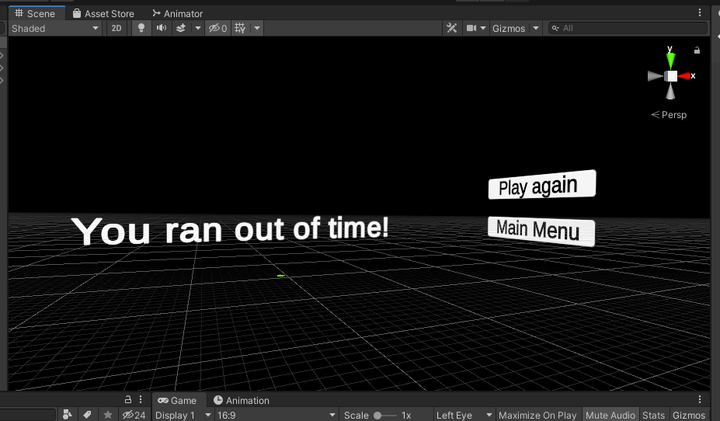

Figure 73 Lose scene menu

|  |
| --- |
| public class Teleports : MonoBehaviour  {  TimeLeft timeleft;  [SerializeField] bool loadPreviuos = false;  [SerializeField] int loseSceneIndex = 0;  bool saveFile = false;  private void Start()  {  timeleft = GetComponent<TimeLeft>();  }  // Update is called once per frame  void Update()  {  if (GameData.End == true && GameData.Victory == false)  {  if (saveFile == false)  {  GlobalData.WriteToFile();  GlobalData.ResetStatic();  BoundryController.ResetCount();  saveFile = true;  }  GameData.SetPreviuosScene(SceneManager.GetActiveScene().buildIndex);  loseScene();  GameData.Cear();  }  }  void loseScene()  {  SceneManager.LoadScene(loseSceneIndex);  }  void restartLevel()  {  SceneManager.LoadScene(SceneManager.GetActiveScene().buildIndex);  }  void LoadPreviuos()  {  SceneManager.LoadScene(GameData.PreviuosSceneId);  }  } |

Table 28 Teleports.cs script component

## **Task #9. Add "Post Processing" (Blurring, blood screen, etc.)**

A slight bloom, slight ambient occlusion to enhance shadows, added vignette for adding some black gradient around screen, color grading and blueish eye adaptation added to enhance the light blue colors of the game scene.

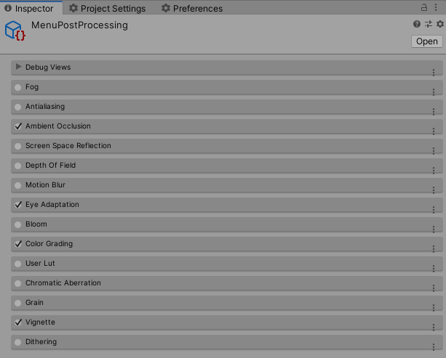

Figure 74 Menu scene post processing

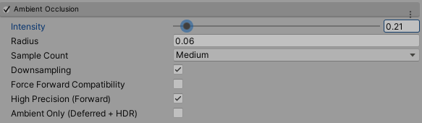

Figure 75 Menu scene ambiant occlusion

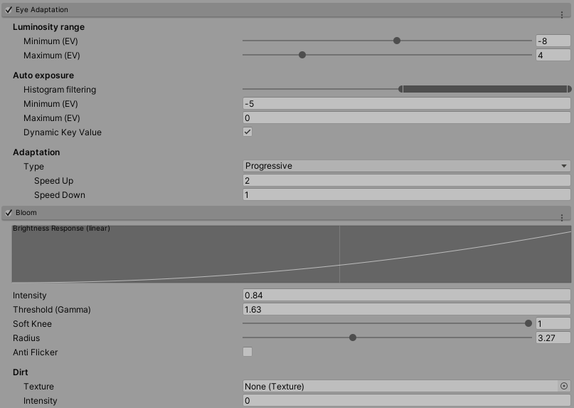

Figure 76 Menu scene post processing Eye Adaptation and Bloom

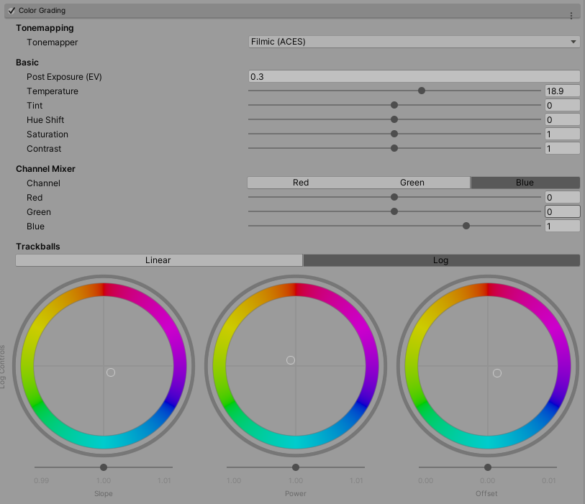

Figure 77 Menu scene post processing Color Grading

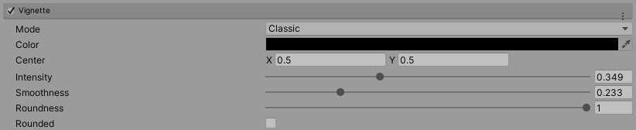

Figure 78 Menu sceme vignette

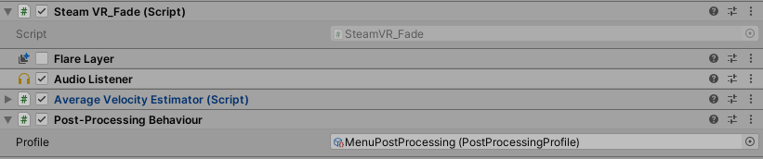

Figure 79 Applied Menu scene post processing

## **Task #10.** **Add Interactive sounds (Sound of step, shoot, die, scream, etc. - minimum 10 different) and music (1 for menu + minimum 3 for in-game)**

Created an empty Game Object, gave it a script with DontDestroyOnLoad behavior, so that the music could be played across the levels seamlessly.

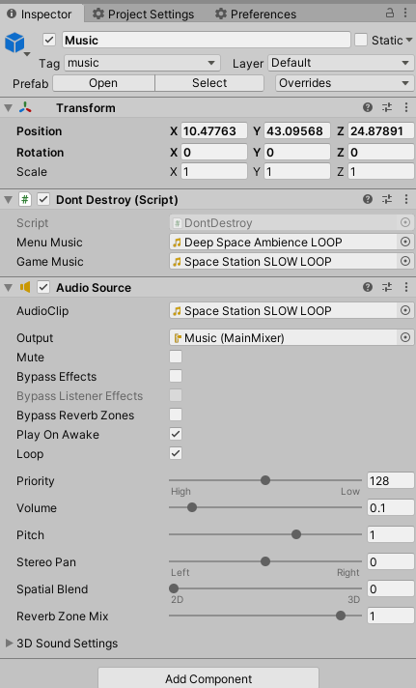

Figure 80 Background music Game Object

|  |
| --- |
| public class DontDestroy : MonoBehaviour  {  private static DontDestroy instance;  private AudioSource aud;  public AudioClip menuMusic;  public AudioClip gameMusic;  private void Start()  {  aud = GetComponent<AudioSource>();  }  private void Awake()  {  if (instance != null && instance != this)  {  Destroy(this.gameObject);  }  else  instance = this;  DontDestroyOnLoad(gameObject);  }  void OnEnable()  {  SceneManager.sceneLoaded += OnSceneLoaded;  }  void OnSceneLoaded(Scene scene, LoadSceneMode mode)  {  if (scene.name == "MainMenu")  {  if (aud == null)  return;  aud.Stop();  aud.clip = menuMusic;  aud.Play();  }  else if (scene.name == "MainGame")  {  if (aud == null)  return;  aud.Stop();  aud.clip = gameMusic;  aud.Play();  }  }  } |

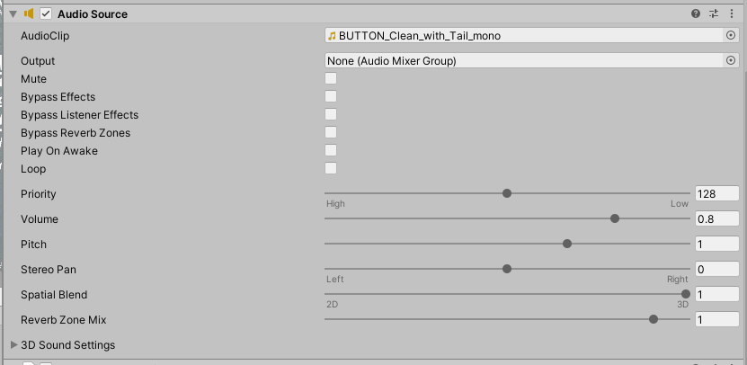

Figure 81 Button Sound

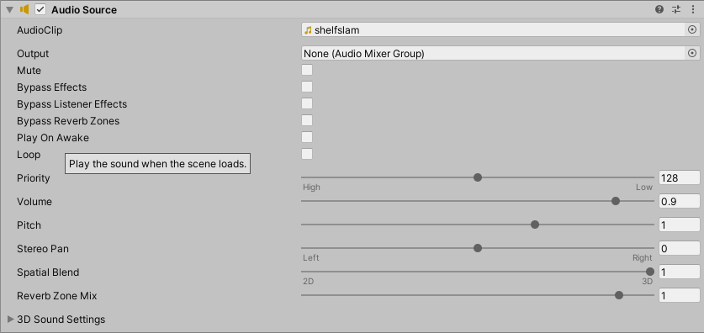

Figure 82 Shelf close sound

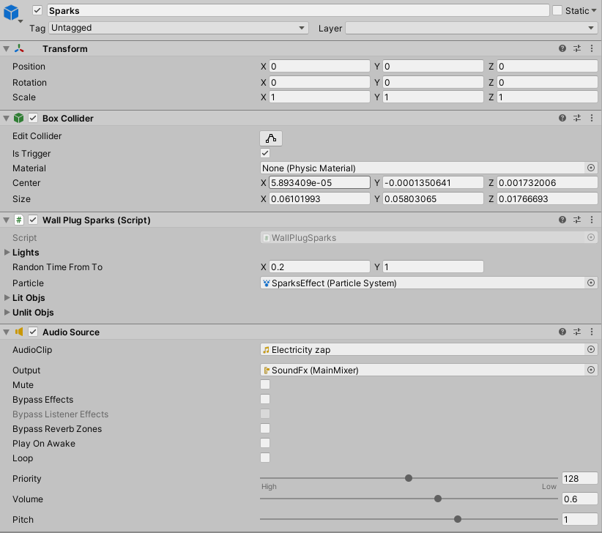

Figure 83 Spark Sound

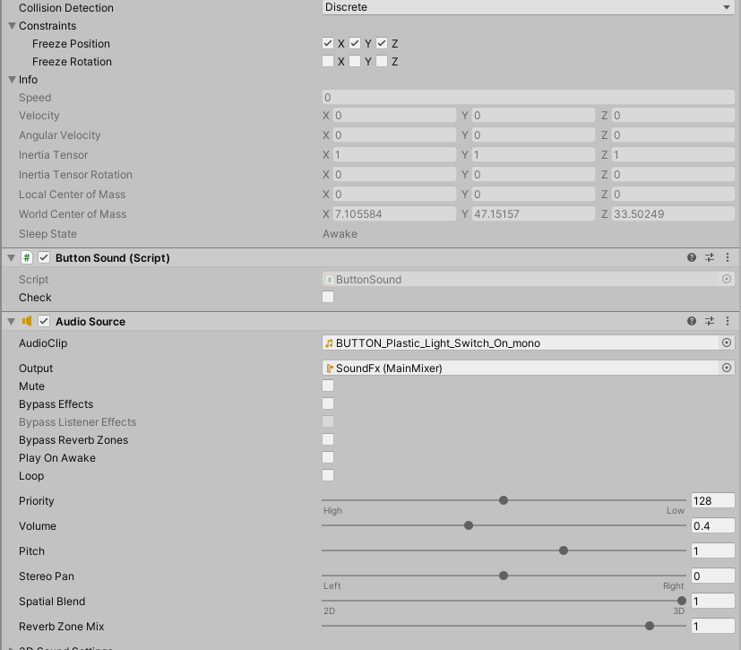

Figure 84 Light switch on sound

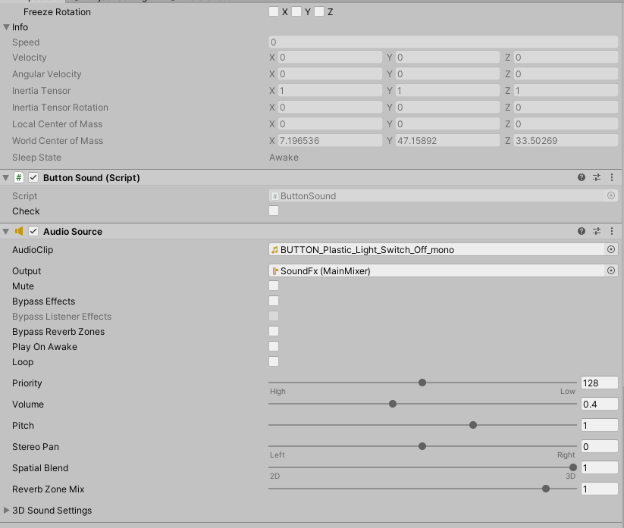

Figure 85 Light switch off sound

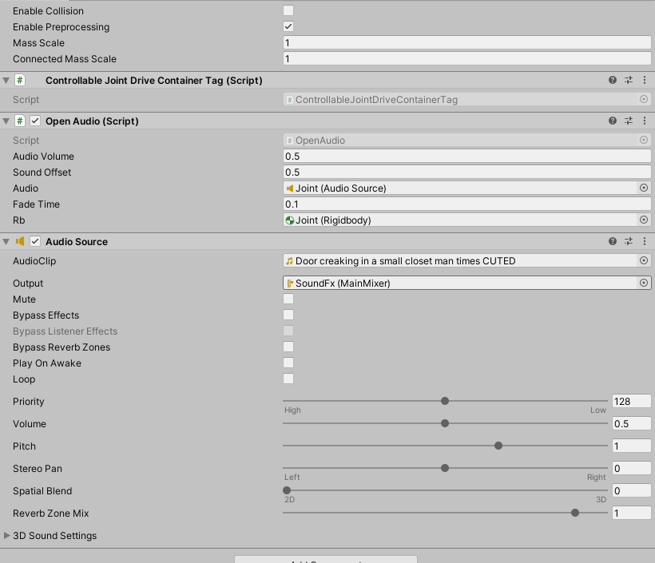

Figure 86 Door creaking sound

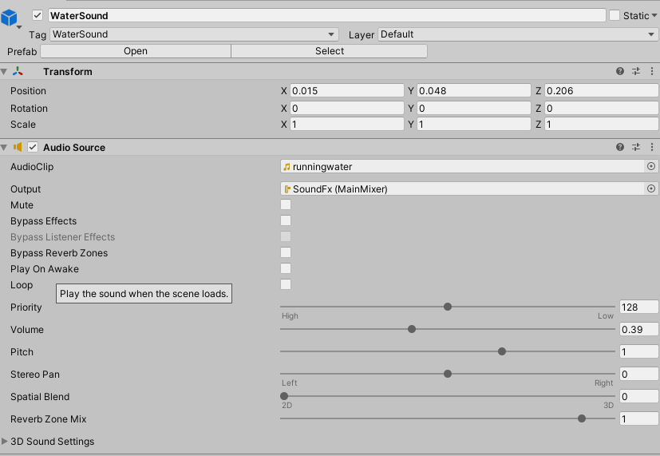

Figure 87 Pouring water sound

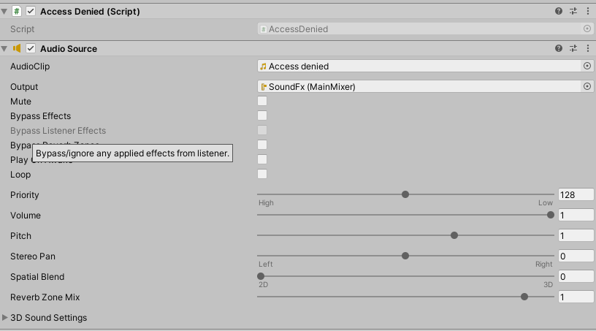

Figure 88 Access denied sound

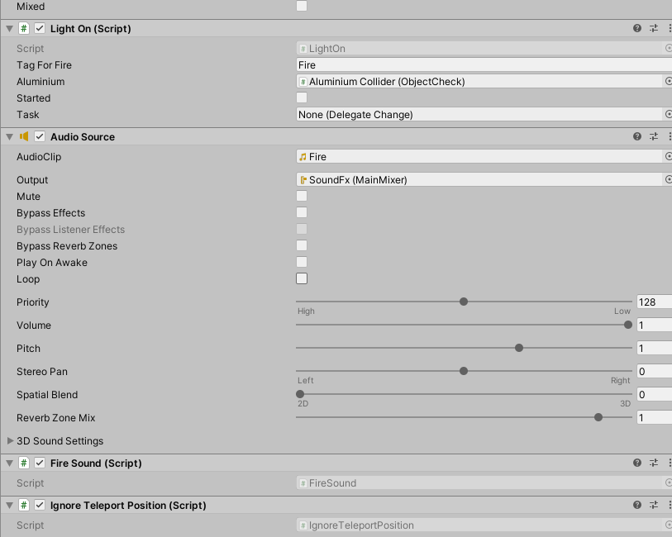

Figure 89 Experiment fire sound

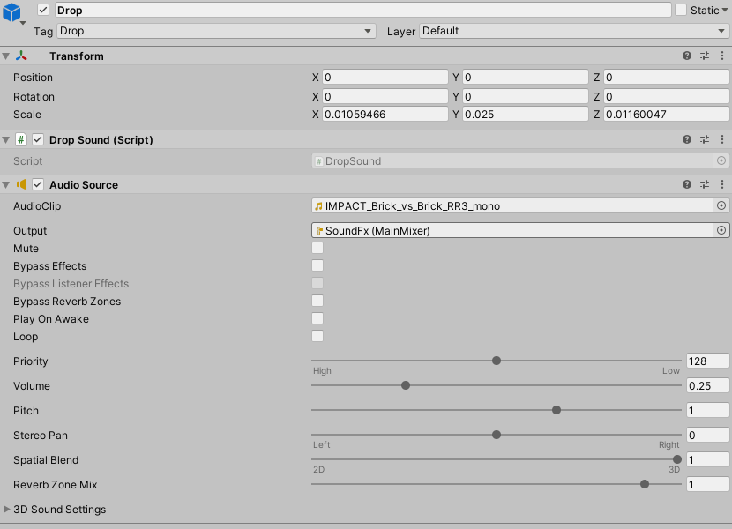

Figure 90 Inpact sound for aluminium

|  |
| --- |
| public class ButtonSound : MonoBehaviour  {  AudioSource audio;  //bool check = false;  public bool check = false;  void Start()  {  audio = GetComponent<AudioSource>();  }  // Update is called once per frame  void Update()  {  if (check)  {  audio.Play();  check = false;  }  }  public void EnableSound()  {  check = true;  }  } |

Figure 91 ButtonSounc.cs component

|  |
| --- |
| public class ShelfSound : MonoBehaviour  {  [SerializeField] float audioVolume = 0.35f;  float firstAngle;  float fisrstAngleTracking;  Vector3 angle;  bool firstAngleCheck;  bool sound;  float timer;  float speeds;  bool timerbool;  bool oneTime;  [SerializeField] AudioSource audio;  [SerializeField] Rigidbody rg;  [SerializeField] Transform tf;  [SerializeField] float speed = 0.1f;  [SerializeField] bool startFrom360 = false;  //// Start is called before the first frame update  void Start()  {    StartCoroutine(muteSound());  sound = false;  timerbool = true;  oneTime = false;  timer = 0.4f;  speeds = rg.velocity.magnitude;  firstAngleCheck = true;    }  //// Update is called once per frame  void Update()  {  angle = tf.localEulerAngles;  speeds = rg.velocity.magnitude;  //timer -= Time.deltaTime*2;  //if (timer < 0)  //{  //Debug.Log(tf.localEulerAngles.y);  if (!startFrom360)  {  if (speeds > speed && speeds < 1 && (tf.localEulerAngles.y <= 0.01 || tf.localEulerAngles.y > 350) && oneTime == false)  {  timer = 0.4f;  timerbool = false;  sound = true;  oneTime = true;  }  else if (speeds > 0.001 && speeds < 1 && (tf.localEulerAngles.y <= 0.01 || tf.localEulerAngles.y > 350) && oneTime == false)  {  oneTime = true;  }  else if (speeds > speed && tf.localEulerAngles.y > 0.1 && (tf.localEulerAngles.y < 200) && oneTime == true)  {  timer = 0.4f;  timerbool = true;  sound = false;  oneTime = false;  }  //}  if (sound == true && !audio.isPlaying && timerbool == false)  {  audio.Play();  sound = false;  }  }  else {  if (speeds > speed && speeds < 1 && (tf.localEulerAngles.y >= 0.01 && tf.localEulerAngles.y <= 260) && oneTime == false)  {  timer = 0.4f;  timerbool = false;  sound = true;  oneTime = true;  }  else if (speeds > 0.001 && speeds < 1 && (tf.localEulerAngles.y >= 0.01 && tf.localEulerAngles.y <= 260) && oneTime == false)  {  oneTime = true;  }  else if (speeds > speed && tf.localEulerAngles.y > 260 && (tf.localEulerAngles.y < 360) && oneTime == true)  {  timer = 0.4f;  timerbool = true;  sound = false;  oneTime = false;  }  //}  if (sound == true && !audio.isPlaying && timerbool == false)  {  audio.Play();  sound = false;  }  }  }  IEnumerator muteSound()  {  audio.volume = 0;  yield return new WaitForSeconds(5);  audio.volume = audioVolume;  }  } |

Figure 92 ShelfSound.cs componenet

|  |
| --- |
| public class WallPlugSparks : MonoBehaviour  {  //TODO fix animation component disabling/enabling  [SerializeField] List<GameObject> lights;  [SerializeField] Vector2 RandonTimeFromTo = Vector2.zero;  [SerializeField] ParticleSystem particle;  public GameObject[] litObjs;  public GameObject[] unlitObjs;  List<float> timeToSpark;  List<float> timeCount;  List<bool> checkSparkle;  bool spark = false;  int lightBlinked = 0;  AudioSource aud;  bool isTouched = false;  private void Start()  {  timeToSpark = new List<float>();  timeCount = new List<float>();  checkSparkle = new List<bool>();  for (int i = 0; i < lights.Count; i++)  {  timeToSpark.Add(Random.Range(RandonTimeFromTo.x, RandonTimeFromTo.y));  checkSparkle.Add(false);  timeCount.Add(0);  }    aud = GetComponent<AudioSource>();  }  private void OnTriggerEnter(Collider other)  {  if (other.tag != "GameController" && other.name != "[VRTK][AUTOGEN][Controller][NearTouch][CollidersContainer]" && other != null)  {  particle.Play();  aud.Play();  spark = true;  for (int i = 0; i < timeToSpark.Count; i++)  {  timeToSpark[i] = Random.Range(RandonTimeFromTo.x, RandonTimeFromTo.y);  }  }  }  private void Update()  {  if (isTouched && spark == false)  {  particle.Play();  aud.Play();  spark = true;  for (int i = 0; i < timeToSpark.Count; i++)  {  timeToSpark[i] = Random.Range(RandonTimeFromTo.x, RandonTimeFromTo.y);  }  }  if (spark)  {  for (int i = 0; i < timeToSpark.Count; i++)  {  if (timeToSpark[i] >= timeCount[i])  {  litObjs[i].SetActive(false);  unlitObjs[i].SetActive(true);  lights[i].GetComponent<Light>().enabled = false;  timeCount[i] += Time.deltaTime;  }  else if (timeToSpark[i] < timeCount[i] && !checkSparkle[i])  {  lightBlinked++;  litObjs[i].SetActive(true);  unlitObjs[i].SetActive(false);  lights[i].GetComponent<Light>().enabled = true;  checkSparkle[i] = true;  }  }  if (lightBlinked >= timeToSpark.Count)  {  for (int i = 0; i < timeToSpark.Count; i++)  {  if (lightBlinked == timeToSpark.Count)  {  checkSparkle[i] = false;  timeCount[i] = 0;  }  }  spark = false;  lightBlinked = 0;  }  }  }  public void Touch()  {  isTouched = true;  }  public void Relise()  {  isTouched = false;  }  } |

Figure 93 WallPlugSpark.cs Component

|  |
| --- |
| public class OpenAudio : MonoBehaviour  {  [SerializeField] float audioVolume = 0.09f;  [SerializeField] float soundOffset = 0.5f;  [SerializeField] AudioSource audio;  public float fadeTime = 1;  [SerializeField]Rigidbody rb;  float timeCnt = 0;  float stopedAt = 0;  bool stopped = true;  float speed = 0;  Vector3 speedCalc = Vector3.zero;  float startXPos = 0;  Vector3 tempx = Vector3.zero;  float chunksCnt = 0;  float chunkSize = 0;  // Start is called before the first frame update  private void OnEnable()  {  if (rb == null)  {  rb = gameObject.GetComponent<Rigidbody>();  }  }  void Start()  {  chunksCnt = fadeTime / Time.deltaTime;  chunkSize = audioVolume / chunksCnt;  startXPos = rb.gameObject.transform.localPosition.x;  }  // Update is called once per frame  void Update()  {  if (tempx != rb.gameObject.transform.localPosition)  {  speedCalc = rb.gameObject.transform.localPosition - tempx;  speedCalc /= Time.deltaTime;  tempx = rb.gameObject.transform.localPosition;  speed = speedCalc.magnitude;  }  else if (tempx == rb.gameObject.transform.localPosition)  {  speed = Vector3.zero.magnitude;  }  //Debug.Log(speed);  if (speed > 0.04 && startXPos > rb.gameObject.transform.localPosition.x && stopped)  {  audio.volume = audioVolume;  audio.time = stopedAt;  audio.Play();  stopped = false;  timeCnt = 0;  }  else if (speed > 0.04 && startXPos > rb.gameObject.transform.localPosition.x && !stopped)  {  //Debug.Log("HaHa");  if (audio.isPlaying && audio.time > audio.clip.length - soundOffset)  {  audio.volume = audioVolume;  audio.time = soundOffset;  audio.Play();  }  else if (!audio.isPlaying)  {  audio.volume = audioVolume;  audio.time = soundOffset;  audio.Play();  }  timeCnt = 0;  }  else  {  timeCnt += Time.deltaTime;  audio.volume -= chunkSize;  if (timeCnt >= fadeTime && !stopped)  {  stopedAt = audio.time;  audio.Stop();  stopped = true;  }  }  }  } |

Figure 94 Door open component

|  |
| --- |
| public class FallingWater : MonoBehaviour  {  public bool Active = false;  public GameObject particle;  [SerializeField] AudioSource audio;  // Start is called before the first frame update  void Start()  {    }  // Update is called once per frame  void Update()  {  if (gameObject.transform.rotation.eulerAngles.z >= 340)  {  particle.GetComponent<ParticleSystem>().Play();  if (!audio.isPlaying)  {  audio.Play();  }  Active = true;  }  else  {  particle.GetComponent<ParticleSystem>().Stop();  audio.Stop();  Active = false;  }  }  } |

Figure 95 Falling water component

|  |
| --- |
| public class AccessDenied : MonoBehaviour  {  AudioSource audio;  bool started = false;  private void Start()  {  audio = GetComponent<AudioSource>();  }  public void StartSound()  {  if (started && !audio.isPlaying)  {  started = false;  }  if (!started)  {  audio.Play();  started = true;  }    }  } |

Figure 96 Access denied component

|  |
| --- |
| public class FireSound : MonoBehaviour  {  AudioSource audio;  bool Fire = true;  LightOn fireScript;  // Start is called before the first frame update  void Start()  {  audio = GetComponent<AudioSource>();  fireScript = GetComponent<LightOn>();  }  // Update is called once per frame  void Update()  {  if (fireScript.Started && Fire)  {  audio.Play();  Fire = false;  }  else if (!fireScript.Started && !Fire)  {  Fire = true;  }  }  } |

Figure 97 Fire sound component

|  |
| --- |
| public class DropSound : MonoBehaviour  {  int cnt = 0;  AudioSource aud;  // Start is called before the first frame update  void Start()  {  aud = GetComponent<AudioSource>();  }  public void PlaySound()  {  if (!aud.isPlaying)  {  aud.Play();  }  }  } |

Figure 98

## **Task #11. Defense**

# **Literature list**

1. Source #1. <https://vrtoolkit.readme.io/>
2. Source #2. <https://assetstore.unity.com/>
3. Source #3. <https://docs.unity3d.com/Manual/index.html>
4. Source #4. <https://docs.unity3d.com/ScriptReference/>
5. Source #5. <https://unity.com/unity/features/vr>

# **ANNEX**

All source code is contained in this part.

using System.Collections;

using System.Collections.Generic;

using UnityEngine;

using VRTK;

using VRTK.Prefabs.Interactions.Controllables;

public class LockUnlockWithKey : MonoBehaviour

{

[SerializeField] GameObject[] Note;

[SerializeField] GameObject doorsControll;

[SerializeField] Rigidbody rb;

[SerializeField] string checkKey;

[SerializeField] bool x = false;

[SerializeField] bool y = false;

[SerializeField] bool z = false;

bool isSnapped = false;

IdForUnlock[] unlock;

public bool Open = false;

bool oneTime = true;

bool check = false;

private int unlockId = 0;

bool rigidbodyExists = false;

int index = 0;

[SerializeField] DelegateChange Task;

// Start is called before the first frame update

void Start()

{

doorsControll.SetActive(false);

foreach ( GameObject obj in Note )

{

obj.SetActive(false);

}

if (x)

{

rb.constraints = RigidbodyConstraints.FreezeRotationX;

}

else if (y)

{

rb.constraints = RigidbodyConstraints.FreezeRotationY;

}

else if (z)

{

rb.constraints = RigidbodyConstraints.FreezeRotationZ;

}

}

// Update is called once per frame

void Update()

{

if (!check && isSnapped)

{

unlock = FindObjectsOfType<IdForUnlock>();

if (index < unlock.Length)

{

if (unlock[index] != null && unlock[index].tag == checkKey)

{

int id = Random.Range(1, 20);

unlockId = id;

unlock[index].SetId(id);

check = true;

}

else if(unlock[index] != null && unlock[index].tag != checkKey)

{

index++;

}

}

else if(index >= unlock.Length)

{

index = 0;

}

}

else

{

if (Open == true && oneTime)

{

doorsControll.SetActive(true);

rb.constraints = RigidbodyConstraints.None;

foreach (GameObject obj in Note)

{

obj.SetActive(true);

}

oneTime = false;

rigidbodyExists = true;

Task.AddTask();

Destroy(this);

}

if (isSnapped && unlock[index].GetId() == unlockId)

{

Open = true;

}

}

}

public bool isChestOpen()

{

if (rigidbodyExists)

return Open;

else

return false;

}

public void Snap()

{

isSnapped = true;

}

public void UnSnap()

{

isSnapped = false;

}

}

using System.Collections;

using System.Collections.Generic;

using UnityEngine;

using VRTK;

using VRTK.Prefabs.Interactions.Controllables;

using VRTK.Prefabs.Interactions.Controllables.ComponentTags;

public class CloseDoors : MonoBehaviour

{

[SerializeField] GameObject doorController;

[SerializeField] float doorSpeed = 0.05f;

[SerializeField] GroundControll controll;

public Rigidbody rb;

public bool isClosing = false;

bool isGrabbed = false;

//public RotationalJointDrive rotator;

public GameObject rotator;

int count = 0;

// Start is called before the first frame update

void Start()

{

//rotator = doorController.GetComponent<RotationalDriveFacade>();

//rb = doorController.GetComponent<Rigidbody>();

}

private void Update()

{

if (doorController.transform.rotation.eulerAngles.y < 0.002 && doorController.transform.rotation.eulerAngles.y > 0 && isClosing)

{

rb.constraints = RigidbodyConstraints.FreezeRotationY;

Destroy(this);

count++;

}

}

public void Grabb()

{

isGrabbed = true;

}

public void UnGrabb()

{

isGrabbed = false;

}

private void OnTriggerEnter(Collider other)

{

if (other.name == "Head" && count < 1 && doorController.transform.rotation.eulerAngles.y > 1)

{

isClosing = true;

ForceToClose();

Lock();

count++;

Debug.Log(count);

}

}

void ForceToClose()

{

rb.AddForce(transform.right * doorSpeed);

}

void Lock()

{

//controll.coridorOff();

rotator.SetActive(false);

}

}

using System.Collections;

using System.Collections.Generic;

using UnityEngine;

public class StopTime : MonoBehaviour

{

public LockUnlockWithKey locks;

[SerializeField] TimeLeft time;

// Start is called before the first frame update

// Update is called once per frame

void Update()

{

if (locks.isChestOpen())

{

time.StopTimer();

time.finalStop = true;

//time.OneTimeSend();

}

}

}

using System.Collections;

using System.Collections.Generic;

using UnityEngine;

using UnityEngine.UI;

using System;

using TMPro;

public class TimeLeft : MonoBehaviour

{

[SerializeField] TextMeshPro timerMinutes;

[SerializeField] TextMeshPro timerSeconds;

private float stopTime;

public float timerTime;

public bool finalStop = false;

private bool isRunning = false;

private bool check = false;

private void Start()

{

StopTimer();

GlobalData.LevelsTime += timerTime;

}

private void Update()

{

if (isRunning && !finalStop)

{

timerTime = stopTime + (timerTime - Time.deltaTime);

int minutesInt = (int)timerTime / 60;

int secondsInt = (int)timerTime % 60;

timerMinutes.text = (minutesInt < 10) ? "0" + minutesInt : minutesInt.ToString();

timerSeconds.text = (secondsInt < 10) ? "0" + secondsInt : secondsInt.ToString();

if(timerTime <= 0)

{

GameData.SetEnd(true);

GameData.SetVictory(false);

isRunning = false;

}

}

else if(!isRunning && finalStop && !check)

{

OneTimeSend();

check = true;

}

}

public void StopTimer()

{

isRunning = false;

}

public void TimerStart()

{

if(!isRunning)

{

print("timer is running");

isRunning = true;

}

}

public void MinusTime(float seconds)

{

timerTime -= seconds;

}

public void OneTimeSend()

{

//Debug.Log(timerTime.ToString());

GlobalData.Timer.Add(timerTime);

}

}

using System.Collections;

using System.Collections.Generic;

using UnityEngine;

public class BottleSmash : MonoBehaviour {

// Use this for initialization

//all of the required items in order to gie the impression of hte glass breaking.

[ColorUsageAttribute(true, true, 0f, 8f, 0.125f, 3f)]

public Color color;

//to use to find any delta

[HideInInspector]

private Color cachedColor;

//used to update any colors when the value changes, not by polling

[SerializeField]

[HideInInspector]

private List<ColorBase> registeredComponents;

public GameObject Cork, Liquid, Glass, Glass_Shattered, Label;

//default despawn time;

public float DespawnTime = 5.0f;

public float time = 0.5f;

float tempTime;

float clacTime;

public float splashLevel = 0.006f;

public bool colided = false;

//splash effect.

public ParticleSystem Effect;

//3D mesh on hte ground (given a specific height).

public GameObject Splat;

//such as the ground layer otherwise the broken glass could be considered the 'ground'

public LayerMask SplatMask;

//distance of hte raycast

public float maxSplatDistance = 5.0f;

//if the change in velocity is greater than this THEN it breaks

public float shatterAtSpeed = 2.0f;

//if the is disabled then it wont shatter by itself.

public bool allowShattering = true;

//if it collides with an object then and only then is there a period of 0.2f seconds to shatter.

public bool onlyAllowShatterOnCollision = true;

//for the ability to find the change in velocity.

[SerializeField]

[HideInInspector]

private Vector3 previousPos;

[SerializeField]

[HideInInspector]

private Vector3 previousVelocity;

[SerializeField]

[HideInInspector]

private Vector3 randomRot;

[SerializeField]

[HideInInspector]

private float _lastHitSpeed = 0;

//dont break if we have already broken, only applies to self breaking logic, not by calling Smash()

public bool broken = false;

//timeout

float collidedRecently = -1;

LiquidVolumeAnimator lva;

SteamVrSceleton skeleton;

void Start () {

if (Liquid != null)

{

lva = Liquid.GetComponent<LiquidVolumeAnimator>();

}

skeleton = GetComponent<SteamVrSceleton>();

clacTime = time;

tempTime = time;

previousPos = transform.position;

}

//Smash function so it can be tied to buttons.

public void RandomizeColor()

{

color = new Color(Random.Range(0, 1), Random.Range(0, 1), Random.Range(0, 1), 1);

}

void OnCollisionEnter(Collision collision)

{

//set a timer for about 0.2s to be able to be broken

_lastHitSpeed = collision.impulse.magnitude;

if (collision.transform.tag != "Liquid" && collision.transform.tag != "Absorver")

{

//Debug.Log(collision.transform.name);

collidedRecently = 0.2f;

}

}

public void AttemptCollision(Collision col)

{

OnCollisionEnter(col);

}

public void RegisterColorBase(ColorBase cb)

{

registeredComponents.Add(cb);

}

public void ChangedColor()

{

if(cachedColor != color)

{

cachedColor = color;

//update all registered components

foreach (ColorBase cb in registeredComponents)

{

cb.Unify();

}

}

}

public Vector3 GetRandomRotation()

{

return randomRot;

}

public void RandomRotation()

{

randomRot = (Random.insideUnitSphere + Vector3.forward).normalized;

}

public void Smash()

{

skeleton.UnGrab();

broken = true;

//the Corks collider needs to be turned on;

if (Cork != null)

{

Cork.transform.parent = null;

Cork.GetComponent<Collider>().enabled = true;

Cork.GetComponent<Rigidbody>().isKinematic = false;

Destroy(Cork.gameObject, DespawnTime);

}

//the Liquid gets removed after n seconds

if (Liquid != null)

{

float t = 0.0f;

//if (Effect != null)

// t = (Effect.main.startLifetime.constantMin + Effect.main.startLifetime.constantMax)/2;

Destroy(Liquid.gameObject, t);

}

//particle effect

if(Effect != null && lva != null && lva.level > splashLevel)

{

Effect.Play();

Destroy(Effect.gameObject, Effect.main.startLifetime.constantMax);

}

else if (Effect != null && lva != null && lva.level < splashLevel)

{

Destroy(Effect.gameObject, Effect.main.startLifetime.constantMax);

}

else if (Effect != null && lva == null)

{

Destroy(Effect.gameObject, Effect.main.startLifetime.constantMax);

}

//now the label;

if (Label != null)

{

//Label.transform.parent = null;

//Label.GetComponent<Collider>().enabled = true;

//Label.GetComponent<Rigidbody>().isKinematic = false;

Destroy(Label.gameObject);

}

//turn Glass off and the shattered on.

if (Glass != null)

{

Destroy(Glass.gameObject);

}

if (Glass_Shattered != null)

{

Glass_Shattered.SetActive(true);

Glass_Shattered.transform.parent = null;

Destroy(Glass_Shattered, DespawnTime);

}

//instantiate the splat.

RaycastHit info = new RaycastHit();

if(Splat != null)

if (Physics.Raycast(transform.position, Vector3.down, out info, maxSplatDistance, SplatMask))

{

GameObject newSplat = Instantiate(Splat);

newSplat.transform.position = info.point;

}

Destroy(transform.gameObject, DespawnTime);

}

// Update is called once per frame, for the change in velocity and all that jazz...

void FixedUpdate () {

ChangedColor();

collidedRecently -= Time.deltaTime;

Vector3 currentVelocity = (transform.position - previousPos) / Time.fixedDeltaTime;

if ((onlyAllowShatterOnCollision && collidedRecently >= 0.0f) | !onlyAllowShatterOnCollision)

{

if (allowShattering)

{

if (Vector3.Distance(currentVelocity, previousVelocity) > shatterAtSpeed || _lastHitSpeed > shatterAtSpeed)

{

if (!broken)

Smash();

}

}

}

_lastHitSpeed = 0;

previousVelocity = currentVelocity;

previousPos = transform.position;

}

public void ResetVelocity()

{

previousVelocity = Vector3.zero;

previousPos = transform.position;

}

}

using System.Collections;

using System.Collections.Generic;

using UnityEngine;

public class ColbaNoBreaking : MonoBehaviour

{

[SerializeField] float time = 0;

float calTime = 0;

BottleSmash smash;

bool grabbed = false;

// Start is called before the first frame update

void Start()

{

smash = GetComponent<BottleSmash>();

}

// Update is called once per frame

void Update()

{

if (grabbed) {

if (calTime < time)

{

smash.enabled = false;

calTime += Time.deltaTime;

}

else {

smash.ResetVelocity();

smash.enabled = true;

}

}

else if (!grabbed)

{

smash.ResetVelocity();

smash.enabled = true;

calTime = 0;

}

}

public void Grab()

{

grabbed = true;

}

public void Ungrab()

{

grabbed = false;

}

}

using System.Collections;

using System.Collections.Generic;

using UnityEngine;

using System.Linq;

public class LiquidAbsorption : MonoBehaviour {

//public int collisionCount = 0;

[SerializeField] List<string> tagsIgnore = new string[] { "Fire", "DrySmoke" }.ToList<string>();

public Color currentColor;

public BottleSmash smashScript;

public LiquidLevel level;

[SerializeField] ParticleColor particleColor;

public float particleValue = 0.02f;

//public LiquidVolumeAnimator LVA;

// Use this for initialization

void Start () {

//if(LVA == null)

//LVA = GetComponent<LiquidVolumeAnimator>();

}

void OnParticleCollision(GameObject other)

{

//check if it is the same factory.

if (!tagsIgnore.Contains(other.tag))

{

if (other.transform.parent == transform.parent)

return;

bool available = false;

if (smashScript.Cork == null)

{

available = true;

}

else

{

//if the cork is not on!

if (!smashScript.Cork.activeSelf)

{

available = true;

}

//or it is disabled (through kinamism)? is that even a word?

else if (!smashScript.Cork.GetComponent<Rigidbody>().isKinematic)

{

available = true;

}

}

if (available)

{

currentColor = smashScript.color;

if (level.level < 1.0f - particleValue)

{

//essentially, take the ratio of the bottle that has liquid (0 to 1), then see how much the level will change, then interpolate the color based on the dif.

Color impactColor;

if (other.GetComponentInParent<BottleSmash>() != null)

{

impactColor = other.GetComponentInParent<BottleSmash>().color;

}

else

{

impactColor = other.GetComponent<ParticleSystem>().GetComponent<Renderer>().material.GetColor("_TintColor");

}

if (level.level <= float.Epsilon * 10)

{

currentColor = impactColor;

}

else

{

currentColor = Color.Lerp(currentColor, impactColor, particleValue / level.level);

}

//collisionCount += 1;

level.level += particleValue;

smashScript.color = currentColor;

}

}

}

}

// Update is called once per frame

void Update ()

{

smashScript.ChangedColor();

currentColor = smashScript.color;

particleColor.Unify();

}

}

using System.Collections;

using System.Collections.Generic;

using UnityEngine;

using TMPro;

using VRTK;

public class NoteBoard : MonoBehaviour

{

[SerializeField] GameObject printKey;

bool isGrabbed = false;

TextMeshPro print;

TextMeshPro key;

int count = 0;

[SerializeField] DelegateChange Task;

// Start is called before the first frame update

void Start()

{

print = printKey.GetComponent<TextMeshPro>();

key = GetComponentInChildren<TextMeshPro>();

}

// Update is called once per frame

void FixedUpdate()

{

if (isGrabbed)

{

print.text = key.text;

Task.AddTask();

}

}

private void OnTriggerEnter(Collider other)

{

isGrabbed = true;

}

private void OnTriggerEnter(Collider other)

{

isGrabbed = false;

}

}

using System.Collections;

using System.Collections.Generic;

using UnityEngine;

public class StartTime : MonoBehaviour

{

TimeLeft time;

int count = 0;

void Start()

{

time = GetComponentInParent<TimeLeft>();

}

private void OnTriggerEnter(Collider other)

{

if (other.name == "Head" && count <= 2)

{

time.TimerStart();

count++;

}

//else if (other.name == "[VRTK][AUTOGEN][Controller][NearTouch][CollidersContainer]" && count >= 3)

//{

//}

}

}

using System.Collections;

using System.Collections.Generic;

using UnityEngine;

using UnityEngine.UI;

using TMPro;

public class InteractableCollisionUI : MonoBehaviour

{

[SerializeField] float sliderOffset = 0.5f;

[SerializeField] float thicknes = 0.01f;

[SerializeField] bool buttonPressWithTrigger = false;

[SerializeField] GameObject triggerGo;

BoxCollider colliderForPosition;

List<UiButtonClick> buttons;

List<UiSliderControll> sliders;

List<UiDropdownControll> dropdowns;

RectTransform uiTransform;

static float SliderOffset = 0;

// Start is called before the first frame update

void Start()

{

if (triggerGo != null)

{

if (buttonPressWithTrigger)

{

triggerGo.SetActive(true);

}

else

{

triggerGo.SetActive(false);

}

}

buttons = new List<UiButtonClick>();

sliders = new List<UiSliderControll>();

dropdowns = new List<UiDropdownControll>();

gameObject.AddComponent<Rigidbody>();

gameObject.AddComponent<BoxCollider>();

uiTransform = GetComponent<RectTransform>();

colliderForPosition = gameObject.GetComponent<BoxCollider>();

colliderForPosition.size = new Vector3(uiTransform.sizeDelta.x, uiTransform.sizeDelta.y, thicknes);

colliderForPosition.isTrigger = true;

Rigidbody rb = GetComponent<Rigidbody>();

rb.isKinematic = true;

RecursiveChilds(gameObject.transform);

SliderOffset = sliderOffset;

}

void RecursiveChilds(Transform transformGo)

{

for (int i = 0; i < transformGo.childCount; i++)

{

if (transformGo.GetChild(i).GetComponent<Button>() != null)

{

transformGo.GetChild(i).gameObject.AddComponent<BoxCollider>();

UiButtonClick btn = transformGo.GetChild(i).gameObject.AddComponent<UiButtonClick>();

buttons.Add(btn);

btn.SetUiController(this);

btn.UseButtonWithTrigger(buttonPressWithTrigger);

RectTransform uiTransformTemp = transformGo.GetChild(i).gameObject.GetComponent<RectTransform>();

BoxCollider colliderForPositionTemp = transformGo.GetChild(i).gameObject.GetComponent<BoxCollider>();

float tempThicknes = thicknes + 0.02f;

colliderForPositionTemp.size = new Vector3(uiTransformTemp.sizeDelta.x, uiTransformTemp.sizeDelta.y, tempThicknes);

colliderForPositionTemp.center = new Vector3(0, 0, 0);

}

if (transformGo.GetChild(i).GetComponent<Slider>() != null)

{

transformGo.GetChild(i).gameObject.AddComponent<BoxCollider>();

UiSliderControll slider = transformGo.GetChild(i).gameObject.AddComponent<UiSliderControll>();

sliders.Add(slider);

slider.SetUiController(this);

slider.UseButtonWithTrigger(buttonPressWithTrigger);

RectTransform uiTransformTemp = transformGo.GetChild(i).gameObject.GetComponent<RectTransform>();

BoxCollider colliderForPositionTemp = transformGo.GetChild(i).gameObject.GetComponent<BoxCollider>();

float tempThicknes = thicknes + 0.02f;

colliderForPositionTemp.size = new Vector3(uiTransformTemp.sizeDelta.x, uiTransformTemp.sizeDelta.y, tempThicknes);

colliderForPositionTemp.center = new Vector3(0, 0, 0);

}

if (transformGo.GetChild(i).GetComponent<TMP_Dropdown>() != null || transformGo.GetChild(i).GetComponent<Dropdown>() != null)

{

transformGo.GetChild(i).gameObject.AddComponent<BoxCollider>();

UiDropdownControll dropdown = transformGo.GetChild(i).gameObject.AddComponent<UiDropdownControll>();

dropdowns.Add(dropdown);

dropdown.SetUiController(this);

dropdown.UseButtonWithTrigger(buttonPressWithTrigger);

RectTransform uiTransformTemp = transformGo.GetChild(i).gameObject.GetComponent<RectTransform>();

BoxCollider colliderForPositionTemp = transformGo.GetChild(i).gameObject.GetComponent<BoxCollider>();

float tempThicknes = thicknes + 0.02f;

colliderForPositionTemp.size = new Vector3(uiTransformTemp.sizeDelta.x, uiTransformTemp.sizeDelta.y, tempThicknes);

colliderForPositionTemp.center = new Vector3(0, 0, 0);

}

if (transformGo.GetChild(i).GetComponent<Scrollbar>() != null)

{

BoxCollider bx = transformGo.GetChild(i).gameObject.AddComponent<BoxCollider>();

ScrollRect sr = transformGo.GetChild(i).parent.GetComponent<ScrollRect>();

bx.center = new Vector3(-(bx.gameObject.GetComponent<RectTransform>().sizeDelta.x / 2), -(sr.GetComponent<RectTransform>().sizeDelta.y / 2), 0);

bx.size = new Vector3(bx.gameObject.GetComponent<RectTransform>().sizeDelta.x, sr.GetComponent<RectTransform>().sizeDelta.y, 0.1f);

transformGo.GetChild(i).gameObject.AddComponent<VerticalScroll>();

VerticalScroll temp = sr.gameObject.transform.GetChild(sr.gameObject.transform.childCount - 1).gameObject.GetComponent<VerticalScroll>();

temp.UseButtonWithTrigger(buttonPressWithTrigger);

}

RecursiveChilds(transformGo.GetChild(i).transform);

}

}

public static float SliderOffsetReturn()

{

return SliderOffset;

}

public bool buttonWithTrigger()

{

return buttonPressWithTrigger;

}

}

using System.Collections;

using System.Collections.Generic;

using UnityEngine;

using UnityEngine.SceneManagement;

using UnityEngine.Audio;

public class UiButtonControll : MonoBehaviour

{

[SerializeField] GameObject loadingScreen;

[SerializeField] AudioMixer volumeControll;

ButtonClick menu;

private void OnEnable()

{

menu = gameObject.transform.parent.parent.GetComponent<ButtonClick>();

}

public void LoadLevel(int index)

{

StartCoroutine(LoadAsynchronously(index));

}

public void RestartLevel()

{

StartCoroutine(LoadAsynchronously(SceneManager.GetActiveScene().buildIndex));

}

IEnumerator LoadAsynchronously(int sceneIndex)

{

loadingScreen.SetActive(true);

AsyncOperation operation = SceneManager.LoadSceneAsync(sceneIndex);

while (!operation.isDone)

{

float progress = Mathf.Clamp01(operation.progress / .9f);

Debug.Log(progress);

yield return null;

}

}

public void LoadExit()

{

Debug.Log("EXIT");

Application.Quit();

}

public void BackToPlay()

{

menu.ButtonPress();

}

public void MasterVolumeSlider(float masterVolume)

{

volumeControll.SetFloat("MasterVolume", masterVolume);

}

public void FXVolumeSlider(float fxVolume)

{

volumeControll.SetFloat("SoundFxVolume", fxVolume);

}

public void MusicVolumeSlider(float musicVolume)

{

volumeControll.SetFloat("MusicVolume", musicVolume);

}

}

using System.Collections;

using System.Collections.Generic;

using UnityEngine;

using TMPro;

using UnityEngine.VR;

public class StartResolutionUi : MonoBehaviour

{

TMP_Dropdown dropdown;

int indexResolution = 0;

bool found = false;

List<Resolution> res;

public static bool fullScreen = false;

public bool firstTime = true;

// Start is called before the first frame update

void OnEnable()

{

//reikia padaryti tik pirma karta kaip pajungi game naudoja screen.current, o poto saved naudoti, ir kai atidaro game tik tada sukuria lista, ir poto jo nebekuria is naujo

indexResolution = 0;

if (firstTime)

{

found = false;

if (PlayerPrefs.HasKey("WindowMode"))

{

if (PlayerPrefs.GetInt("WindowMode") == 0)

{

fullScreen = true;

}

else

{

fullScreen = false;

}

}

else

{

fullScreen = Screen.fullScreen;

}

Resolution[] resolutions = Screen.resolutions;

dropdown = GetComponent<TMP_Dropdown>();

dropdown.ClearOptions();

List<string> options = new List<string>();

res = new List<Resolution>();

foreach (Resolution item in resolutions)

{

res.Add(item);

options.Add(item.width + "X" + item.height);

if (!PlayerPrefs.HasKey("ResolutionSave"))

{

if (item.width != Screen.width && item.height != Screen.height && !found)

{

indexResolution++;

}

else if (item.width == Screen.width && item.height == Screen.height && !found)

{

found = true;

}

}

else

{

if (item.width + "X" + item.height != PlayerPrefs.GetString("ResolutionSave") && !found)

{

indexResolution++;

}

else if (item.width + "X" + item.height == PlayerPrefs.GetString("ResolutionSave") && !found)

{

found = true;

}

}

}

dropdown.AddOptions(options);

firstTime = false;

}

else

{

found = false;

for (int i = 0; i < res.Count; i++)

{

if (!PlayerPrefs.HasKey("ResolutionSave"))

{

if (res[i].width == Screen.width && res[i].height == Screen.height && !found)

{

found = true;

indexResolution = i;

}

}

else

{

if (res[i].width + "X" + res[i].height == PlayerPrefs.GetString("ResolutionSave") && !found)

{

found = true;

indexResolution = i;

}

}

}

}

dropdown.value = indexResolution;

ChangeResolution(indexResolution);

}

public void ChangeResolution(int index)

{

Screen.SetResolution(res[index].width, res[index].height, fullScreen);

PlayerPrefs.SetString("ResolutionSave", res[index].width + "X" + res[index].height);

//UpdateSettings.Save = true;

}

}

using System.Collections;

using System.Collections.Generic;

using UnityEngine;

using TMPro;

public class WindowUI : MonoBehaviour

{

TMP_Dropdown dropdown;

private void OnEnable()

{

if (dropdown == null)

{

dropdown = GetComponent<TMP_Dropdown>();

}

if (Screen.fullScreen)

{

dropdown.value = 0;

}

else

{

dropdown.value = 1;

}

}

public void SetFullscreen(int isFullscreen)

{

if (isFullscreen == 0)

{

Screen.fullScreen = true;

StartResolutionUi.fullScreen = true;

}

else if (isFullscreen == 1)

{

Screen.fullScreen = false;

StartResolutionUi.fullScreen = false;

}

UpdateSettings.Save = true;

}

}

using System.Collections;

using System.Collections.Generic;

using UnityEngine;

using TMPro;

public class StartQualityUi : MonoBehaviour

{

TMP_Dropdown dropdown;

// Start is called before the first frame update

private void OnEnable()

{

if (dropdown != null)

{

dropdown.value = QualitySettings.GetQualityLevel();

}

}

void Start()

{

dropdown = GetComponent<TMP_Dropdown>();

dropdown.ClearOptions();

List<string> options = new List<string>();

for (int i = 0; i < QualitySettings.names.Length; i++)

{

options.Add(QualitySettings.names[i]);

}

dropdown.AddOptions(options);

dropdown.value = QualitySettings.GetQualityLevel();

}

public void ChangeQuality(int index)

{

QualitySettings.SetQualityLevel(index, true);

transform.parent.gameObject.SetActive(false);

transform.parent.gameObject.SetActive(true);

UpdateSettings.Save = true;

}

}

using System.Collections;

using System.Collections.Generic;

using UnityEngine;

using TMPro;

public class ShadowQualityResUi : MonoBehaviour

{

TMP_Dropdown dropdown;

// Start is called before the first frame update

private void OnEnable()

{

if (dropdown == null)

{

dropdown = GetComponent<TMP_Dropdown>();

}

if (QualitySettings.shadowResolution == ShadowResolution.Low)

{

dropdown.value = 0;

}

else if (QualitySettings.shadowResolution == ShadowResolution.Medium)

{

dropdown.value = 1;

}

else if (QualitySettings.shadowResolution == ShadowResolution.High)

{

dropdown.value = 2;

}

else if (QualitySettings.shadowResolution == ShadowResolution.VeryHigh)

{

dropdown.value = 3;

}

}

public void ChangeShadowRes(int index)

{

if (index == 0)

{

QualitySettings.shadowResolution = ShadowResolution.Low;

}

else if (index == 1)

{

QualitySettings.shadowResolution = ShadowResolution.Medium;

}

else if (index == 2)

{

QualitySettings.shadowResolution = ShadowResolution.High;

}

else if (index == 3)

{

QualitySettings.shadowResolution = ShadowResolution.VeryHigh;

}

UpdateSettings.Save = true;

}

}

using System.Collections;

using System.Collections.Generic;

using UnityEngine;

using TMPro;

public class ShadowCascadesUi : MonoBehaviour

{

TMP_Dropdown dropdown;

private void OnEnable()

{

if (dropdown == null)

{

dropdown = GetComponent<TMP_Dropdown>();

}

if (QualitySettings.shadowCascades == 0)

{

dropdown.value = 0;

}

else if (QualitySettings.shadowCascades == 2)

{

dropdown.value = 1;

}

else if (QualitySettings.shadowCascades == 4)

{

dropdown.value = 2;

}

}

public void SetShadowCascades(int index)

{

if (index == 0)

{

QualitySettings.shadowCascades = 0;

}

else if (index == 1)

{

QualitySettings.shadowCascades = 2;

}

else if (index == 2)

{

QualitySettings.shadowCascades = 4;

}

UpdateSettings.Save = true;

}

}

using System.Collections;

using System.Collections.Generic;

using UnityEngine;

using UnityEngine.UI;

public class ShadowDistanceUi : MonoBehaviour

{

Slider slider;

private void OnEnable()

{

if (slider == null)

{

slider = GetComponent<Slider>();

}

slider.value = QualitySettings.shadowDistance;

}

public void SetShadowDistance(float index)

{

QualitySettings.shadowDistance = slider.value;

UpdateSettings.Save = true;

}

}

using System.Collections;

using System.Collections.Generic;

using UnityEngine;

using TMPro;

public class AntiAliasing : MonoBehaviour

{

TMP_Dropdown dropdown;

void Start()

{

dropdown = GetComponent<TMP_Dropdown>();

}

private void OnEnable()

{

if (dropdown != null)

{

switch (QualitySettings.antiAliasing)

{

case 0:

dropdown.value = 0;

break;

case 2:

dropdown.value = 1;

break;

case 4:

dropdown.value = 2;

break;

default:

dropdown.value = 3;

break;

}

}

}

public void SetAntiAliasing(int index)

{

switch (dropdown.value)

{

case 0:

index = 1;

break;

case 1:

index = 2;

break;

case 2:

index = 4;

break;

default:

index = 8;

break;

}

QualitySettings.antiAliasing = index;

UpdateSettings.Save = true;

}

}

using System.Collections;

using System.Collections.Generic;

using UnityEngine;

using TMPro;

public class SoftParticlesUi : MonoBehaviour

{

TMP_Dropdown dropdown;

// Start is called before the first frame update

private void OnEnable()

{

if (dropdown == null)

dropdown = GetComponent<TMP_Dropdown>();

if (QualitySettings.softParticles == false)

{

dropdown.value = 0;

}

else

dropdown.value = 1;

}

public void SetSoftParticle(int index)

{

if (index == 0)

{

QualitySettings.softParticles = false;

}

else if (index == 1)

{

QualitySettings.softParticles = true;

}

UpdateSettings.Save = true;

}

}

using System.Collections;

using System.Collections.Generic;

using UnityEngine;

using TMPro;

public class ShadowQualityUi : MonoBehaviour

{

TMP_Dropdown dropdown;

private void OnEnable()

{

if (dropdown == null)

{

dropdown = GetComponent<TMP_Dropdown>();

if (QualitySettings.shadows == ShadowQuality.HardOnly)

{

dropdown.value = 0;

}

else if (QualitySettings.shadows == ShadowQuality.All)

{

dropdown.value = 1;

}

}

else

{

if (QualitySettings.shadows == ShadowQuality.HardOnly)

{

dropdown.value = 0;

}

else if (QualitySettings.shadows == ShadowQuality.All)

{

dropdown.value = 1;

}

}

}

public void ChangeShadowQuality(int index)

{

if (index == 0)

{

QualitySettings.shadows = ShadowQuality.HardOnly;

}

else if (index == 1)

{

QualitySettings.shadows = ShadowQuality.All;

}

UpdateSettings.Save = true;

}

}

using System;

using System.Collections;

using System.Collections.Generic;

using System.Threading;

using UnityEngine;

using MySql.Data;

using MySql.Data.MySqlClient;

using Steamworks;

using UnityEngine.UI;

using TMPro;

public class ScoreBoardDatabase : MonoBehaviour

{

public static MySqlConnection MySqlConnetionRef;

[SerializeField] string tableName;

[SerializeField] bool isLocal = false;

[SerializeField] int AllLevels = 0;

[SerializeField] GameObject prefab;

[SerializeField] GameObject loading;

[SerializeField] float firstXCoordinate;

[SerializeField] float firstYCoordinate;

[SerializeField] float firstZCoordinate;

[SerializeField] float offSet;

MySqlConnection connection;

float tempPosition;

List<Data> allData;

WriteReadFile file;

bool oneTime = true;

bool dataUpdated = false;

Thread onlineData;

Vector2 firstDimmensionsRect = Vector2.zero;

bool usingSteam = false;

private void OnEnable()

{

if (file == null)

{

file = new WriteReadFile("save.data");

}

if (isLocal)

{

dataUpdated = false;

allData = new List<Data>();

allData = file.ReadAllData();

dataUpdated = true;

}

else

{

if (onlineData != null)

{

onlineData.Join();

}

onlineData = new Thread(DataUpdate);

onlineData.Start();

dataUpdated = false;

}

DestroyAllChild();

loading.SetActive(true);

}

void DataUpdate()

{

allData = new List<Data>();

string connectionInfo = String.Format("server={0};user={1};database={2};password={3}", "server", "user", "database", "pass");

if (connection == null && MySqlConnetionRef == null)

{

connection = new MySqlConnection(connectionInfo);

MySqlConnetionRef = connection;

}

if (MySqlConnetionRef != null && connection == null)

{

connection = MySqlConnetionRef;

}

using (connection)

{

try

{

connection.Open();

string get = String.Format("SELECT * FROM `{0}` WHERE Level={1} ORDER BY Score DESC", tableName, AllLevels);

using (var command = new MySqlCommand(get, connection))

{

using (var reader = command.ExecuteReader())

{

while (reader.Read())

{

Data data = new Data(reader.GetDateTime(1), reader.GetString(2), reader.GetFloat(3));

allData.Add(data);

}

}

}

connection.Close();

}

catch (Exception ex)

{

Debug.Log(ex.ToString());

}

}

if (usingSteam)

{

string name = SteamFriends.GetPersonaName();

CSteamID steamId = SteamUser.GetSteamID();

using (connection)

{

try

{

connection.Open();

string get = String.Format("SELECT * FROM `SteamScoreBoard` WHERE Level={0} AND OwnerKey={1} ORDER BY Score DESC", AllLevels, steamId);

using (var command = new MySqlCommand(get, connection))

{

using (var reader = command.ExecuteReader())

{

while (reader.Read())

{

if (reader.GetString(2) != name)

{

String updateUsername = String.Format("UPDATE SteamScoreBoard SET Usernam={0} WHERE OwnerKey={1}", name, steamId);

}

}

}

}

connection.Close();

}

catch (Exception ex)

{

Debug.Log(ex.ToString());

}

}

}

dataUpdated = true;

onlineData.Abort();

}

void FillScoreBoard()

{

tempPosition = 0;

for (int i = 0; i < allData.Count; i++)

{

if (i == 0)

{

RectTransform rect = gameObject.GetComponent<RectTransform>();

GameObject List = Instantiate(prefab);

rect.sizeDelta = firstDimmensionsRect;

List.gameObject.SetActive(true);

List.name = prefab.name + (i + 1).ToString();

List.transform.SetParent(transform);

List.GetComponent<RectTransform>().localPosition = new Vector3(firstXCoordinate, firstYCoordinate, firstZCoordinate);

List.GetComponent<RectTransform>().localScale = new Vector3(1, 1, 1);

List.GetComponent<RectTransform>().localRotation = Quaternion.Euler(0, 0, 0);

tempPosition = firstYCoordinate;

List.transform.Find("Place").GetComponent<TextMeshProUGUI>().text = (i + 1).ToString();

List.transform.Find("Date").GetComponent<TextMeshProUGUI>().text = allData[i].DatePlay.ToString("yyyy/MM/dd");

List.transform.Find("User").GetComponent<TextMeshProUGUI>().text = allData[i].NickName;

List.transform.Find("Score").GetComponent<TextMeshProUGUI>().text = allData[i].Score.ToString();

}

if (i > 0)

{

RectTransform rect = gameObject.GetComponent<RectTransform>();

rect.sizeDelta = new Vector2(rect.sizeDelta.x, rect.sizeDelta.y + Math.Abs(offSet));

GameObject List = Instantiate(prefab);

List.gameObject.SetActive(true);

List.name = prefab.name + (i + 1).ToString();

List.transform.SetParent(transform);

float yPosition = tempPosition + offSet;

List.GetComponent<RectTransform>().localPosition = new Vector3(firstXCoordinate, yPosition, firstZCoordinate);

List.GetComponent<RectTransform>().localScale = new Vector3(1, 1, 1);

List.GetComponent<RectTransform>().localRotation = Quaternion.Euler(0, 0, 0);

tempPosition = yPosition;

List.transform.Find("Place").GetComponent<TextMeshProUGUI>().text = (i + 1).ToString();

List.transform.Find("Date").GetComponent<TextMeshProUGUI>().text = allData[i].DatePlay.ToString("yyyy/MM/dd");

List.transform.Find("User").GetComponent<TextMeshProUGUI>().text = allData[i].NickName;

List.transform.Find("Score").GetComponent<TextMeshProUGUI>().text = allData[i].Score.ToString();

}

}

}

// Start is called before the first frame update

void Start()

{

usingSteam = SteamManager.Initialized;

RectTransform rect = gameObject.GetComponent<RectTransform>();

firstDimmensionsRect = rect.sizeDelta;

}

// Update is called once per frame

void Update()

{

if (GameData.End == true && oneTime && GameEnd.Inserted)

{

if (isLocal)

{

dataUpdated = false;

allData = new List<Data>();

allData = file.ReadAllData();

dataUpdated = true;

}

else

{

if (onlineData != null)

{

onlineData.Join();

}

onlineData = new Thread(DataUpdate);

onlineData.Start();

dataUpdated = false;

}

loading.SetActive(true);

DestroyAllChild();

oneTime = false;

}

if (dataUpdated)

{

FillScoreBoard();

loading.SetActive(false);

dataUpdated = false;

}

}

void DestroyAllChild()

{

int i = 0;

foreach (Transform objects in transform)

{

if (i > 1)

{

Destroy(objects.gameObject);

}

i++;

}

}

}

using System.Collections;

using System.Collections.Generic;

using UnityEngine;

public class KeySpawn : MonoBehaviour

{

public GameObject key;

public GameObject Flask;

public SteamVrSceleton skeleton;

[SerializeField] DelegateChange Task;

int count;

private void Start()

{

count = 1;

skeleton = GetComponent<SteamVrSceleton>();

}

// Update is called once per frame

void Update()

{

if(Flask == null && count == 1)

{

InstantiateKey();

}

}

private void InstantiateKey()

{

GameObject reference = Instantiate(key, transform.position, transform.rotation);

//reference.GetComponent<SteamVrSceleton>().LeftHand = skeleton.LeftHand;

//reference.GetComponent<SteamVrSceleton>().RightHand = skeleton.RightHand;

Task.AddTask();

Debug.Log("Key spawned!");

count++;

}

}

using System.Collections;

using System.Collections.Generic;

using UnityEngine;

public class MixingScript : MonoBehaviour

{

[SerializeField] string mixedTag = "Mixed";

[SerializeField] int specialLimit = 0;

[SerializeField] string fire;

[SerializeField] List<string> ignoreCollision;

[SerializeField] GameObject ps;

[SerializeField] List<string> LiquidTags;

[SerializeField] int[] absorve;

[SerializeField] bool special;

List<string> tags;

public bool mix = true;

int[] liquidAbsorve;

int MixSpec = 0;

int check = 0;

int cnt = 0;

int indexCheckTag = 0;

bool checkForMixed = false;

public bool mixed = false;

void Start()

{

liquidAbsorve = new int[LiquidTags.Count];

tags = new List<string>();

}

void OnParticleCollision(GameObject other)

{

if (fire != other.tag && other.tag != "Untagged" && !ignoreCollision.Contains(other.tag) && other.tag != mixedTag)

{

if (!tags.Contains(other.tag))

{

tags.Add(other.tag);

}

int i = 0;

foreach (string tag in LiquidTags)

{

if (other.tag == tag && absorve[i] > liquidAbsorve[i])

{

liquidAbsorve[i]++;

break;

}

i++;

}

}

else if (other.tag == mixedTag && special)

{

MixSpec++;

}

}

void Update()

{

if (tags.Count >= LiquidTags.Count)

{

if (indexCheckTag < tags.Count)

{

checkForMixed = false;

string tag = tags[indexCheckTag];

if (!LiquidTags.Contains(tag))

{

mix = false;

}

indexCheckTag++;

}

else if (indexCheckTag >= tags.Count)

{

indexCheckTag = 0;

checkForMixed = true;

}

if (checkForMixed)

{

if (!mixed)

{

if (cnt < liquidAbsorve.Length)

{

if (liquidAbsorve[cnt] >= absorve[cnt])

{

check++;

}

cnt++;

}

else

{

cnt = 0;

check = 0;

}

if ((check == liquidAbsorve.Length && tags.Count == LiquidTags.Count && mix) || (special && specialLimit <= MixSpec && mix))

{

mixed = true;

ps.tag = mixedTag;

}

}

else

{

if ((check == liquidAbsorve.Length && tags.Count > LiquidTags.Count && !mix) || (!mix && special && (tags.Count < LiquidTags.Count)))

{

mixed = false;

ps.tag = "Untagged";

}

}

}

}

}

public void ResetMix()

{

liquidAbsorve = new int[LiquidTags.Count];

tags = new List<string>();

checkForMixed = false;

indexCheckTag = 0;

mixed = false;

mix = true;

cnt = 0;

check = 0;

ps.tag = "Untagged";

}

}

using System.Collections;

using System.Collections.Generic;

using UnityEngine;

public class ChameleonCheck : MonoBehaviour

{

[SerializeField] string changeTagMixed = "SugarNaOHKMnO4";

[SerializeField] string changeTagNoMixed = "SugarNaOH";

[SerializeField] string tag;

[SerializeField] MixingScript mix;

[SerializeField] ParticleSystem ps;

[SerializeField] GameObject material;

[SerializeField] LiquidVolumeAnimator lva;

public bool check;

[SerializeField] DelegateChange Task;

public static bool chameleonActive = false;

BottleSmash smash;

bool change = false;

int cnt = 0;

GameObject go;

Color color;

private void Start()

{

chameleonActive = false;

mix = gameObject.GetComponent<MixingScript>();

smash = gameObject.transform.parent.GetComponent<BottleSmash>();

}

private void OnCollisionEnter(Collision collision)

{

if (collision.collider.tag == tag)

{

go = collision.gameObject;

go.GetComponent<Melting>().lva = lva;

go.GetComponent<Melting>().OneTimeTrigger = true;

collision.gameObject.GetComponent<BoxCollider>().isTrigger = true;

color = lva.mats[0].GetColor("_Color");

}

}

private void Update()

{

if (go != null && go.transform.position.y < lva.finalPoint.y && !check && mix.mixed)

{

ps.tag = changeTagMixed;

check = true;

}

else if (go != null && go.transform.position.y < lva.finalPoint.y && !check && !mix.mixed)

{

ps.tag = changeTagNoMixed;

}

else if (go == null && !check && mix.mixed && ps.tag == changeTagMixed)

{

color = lva.mats[0].GetColor("_Color");

check = true;

}

if (check && ps.tag == changeTagMixed)

{

chameleonActive = true;

Task.AddTask();

if (!change)

{

if (cnt == 0)

{

color.r -= 0.01f;

if (color.r <= 0)

{

color.r = 0;

change = true;

cnt++;

}

}

else if (cnt == 2)

{

color.b -= 0.01f;

if (color.b <= 0)

{

color.b = 0;

change = true;

cnt++;

}

}

else if (cnt == 4)

{

color.g -= 0.01f;

if (color.g <= 0)

{

color.g = 0;

change = true;

}

}

}

else if (change)

{

if (cnt == 1)

{

color.g += 0.01f;

if (color.g >= 1)

{

color.g = 1;

change = false;

cnt++;

}

}

else if (cnt == 3)

{

color.r += 0.01f;

if (color.r >= 1)

{

color.r = 1;

change = false;

cnt++;

}

}

}

smash.color = color;

smash.ChangedColor();

if (cnt == 5)

{

check = false;

Destroy(this);

}

}

}

}

using System.Collections;

using System.Collections.Generic;

using UnityEngine;

public class DryIceCheck : MonoBehaviour

{

[SerializeField] string tag;

[SerializeField] ParticleSystem ps;

public LiquidVolumeAnimator lva;

[SerializeField] BottleSmash bottle;

[SerializeField] LiquidLevel level;

[SerializeField] DelegateChange Task;

public static bool dryIceActive = false;

private void Start()

{

dryIceActive = false;

}

private void OnCollisionEnter(Collision collision)

{

if (collision.collider.tag == tag)

{

dryIceActive = true;

collision.gameObject.GetComponent<Melting>().lva = lva;

collision.gameObject.GetComponent<Collider>().isTrigger = true;

collision.gameObject.GetComponent<Melting>().pscheck = ps;

collision.gameObject.GetComponent<Melting>().collided = true;

collision.gameObject.GetComponent<Melting>().smash = bottle;

level.pscheck = ps;

Task.AddTask();

}

}

}

using System.Collections;

using System.Collections.Generic;

using UnityEngine;

using UnityEngine.SceneManagement;

public class Teleports : MonoBehaviour

{

TimeLeft timeleft;

[SerializeField] bool loadPreviuos = false;

[SerializeField] int loseSceneIndex = 0;

bool saveFile = false;

private void Start()

{

timeleft = GetComponent<TimeLeft>();

}

// Update is called once per frame

void Update()

{

if (Input.GetKeyDown(KeyCode.Space))

{

GlobalData.WriteToFile();

GlobalData.ResetStatic();

BoundryController.ResetCount();

if (!loadPreviuos)

{

restartLevel();

}

else

{

LoadPreviuos();

}

GameData.Cear();

}

if (GameData.End == true && GameData.Victory == false)

{

if (saveFile == false)

{

GlobalData.WriteToFile();

GlobalData.ResetStatic();

BoundryController.ResetCount();

saveFile = true;

}

GameData.SetPreviuosScene(SceneManager.GetActiveScene().buildIndex);

loseScene();

GameData.Cear();

}

}

void loseScene()

{

SceneManager.LoadScene(loseSceneIndex);

}

void restartLevel()

{

SceneManager.LoadScene(SceneManager.GetActiveScene().buildIndex);

}

void LoadPreviuos()

{

SceneManager.LoadScene(GameData.PreviuosSceneId);

}

}

using System.Collections;

using System.Collections.Generic;

using UnityEngine;

using UnityEngine.SceneManagement;

public class DontDestroy : MonoBehaviour

{

private static DontDestroy instance;

private AudioSource aud;

public AudioClip menuMusic;

public AudioClip gameMusic;

private void Start()

{

aud = GetComponent<AudioSource>();

}

private void Awake()

{

if (instance != null && instance != this)

{

Destroy(this.gameObject);

}

else

instance = this;

DontDestroyOnLoad(gameObject);

}

void OnEnable()

{

SceneManager.sceneLoaded += OnSceneLoaded;

}

void OnSceneLoaded(Scene scene, LoadSceneMode mode)

{

if (scene.name == "MainMenu")

{

if (aud == null)

return;

aud.Stop();

aud.clip = menuMusic;

aud.Play();

}

else if (scene.name == "MainGame")

{

if (aud == null)

return;

aud.Stop();

aud.clip = gameMusic;

aud.Play();

}

}

}

using System.Collections;

using System.Collections.Generic;

using UnityEngine;

using UnityEngine.Audio;

public class ButtonSound : MonoBehaviour

{

AudioSource audio;

//bool check = false;

public bool check = false;

void Start()

{

audio = GetComponent<AudioSource>();

}

// Update is called once per frame

void Update()

{

if (check)

{

audio.Play();

check = false;

}

}

public void EnableSound()

{

check = true;

}

}

using System.Collections;

using System.Collections.Generic;

using UnityEngine;

//using VRTK.Controllables.PhysicsBased;

public class ShelfSound : MonoBehaviour

{

[SerializeField] float audioVolume = 0.35f;

float firstAngle;

float fisrstAngleTracking;

Vector3 angle;

bool firstAngleCheck;

bool sound;

float timer;

float speeds;

bool timerbool;

bool oneTime;

[SerializeField] AudioSource audio;

[SerializeField] Rigidbody rg;

[SerializeField] Transform tf;

[SerializeField] float speed = 0.1f;

[SerializeField] bool startFrom360 = false;

//// Start is called before the first frame update

void Start()

{

StartCoroutine(muteSound());

sound = false;

timerbool = true;

oneTime = false;

timer = 0.4f;

speeds = rg.velocity.magnitude;

firstAngleCheck = true;

}

//// Update is called once per frame

void Update()

{

angle = tf.localEulerAngles;

speeds = rg.velocity.magnitude;

//timer -= Time.deltaTime*2;

//if (timer < 0)

//{

//Debug.Log(tf.localEulerAngles.y);

if (!startFrom360)

{

if (speeds > speed && speeds < 1 && (tf.localEulerAngles.y <= 0.01 || tf.localEulerAngles.y > 350) && oneTime == false)

{

timer = 0.4f;

timerbool = false;

sound = true;

oneTime = true;

}

else if (speeds > 0.001 && speeds < 1 && (tf.localEulerAngles.y <= 0.01 || tf.localEulerAngles.y > 350) && oneTime == false)

{

oneTime = true;

}

else if (speeds > speed && tf.localEulerAngles.y > 0.1 && (tf.localEulerAngles.y < 200) && oneTime == true)

{

timer = 0.4f;

timerbool = true;

sound = false;

oneTime = false;

}

//}

if (sound == true && !audio.isPlaying && timerbool == false)

{

audio.Play();

sound = false;

}

}

else {

if (speeds > speed && speeds < 1 && (tf.localEulerAngles.y >= 0.01 && tf.localEulerAngles.y <= 260) && oneTime == false)

{

timer = 0.4f;

timerbool = false;

sound = true;

oneTime = true;

}

else if (speeds > 0.001 && speeds < 1 && (tf.localEulerAngles.y >= 0.01 && tf.localEulerAngles.y <= 260) && oneTime == false)

{

oneTime = true;

}

else if (speeds > speed && tf.localEulerAngles.y > 260 && (tf.localEulerAngles.y < 360) && oneTime == true)

{

timer = 0.4f;

timerbool = true;

sound = false;

oneTime = false;

}

//}

if (sound == true && !audio.isPlaying && timerbool == false)

{

audio.Play();

sound = false;

}

}

}

IEnumerator muteSound()

{

audio.volume = 0;

yield return new WaitForSeconds(5);

audio.volume = audioVolume;

}

}

using System.Collections;

using System.Collections.Generic;

using UnityEngine;

using VRTK;

public class WallPlugSparks : MonoBehaviour

{

//TODO fix animation component disabling/enabling

[SerializeField] List<GameObject> lights;

[SerializeField] Vector2 RandonTimeFromTo = Vector2.zero;

[SerializeField] ParticleSystem particle;

public GameObject[] litObjs;

public GameObject[] unlitObjs;

List<float> timeToSpark;

List<float> timeCount;

List<bool> checkSparkle;

bool spark = false;

int lightBlinked = 0;

AudioSource aud;

bool isTouched = false;

private void Start()

{

timeToSpark = new List<float>();

timeCount = new List<float>();

checkSparkle = new List<bool>();

for (int i = 0; i < lights.Count; i++)

{

timeToSpark.Add(Random.Range(RandonTimeFromTo.x, RandonTimeFromTo.y));

checkSparkle.Add(false);

timeCount.Add(0);

}

aud = GetComponent<AudioSource>();

}

private void OnTriggerEnter(Collider other)

{

if (other.tag != "GameController" && other.name != "[VRTK][AUTOGEN][Controller][NearTouch][CollidersContainer]" && other != null)

{

particle.Play();

aud.Play();

spark = true;

for (int i = 0; i < timeToSpark.Count; i++)

{

timeToSpark[i] = Random.Range(RandonTimeFromTo.x, RandonTimeFromTo.y);

}

}

}

private void Update()

{

if (isTouched && spark == false)

{

particle.Play();

aud.Play();

spark = true;

for (int i = 0; i < timeToSpark.Count; i++)

{

timeToSpark[i] = Random.Range(RandonTimeFromTo.x, RandonTimeFromTo.y);

}

}

if (spark)

{

for (int i = 0; i < timeToSpark.Count; i++)

{

if (timeToSpark[i] >= timeCount[i])

{

litObjs[i].SetActive(false);

unlitObjs[i].SetActive(true);

lights[i].GetComponent<Light>().enabled = false;

timeCount[i] += Time.deltaTime;

}

else if (timeToSpark[i] < timeCount[i] && !checkSparkle[i])

{

lightBlinked++;

litObjs[i].SetActive(true);

unlitObjs[i].SetActive(false);

lights[i].GetComponent<Light>().enabled = true;

checkSparkle[i] = true;

}

}

if (lightBlinked >= timeToSpark.Count)

{

for (int i = 0; i < timeToSpark.Count; i++)

{

if (lightBlinked == timeToSpark.Count)

{

checkSparkle[i] = false;

timeCount[i] = 0;

}

}

spark = false;

lightBlinked = 0;

}

}

}

public void Touch()

{

isTouched = true;

}

public void Relise()

{

isTouched = false;

}

}

using System.Collections;

using System.Collections.Generic;

using UnityEngine;

using UnityEngine.Audio;

public class OpenAudio : MonoBehaviour

{

[SerializeField] float audioVolume = 0.09f;

[SerializeField] float soundOffset = 0.5f;

[SerializeField] AudioSource audio;

public float fadeTime = 1;

[SerializeField]Rigidbody rb;

float timeCnt = 0;

float stopedAt = 0;

bool stopped = true;

float speed = 0;

Vector3 speedCalc = Vector3.zero;

float startXPos = 0;

Vector3 tempx = Vector3.zero;

float chunksCnt = 0;

float chunkSize = 0;

// Start is called before the first frame update

private void OnEnable()

{

if (rb == null)

{

rb = gameObject.GetComponent<Rigidbody>();

}

}

void Start()

{

chunksCnt = fadeTime / Time.deltaTime;

chunkSize = audioVolume / chunksCnt;

startXPos = rb.gameObject.transform.localPosition.x;

}

// Update is called once per frame

void Update()

{

if (tempx != rb.gameObject.transform.localPosition)

{

speedCalc = rb.gameObject.transform.localPosition - tempx;

speedCalc /= Time.deltaTime;

tempx = rb.gameObject.transform.localPosition;

speed = speedCalc.magnitude;

}

else if (tempx == rb.gameObject.transform.localPosition)

{

speed = Vector3.zero.magnitude;

}

//Debug.Log(speed);

if (speed > 0.04 && startXPos > rb.gameObject.transform.localPosition.x && stopped)

{

audio.volume = audioVolume;

audio.time = stopedAt;

audio.Play();

stopped = false;

timeCnt = 0;

}

else if (speed > 0.04 && startXPos > rb.gameObject.transform.localPosition.x && !stopped)

{

//Debug.Log("HaHa");

if (audio.isPlaying && audio.time > audio.clip.length - soundOffset)

{

audio.volume = audioVolume;

audio.time = soundOffset;

audio.Play();

}

else if (!audio.isPlaying)

{

audio.volume = audioVolume;

audio.time = soundOffset;

audio.Play();

}

timeCnt = 0;

}

else

{

timeCnt += Time.deltaTime;

audio.volume -= chunkSize;

if (timeCnt >= fadeTime && !stopped)

{

stopedAt = audio.time;

audio.Stop();

stopped = true;

}

}

}

}

using System.Collections;

using System.Collections.Generic;

using UnityEngine;

using VRTK;

public class FallingWater : MonoBehaviour

{

public bool Active = false;

public GameObject particle;

[SerializeField] AudioSource audio;

// Start is called before the first frame update

void Start()

{

}

// Update is called once per frame

void Update()

{

if (gameObject.transform.rotation.eulerAngles.z >= 340)

{

particle.GetComponent<ParticleSystem>().Play();

if (!audio.isPlaying)

{

audio.Play();

}

Active = true;

}

else

{

particle.GetComponent<ParticleSystem>().Stop();

audio.Stop();

Active = false;

}

}

}

using System.Collections;

using System.Collections.Generic;

using UnityEngine;

using UnityEngine.Audio;

public class AccessDenied : MonoBehaviour

{

AudioSource audio;

bool started = false;

private void Start()

{

audio = GetComponent<AudioSource>();

}

public void StartSound()

{

if (started && !audio.isPlaying)

{

started = false;

}

if (!started)

{

audio.Play();

started = true;

}

}

}

using System.Collections;

using System.Collections.Generic;

using UnityEngine;

public class FireSound : MonoBehaviour

{

AudioSource audio;

bool Fire = true;

LightOn fireScript;

// Start is called before the first frame update

void Start()

{

audio = GetComponent<AudioSource>();

fireScript = GetComponent<LightOn>();

}

// Update is called once per frame

void Update()

{

if (fireScript.Started && Fire)

{

audio.Play();

Fire = false;

}

else if (!fireScript.Started && !Fire)

{

Fire = true;

}

}

}

using System.Collections;

using System.Collections.Generic;

using UnityEngine;

public class DropSound : MonoBehaviour

{

int cnt = 0;

AudioSource aud;

// Start is called before the first frame update

void Start()

{

aud = GetComponent<AudioSource>();

}

public void PlaySound()

{

if (!aud.isPlaying)

{

aud.Play();

}

}

}